RECREATION VEHICLE EXERCISE
To review the course material, I thought we would look at one industry, and the firms in it, in addition to our case. I have assigned groups (see the back of this page) for this exercise so that you can meet some people in the class. Due to drops and adds you may want to download this page again closer to the day we do it because group members may change. These groups are for this exercise only. The chapter power points are up on the web but applying these to an industry, and the companies in it and associated with it, should be more interesting as an exercise.
We are looking at recreational vehicle industry. I picked this industry since it has attributes that make for logical examples of strategic analysis. It’s also somewhat of a mystery. On the one hand, one of the world’s richest people, Warren Buffet, has a big investment in this industry. His firm, Berkshire Hathaway, owns Forest River – a firm with five billion in sales, over 80 plants and over 10,000 employees. On the other hand, it’s not clear, when one starts looks closely at the industry, how anyone, even Warren Buffett, could make money here.
Each industry has its unique set of products and quirks. I thought it might be wise to share some useful terms with you at the start. With regard to products:
- Recreational Vehicles (RVs) are movable, livable structure transported on wheels. These exclude structures used as full-time homes (e.g. modular or “mobile” homes) but include:
- Motorhomes are RVs with engines ranging from ‘C class’ vans to ‘A class’ busses.
- Travel trailers are RVs towed behind a truck (can be 5-40 m², and weigh .5-5 tonnes).
- Tent Trailers can be expanded in length and height using screened & canvas extensions.
- Fifth wheels are RV’s that hang over the truck towing them.

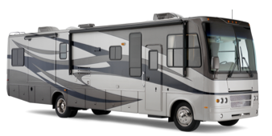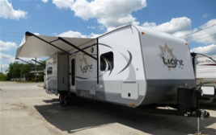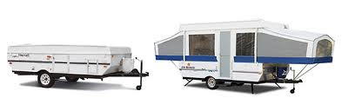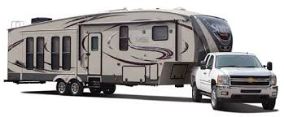
Motorhomes Travel trailers Tent Trailers Fifth wheels

- Toy Haulers are RVs with a garage area that can be used for storing ATVs, bikes, etc.
- Park Models are bigger RVs meant as vacation cabins to be kept in one place.
- Truck Campers, while not vehicles, serve as a livable space mounted on a pick-up truck.
- Sliders, to be clear on the definition, are parts of an RV that can be slid out to create space.

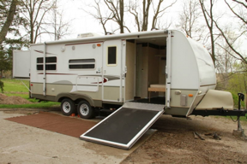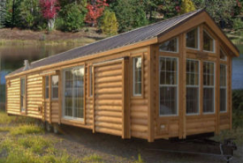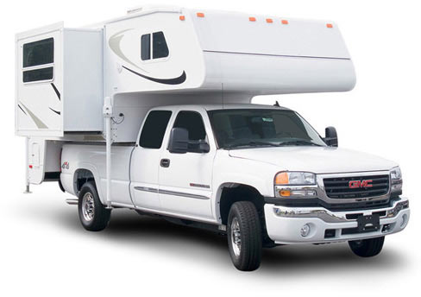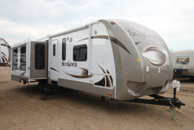
Toy Haulers Park Models Truck Campers Slider

Week 2: There are several factors that influence the industry. Get together with the group listed above and discuss how the following environmental force impacts the RV industry:

Group Group

 | ◆ |  | A |  | Global & Demographic Forces |  | ❍ |  | D |  | Technological & Ecological forces
 |  |  | B |  | Political & Economic Forces |  |  |  | E |  | Buyers & Suppliers
 | ⬥ |  | C |  | Socio-cultural Forces |  | □ |  | F |  | Threats from Substitutes
 |  |  |  |  |  |  |  |  | G |  | Threats from Rivals & Entry

Week 3: The RV industry makes a range of vehicles from ultra-lightweight (two metre long, 600 kilo vehicles) to 12 metre long, 10+ tonne busses. We will discuss a range of vehicles and their manufacturers. To that end, you have each been assigned a company to research. Working in groups, discuss and be prepared to present what your company’s resources, capabilities and core competencies are, and explain why you listed the core competencies you did.

Group Group Group

 | ◆ |  | A |  | Escape Trailers |  | ⬥ |  | C |  | Safari Condo |  |  |  | F |  | Winnebago
 |  |  | B |  | Tiffin Motorhomes |  | ❍ |  | D |  | Trail Manor |  | ❐ |  | G |  | Taylor Coach
 |  |  |  |  |  |  |  |  | E |  | Thor Industries

Given your group’s company from the above list, discuss and present your company’s:
❖ Business level strategy, how it protects from each of Porter’s five forces, and its risks.
❖ Corporate level strategy, how it assists them in executing their business level strategy.
❖ International strategy, and show how it assists them in executing their business level strategy.
❖ Cooperative strategy, and show how it assists them in executing their business level strategy.

Groups | ◆ | Clara W. |  | Amandeep T. | ⬥ | Faiz P. | ❍ | Ana B. |  | Elnaz S. | □ | Katherine Z.
for this | ◆ | Daniel C. |  | Ellis C. | ⬥ | Jessica M. | ❍ | Farnaaz J. |  | Janelle K. | □ | Leo K.
Exercise | ◆ | Duc A. |  | Madison P. | ⬥ | Philip C. | ❍ | Faye W. |  | Joshua F. | □ | Lucas C.
 | ◆ | Micah P. |  | Maniha I. | ⬥ | Ravneet B. | ❍ | Lauren D. |  | Kyle B. | □ | Mandy H.
(Tue.) | ◆ | Rachel R. |  | Richard M. | ⬥ | Richard T. | ❍ | Spencer M. |  | Tony Y. | □ | Nikhil N.
 | ◆ | Viola L. |  | Ziyad B. | ⬥ | Timothy Y. | ❍ | Janice C. |  | Some Others | □ | Everyone Else

Groups |  | Dayan A. | B | Brilliance Z. | C | Avita B. | D | Mengting Z. | E | Alvin M. | F | Adam P.
for this |  | Faiz B. | B | Catherine T. | C | Brendan L. | D | Michael L. | E | Anish P. | F | Alvina C.
Exercise |  | Heidi W. | B | Dingyizhuo W. | C | Connor K. | D | Victoria K. | E | Daniel V. | F | Diana M.
 | A | Marcel P. | B | Gurjinder K. | C | Czarina O. | D | Will W. | E | Jas G. | F | Nadine N.
(Thurs.) |  | Owen C. | B | Jonathan M. | C | Jake L. | D | Zhanyan W. | E | Joban S. | F | Wenlei H.
 |  | Steffi C. | B | Stephanie L. | C | William J. | D | Some Others | E | Verna T. | F | Everyone Else

