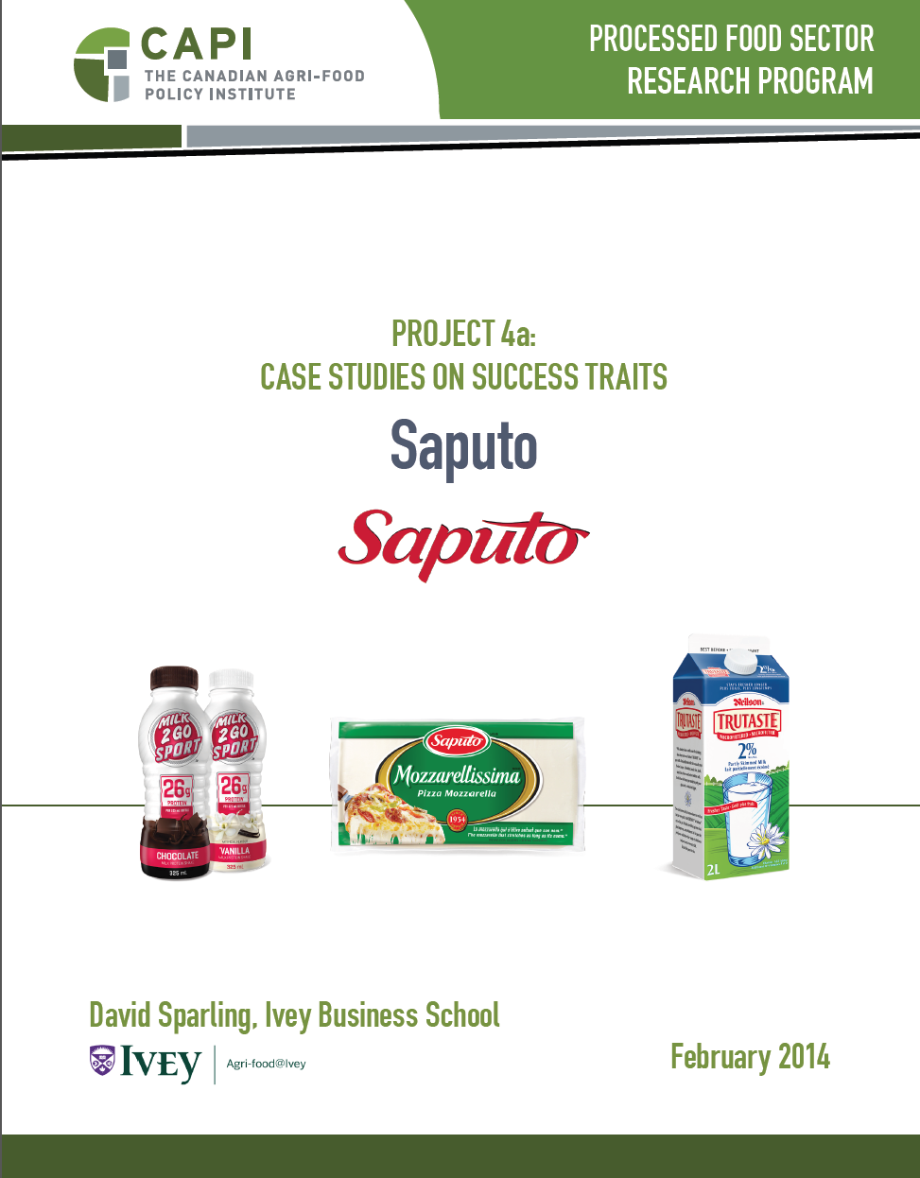
With select 2015 Updates
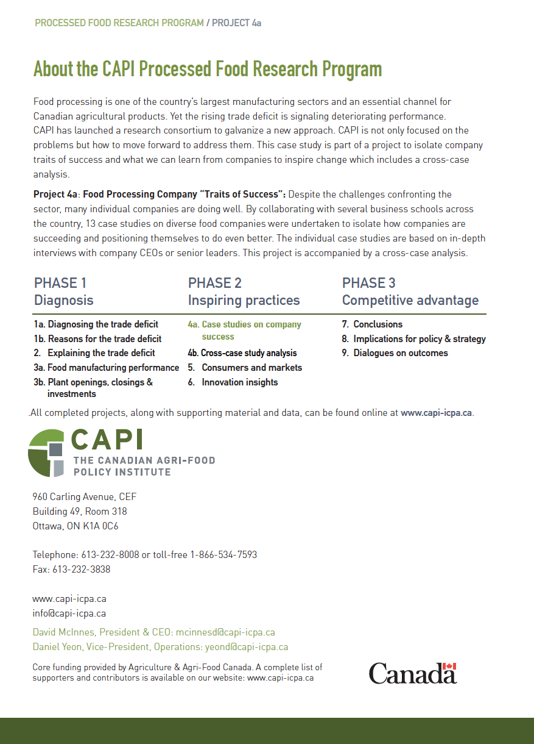

SAPUTO INC.

DAVID SPARLING, IVEY BUSINESS SCHOOL

EXECUTIVE SUMMARY

By any definition, Saputo is a Canadian success story. From humble beginnings, the company has grown into a multi-national force in the dairy and cheese industry. Saputo’s success can be largely attributed to two related factors, operational excellence with a focus on low cost leadership and an aggressive acquisition strategy that takes advantage of the company’s expertise in operations to buy and integrate companies which can benefit from their expertise while complementing existing product lines and production capabilities.

RESEARCH QUESTION AND PHENOMENON

Research Question:
How can a Canadian company become
a global player from a Canadian base, particularly
in a supply-managed commodity?

Saputo has proven that it is possible. The real question is how and what does that mean for Canadian food companies.

COMPETITIVE POSITIONING

Saputo has traditionally focused on being the low cost producer, particularly of cheese. Recent acquisitions have changed that somewhat, adding strong brands and non-cheese products. Market interest in more specialty products is causing Saputo to expand focus into higher value products where cost is less of a factor and innovative new products are the key to success. Although the company’s positioning has expanded somewhat to include supporting strong brands, the main competitive priority remains on being a lowest-cost competitor. Saputo management feels that its costs are the lowest in the industry, at least in Canada.

SUCCESS FACTORS

Interviews with three senior executives at Saputo were consistent in the factors to which they attributed the company’s success. Saputo has become a global player by using acquisitions to achieve global scale and export platforms, and operational excellence to integrate those acquisitions into the company to be the lowest cost competitor.
Operational Excellence and Efficiency – Saputo executives strongly believe that the company’s success is built on its superior capabilities in managing production operations, leading in both cost and quality. There are many elements to achieving operational excellence – consolidating to gain efficient scale, incorporating new technologies and systems, and using appropriate incentives.
Growth Through Targeted Acquisitions – To achieve greater global scale and enter new markets Saputo has grown continuously through an aggressive expansion through acquisition strategy. The company looks for acquisitions that complement existing product lines and where operations can be improved using Saputo’s expertise. Acquisitions should provide a platform for export while also taking advantage of the domestic market in the country where the acquisition is located.
More recent priorities include food safety and research and development aimed at maximizing the value from their high end products.

COMPANY BACKGROUND

Lino Saputo Sr. and his parents, initially selling homemade fresh mozzarella by way of bicycle, founded Saputo Inc. in 1954. To satisfy growing demand, Saputo’s first plant was opened in 1957 in the Saint-Michel neighbourhood of Montreal. The 1960s meant huge growth for Saputo, thanks to the mass popularization of pizza. To meet growing demand, Saputo acquired a number of manufacturing plants across Canada in the 1970s to achieve national distribution. By the end of the 1970s, Saputo was known as Canada’s most important mozzarella supplier to the food service industry.

SAPUTO’S ACQUISITION HISTORY

Saputo has continued to grow through acquisition since the 1970s. During the 1980s, Saputo continued to acquire Canadian plants, adding locations in Mont-Laurier Quebec, St. Hyacinthe, Que., and Cookstown, Ont. In 1988, the company entered the U.S. market by acquiring two cheese plants – one in Richmond, Vermont, and one in Jefferson, Maryland.
In the 1990s, Saputo undertook a number of strategic acquisitions to diversify their portfolio and expand distribution capabilities. They acquired Fromage Caron Inc., a Quebec importer and distributor of fine cheeses, in 1996. In 1997, they entered the fluid milk market by acquiring Cremerie des Trois Rivieres. Also in 1997, Saputo issued their first Canadian IPO for $4.25 per common share. Most notable, Saputo acquired the U.S. company, Stella Foods in 1997. With this move, Saputo became one of the most important natural cheese producers in the U.S. In 1999, they entered the bakery business with the acquisition of Culinar Inc., a Canadian producer of snack cakes, fine breads, soups, and crackers.
In 2000, Saputo acquired Cayer JCB Group, a Quebec based producer of European style cheese such as Havarti, Camembert, Brie, etc. The acquisition of Dairyworld Foods in 2001 made Saputo the number one player in the Canadian milk processing industry. In 2003, Saputo continued to expand their presence in the U.S. by acquiring the Treasure Cave and Nauvoo brands, making them the leading blue cheese producer in the U.S. retail segment. Also in 2003, Saputo expanded their operations to Argentina with the acquisition of Molfino Hermanos. In 2005, Saputo acquired the Quebec based Fromage Cote and Distributions Kingsey, as well as Schneider Cheese in the U.S.
Saputo entered the European market in 2006 with the acquisition of German cheese producer Spezialitaten-Kaserei De Lucia. Also in 2006 brought further expansion of the bakery division, by acquiring Boulangerie Rondeau as well as Biscuits Rondeau, both out of Quebec. In 2007, Saputo acquired UK food service manufacturer Dansco Dairy Products, as well as Land O’Lakes’ West Coast Industrial cheese business. In 2008, they acquired the Alto Dairy Cooperative in Wisconsin, as well as Neilson Dairy in Canada. In 2009, they acquired F&A Dairy of California and in 2011, Fairmount Cheese Holdings (parent company of DCI Cheese Company).
In 2013, Saputo completed the $1.45 billion acquisition of Morningstar Foods, a subsidiary of Dean Foods, which supplies ESL (extended-shelf-life) fluid dairy, non-dairy and cultured products to foodservice and control label retail customers in the United States. In 2013 Saputo began a bidding war for Warnambool Cheese and Butter Factory Co. of Australia, competing against local farmer Murray Goulburn Co-Operative Co. Saputo subsequently won control of Warnambool, owning 88 percent of shares; shareholders accepting Saputo’s offer of AUS$9.60. The acquisition of Warnambool allows Saputo to not only access new markets in Australia, but also in Asia, where 50 percent of the Warnambool’s sales are located.
Currently, Saputo operates in two business segments: dairy products and grocery products, manufacturing and marketing products such as cheese, milk, cream, sour cream, cottage cheese and yogurt. Major brands include Saputo, Alexis de Portneuf, Armstrong, Baxter, Dairyland, Dragone, Danscorella, DuVillage 1860, Frigo Cheese Heads, Great Midwest, King’s Choice, Kinsey, La Paulina, Neilson, Nutrilait, Ricrem, Salemville, Stella, Treasure Cave, Hop & Go, Rondeau, and Vachon. Saputo is headquartered in Quebec, employs about 12,000 people and by 2015 had achieved revenues of over $10 billion. Saputo operates in Canada, Argentina, the U.S., Australia and Europe. Saputo has 53 manufacturing plants, and offers products in more than 50 countries.
The impact of Saputo’s aggressive growth strategy can also be observed in its financial and employment numbers, doubling revenue and increasing employment by 75 percent.

 | 1998 | 2003 | 2008 | 2013
Revenue (million CAD) | $ 817 | $ 3,398 | $ 5,059 | $ 7,298
C A G R (percent) | - | 32.97 % | 8.28 % | 7.60 &
15 - year C A G R | 15.71 %
Employees |  | 6,900 | 9,300 | 12,089

Source: Mergent Online

OPERATING ENVIRONMENT

Domestically – Saputo’s strategy has been greatly influenced by the regulatory environment in Canada. The supply management system limits production to that needed to supply the Canadian market. The small market and low volumes limit the scale and efficiency of Saputo’s Canadian plants. Canada’s retail market is highly concentrated with significant buyer power and so the market is extremely competitive and price sensitive.
Saputo is operating in an industry where demand that is essentially flat in developed markets and growing in rapidly developing economics. This difference has added additional impetus to Saputo’s drive to build significant export capabilities outside North America. Saputo’s management intends to capture part of the growing global demand for milk products.
Globally – the cheese and dairy industry still has many regional differences. The U.S. market is highly competitive but there are more players and market opportunities. The U.S. has always been the big driver for volume and efficiency. The market in the E.U. is very different, with many products and also many players.
One of Saputo’s largest markets is Argentina. They entered the country through acquisition and intended to use it primarily as a base for exports. However, management recognized that a company can not operate as an exporter without effectively servicing the domestic market as well so it is now focused on building both businesses.

BUSINESS AND CORP. STRATEGIES AIMED AT DAIRY AND CHEESE COST LEADERSHIP

Saputo views itself as a dairy company with a growth oriented strategy. That growth is achieved by purchasing companies or facilities where their excellence in operations can bring new value to the acquisition. Saputo acts as a consolidator, purchasing under-performing assets and turning them around by focusing on operating effectiveness and efficiency. Their acquisition strategy has been built on two principles.
Product complementarity – Buy companies where the output complements and enhances existing product lines. Ideally, the companies should also provide platforms for exports to other markets.
Ability to benefit from Saputo’s expertise in operating efficiency – Saputo’s acquisition team looks at the current efficiency and effectiveness of the target and critically assesses the opportunity on the basis of what the target is doing in operations. “What would we do differently in terms of operations and what impact would that have on the bottom line?” They also look at the team running the organization and the culture and atmosphere in the organization - Is significant change possible in the target? Senior management is disciplined in buying. According to management, they will not overpay for acquired assets.
Acquisitions do not always work as planned. Saputo tried one foray into Europe, purchasing one small processing operation in Wales and another in Germany. Management thought that they could use these as bases for expansion into the E.U. through additional acquisitions. Saputo realized that they could not succeed without much larger scale. Unfortunately, management could not find additional acquisitions needed to reach the scale they wanted to achieve at an affordable price so ultimately they decided to exit the E.U. As well, in 2015 Saputo Bakery was sold to Canada Bread Company (a subsidiary of the world’s largest baker, Mexico’s Grupo Bimbo) for $120 million.

OPERATIONAL EXCELLENCE

The Operations function is critical to the company – high quality, low cost manufacturing has always been the root of Saputo’s success. Saputo’s goal is to be at the forefront of manufacturing costs, building on the skills of their people and technology. The reality in the global dairy industry today is that the margins are extremely small. Scale, volume and plant efficiency are critical to cost competitiveness. These factors drive much of Saputo’s decision-making and investment. As much as 85 percent of Saputo’s cost can be in the raw material. This is common for all manufacturers so efficiency in transforming milk into cheese can be a significant differentiator. Older plants do not achieve the kinds of yields that are now possible with newer plants. Labour is the other important cost. Automation can reduce labour costs, particularly in packaging, which is more labour intensive. Robotics are improving but there are still question around finding the right platform.
Saputo’s cold chain infrastructure is unmatched in Canada providing the company with coast-to-coast distribution of refrigerated dairy products in addition to what Saputo manufactures.

TECHNOLOGY DRIVES CAPACITY

New equipment can increase processing capacity and efficiency, especially in cheese. In the past, capacity has been constrained by technology. Much of the drive for greater capacity has come from the U.S., where specialized European dairy processing and packaging equipment was scaled up to meet the demand. In the early to mid 2000s a significant change in processing technology occurred. Saputo is now gearing up to larger scale operations. The company continues to invest in automation and robotics but always with a focus on the impact on the bottom line. Incorporating the latest technology into their manufacturing operations has been a very high priority in the last few years.
Increasing emphasis on sustainability has added new dimensions to Saputo’s drive for efficiency. The company has become much more active in reducing food waste and use of energy and water.

MANUFACTURING FOOTPRINT

Saputo still has 24 dairy plants in Canada. Many are older and too small by today’s competitive standards. There will likely be further consolidation in the future. Saputo has not built a new plant in Canada although they are upgrading and converting some plants such as the investment last year in new cheese making in British Columbia. All have been acquired through acquisition. To increase its efficiency and reduce costs, Saputo has also been consolidating warehouses and using new technology to streamline operations and reduce complexity. The company supports its operations through an Enterprise Resource Planning (ERP) system but continues to work on better integration of software systems.

ORGANIZATIONAL STRUCTURE

As it expanded, Saputo had to adapt its structure. The company is now organized into three divisions, Canada, U.S. and International, each with its own president. The International division handles all international sales, so if the U.S. division wants to export it sells to the International division. Overseeing all company activities is a powerful organizational super-structure that makes sure that all divisions are working to maximize benefits to the entire company. If one division proposes a new project the leaders determine how this will affect the entire company and how to maximize value across all divisions. There is also an organizational Research and Development Group to support the different divisions. Management feels that this structure is highly effective.

CULTURE

Saputo executives describe the culture in the company as entrepreneurial. Authority and responsibility are pushed down to the unit level, with different divisions and units within them operating as profit/loss centres. This helps managers in the organization understand their impact on the financial situation in the company. There is a great deal of trust and empowerment and their control systems ensure that leaders are accountable for their actions.
At Saputo the culture is highly oriented toward running the most efficient, low cost operations in the industry. All managers were very aware that the constant focus on driving out costs was an important factor in their success, and their reward systems recognized that.
LABOUR

As production technology changes Saputo needs more people with good technical skills. Currently, they find that a challenge in Canada and anticipate it getting worse in the future. In low unemployment regions like Alberta and Saskatchewan Saputo has difficulty attracting and retaining personnel, particularly skilled labour like mechanics.

IMPACT OF CANADIAN POLICY

Saputo is an interesting case of a company that planned to build an export oriented cheese business from Canada but had to change its strategy due to government policy around supply management and regulated marketing in Canada. For Saputo, the Canadian supply management system has been a constraint, at least on domestic operations. Small market, limited production volumes and static supply have reduced overall efficiency and also restricted the incentives to innovate. Greater cooperation and coordination between processors and dairy farmers in Canada would help the industry be more effective, particularly when changes are contemplated by either group.
A big question for Saputo is how new trade agreements will ultimately affect the Canadian supply management system and what impact that might have on the industry and Saputo’s operations.
Saputo experiences some challenges around food standards like the cheese composition standards, which can vary between its different operating regions. There are also issues around health and labelling regulations. Health Canada is focused on sodium reduction but well behind on other areas and not moving fast enough with things like plant sterols. We are behind the U.S. and EU. You cannot add anything to milk and still call it milk. All of these hamper innovation in Canada.
Because Saputo undertakes research and development in Canada it uses SRED tax credits. The company also has one individual who monitors provincial and federal programs for appropriate funding opportunities.

WHAT CAN CANADIAN FOOD MANUFACTURERS LEARN FROM SAPUTO

There are a number of lessons from Saputo. First, Saputo has clearly shown that Canadian firms can become successful global players. However, to do that they need a clear understanding of how they will compete. In Saputo’s case that was through a focus on building export platforms via acquisitions and cost leadership. Scale and operational excellence are important components of cost leadership, acquiring promising facilities and assets and using their expertise in operations to consolidate, upgrade, and extract the greatest value from their facilities. To be a global player, companies also have to take risks and not every initiative will be successful. However, as their recent acquisition in Australia proves, Saputo is far from done in its quest for global industry leadership.

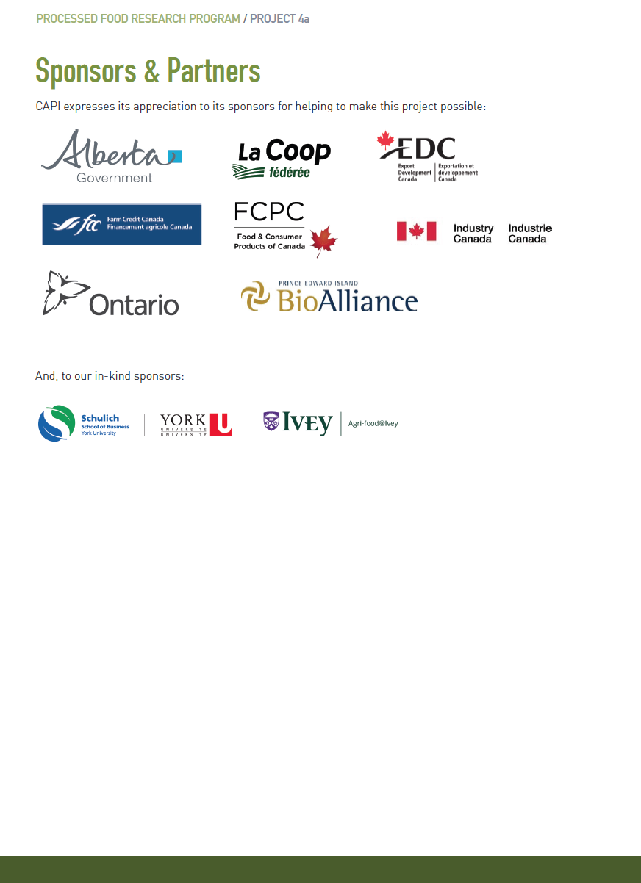

Sources: MarketLine Advantage, Dow Jones Institutional News, Company Website

