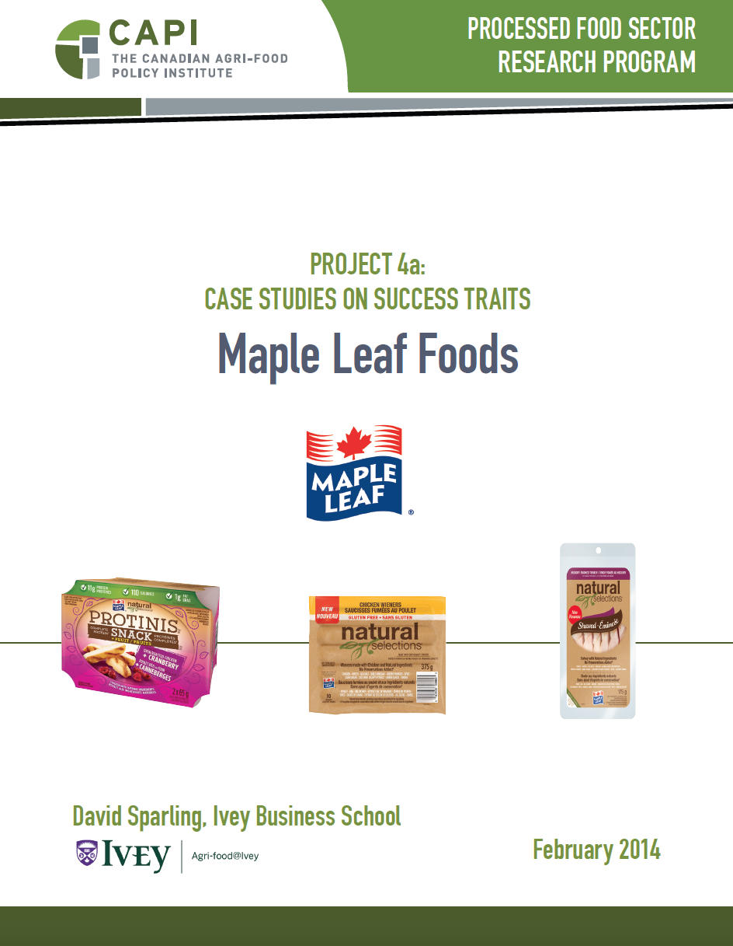

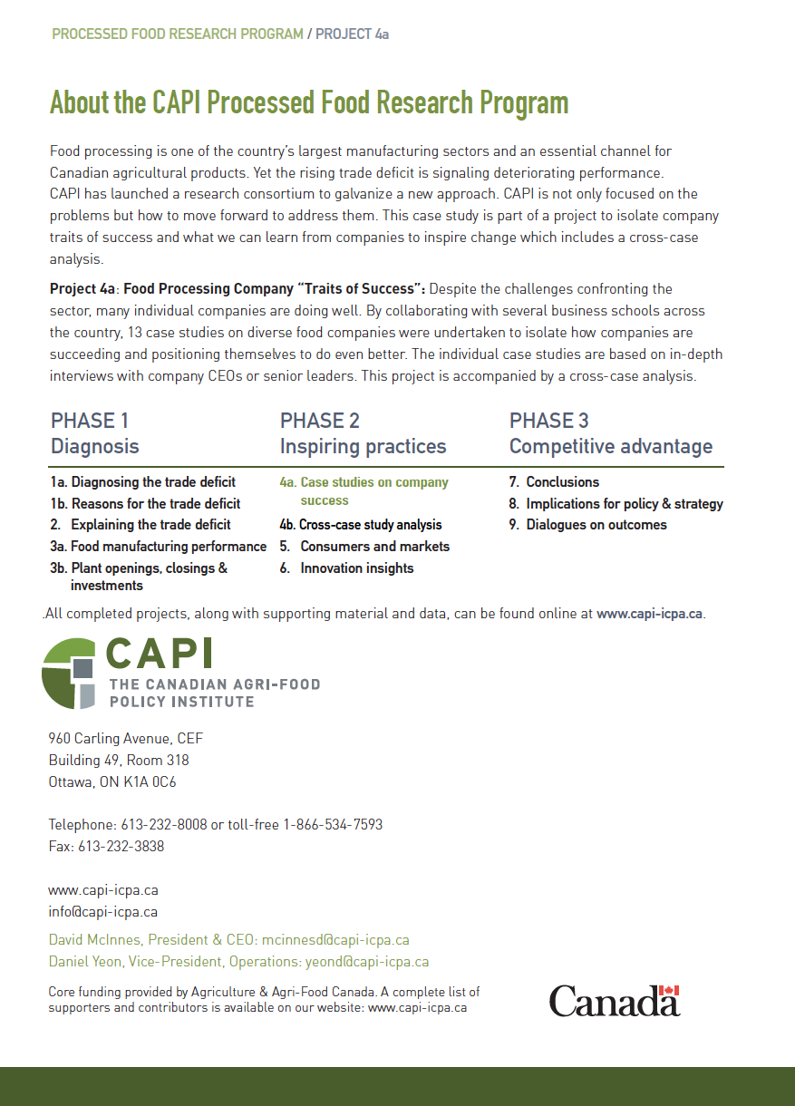

MAPLE LEAF FOODS INC.

DAVID SPARLING, IVEY BUSINESS SCHOOL

EXECUTIVE SUMMARY

Maple Leaf has been through a turbulent decade, challenged by the rising Canadian dollar, increased foreign competition, a consolidating customer base, a major food safety crisis and a fight for shareholder control of the company. The company has weathered the storm and is laser focused on creating a globally competitive company, primarily in terms of cost structure, but also in the strength of its brands. To that end, Maple Leaf continues to restructure operations, invest in new plants, technology and systems, and generally streamline and modernize operations and product lines. It is also selling off non-core assets to finance the company restructuring. The company’s current focus is on building the right business model and supporting systems to compete successfully domestically and then to expand further into export markets. For Maple Leaf, this has been a challenging decade-long process which management believes is nearing the end.

Research Question and Phenomenon

Research Question:
How can a Canadian meat company restructure to become globally competitive?

Maple Leaf has been working hard at staying competitive. The real question is what does this mean for Canadian food companies.

Competitive Positioning

Maple Leaf is primarily a meat company producing high quality branded meat products. Its competitive positioning is based on quality, safety and value. Maple Leaf Foods’ management believes that their strong brands can only be competitive if they are supported by an efficient and cost competitive manufacturing system. Although the company does export, particularly to the U.S. and Japan, the major focus is currently on competing in domestic markets, particularly against imports.
Success Factors

Maple Leaf’s strategy is to be globally competitive through a combination of strong brands, supported by world class manufacturing capabilities that provide cost competitiveness, particularly compared with U.S. competitors. Therefore, its success factors focus on upgrading manufacturing capabilities supporting company brands. The changes that Maple Leaf has made in pursuit of global competitiveness are highlighted below, and are discussed in more detail throughout the paper2
Manufacturing Competitiveness – Production and distribution efficiency are critical to Maple Leaf’s cost competitiveness. Maple Leaf is achieving this through a combination of increasing production to global scale, investing in new technologies which reduce labour costs, investing in a company-wide $90-million SAP system to control and integrate operations and functional areas across the company, and investing in systems like Six Sigma and lean manufacturing to improve processes and employee capabilities.
Strong Brands – Maple Leaf controls several major brands in both meat and bakery products, although the bakery division was recently sold. Maple Leaf continually strives to bring innovative new products to market and improve the quality of the products.
Expanding Through Successful Acquisitions – Maple Leaf has used acquisitions to achieve greater scale but also to acquire major competing or complementary brands.
Maintaining the Highest Quality and Safety – Maple Leaf’s listeriosis crisis in 2008 changed the way Maple Leaf addresses food safety specifically, but also the company’s approach to how it manages operations. Food safety is now one of the company’s highest strategy priorities as evidenced by the creation of the position of Chief Food Safety Officer reporting directly to the CEO.
Strong Leadership – Maple Leaf has been through a turbulent decade. Throughout its challenges and many changes, management under CEO Michael McCain has remained focused on moving the company forward and becoming a global competitor in the meat products industry with the cost structure, quality and food safety levels needed to compete with the best in the world. Although the path has been far from easy, the way forward has been clearly laid out.

COMPANY BACKGROUND

Maple Leaf Foods was created in 1991 through a merger between Maple Leaf Mills and Canada Packers, companies with histories dating back over 100 years which were themselves collections of merged companies. In 1995, McCain Capital and Ontario Teachers’ Pension Plan acquired a controlling interest. That same year, Maple Leaf acquired The Landmark Group, an animal agriculture company in Western Canada. In 2000, Maple Leaf entered the Chinese market. In the following years, they acquired many strategic business units including Schneider’s, Grace Baking Company, and Canada Bread. Between 1995 and 2004, Maple Leaf completed 25 acquisitions worth $500 million and 10 divestitures worth a total of $130 million, reshaping the company. The most recent divestitures include Rothsay Rendering, Olivieri Pasta and Canada Bread. The sale of Canada Bread in 2014 made Maple Leaf debt free.

More recently, the company has undergone a massive restructuring to simplify distribution and product lines, in hopes of restoring profitability. The company is currently investing over $400 million in a new meat plant in Hamilton, Ontario. By the end of 2014, production from plants in North Battleford, Saskatchewan, in Kitchener, Hamilton, and Toronto, Ontario., in Moncton, New Brunswick, and a small facility in Winnipeg, Manitoba., will be consolidated into three existing plants and the new plant in Hamilton.

Maple Leaf Foods’ main business is in consumer‐packaged products, which includes meats, ready‐to‐eat meals and bakery items. The company operates in North America, Europe and Asia. It is headquartered in Toronto, and employed 20,000 people on December 31, 2012. Prior to the sale of Canada Bread, major brands included Maple Leaf, Schneiders, Dempster’s, Shopsy’s, POM, and Mitchell’s Gourmet Foods, among others. The company operated 85 plants across North America and the UK. It serves wholesale, retail, foodservice, industrial, and agricultural customers in Canada, the US, and Mexico. It operated through three business divisions: meat products, bakery products, and agribusiness. Overall sales of $4.9 billion came from meat products ($3 billion), bakery ($1.5 billion) and agribusiness ($0.3 billion). The recent sale of Canada Bread repositions the company and reaffirms Maple Leaf’s primary commitment to the meat product business.

Operating Environment

Maple Leaf has been hit particularly hard by the changes in the environment. A higher Canadian dollar and higher commodity prices reduced company earnings. Consolidation and intense competition at retail meant that the pricing on products was tight and it was difficult to pass on higher costs. This was slightly mitigated by the drop in the prices of hogs and cattle, but those have recovered recently. In addition to a more costly and competitive environment, Maple Leaf’s recently sold bakery division was being further challenged by shifting health attitudes toward bread and the gluten‐free trend. Close relationships between competitors and some retailers reduced opportunities for Maple Leaf. For example, Weston bakeries sells roughly 60% of its production to Loblaw stores, while U.S. based retailers like Wal-Mart and Target have long term affiliations with U.S. suppliers and it can be difficult to displace them.

In export markets, the devaluation of the yen hurt margins in Japan. Korea’s recent trade deal with the U.S., but not Canada, eroded markets there and differences in drug use regulations in pork, specifically Russia’s ban on the use of Ractopamine, hurt exports to that country.

Strategy – Consolidation & Operations Efficiency to Support Brands & Price Competitiveness

Maple Leaf’s strategy is focused on manufacturing that is globally competitive. For Maple Leaf, global competitiveness means being cost competitive through a combination of scale and use of technology and management systems. It also means having industry-leading levels of food safety and quality to support strong brands. One part of the strategy is to create Centres of Excellence where plants specialize on particular product lines – with a development function focus on the product lines and manufacturing operations and processes that take advantage of both scale and technology to produce and deliver the products. Automating and scaling up production and creating an efficient distribution network to move products across the country are all tactics the company is using. Examples include focusing bakery operations in Hamilton and having a single plant producing bacon in Winnipeg. The company is now cost‐competitive in some of the larger plants, but is still a couple of years from being globally cost‐competitive in others. The investments, consolidations and closures in production and four distribution facilities being made to achieve global scale and cost structure are highlighted throughout this case study.

Although the current focus in on domestic markets, longer term, the growth in the protein markets internationally is perceived as a huge opportunity for Maple Leaf.

PRODUCTS

Product focus is still on protein (and bakery until recently) although there are efforts to diversify into more meal solutions, which is seen as a growth opportunity. Canada lags behind other regions like the United Kingdom in both selection and consumption of ready to eat meals. However, Maple Leaf’s sale of its Olivieri business makes this move more challenging. One challenge in Canada is logistics. Logistics can be cost‐effective in major centres like Toronto, but in most of Canada distribution is an issue. Retailers and consumers may be ready but getting products to them may be too costly in some cases.

Maple Leaf was in seafood at one point. The company was importing tilapia from China to add a fish line to a meat plant in Quebec, but backed away due to regulatory issues of combining meat and fish in the same plant.

The company is trying to move its product offerings from partially processed to higher value, further processed products. The real margin opportunities are in branded product. Store brands are significantly lower margin with fewer opportunities to innovate and to differentiate products. As interest in natural ingredients grows in the marketplace, Maple Leaf has been extending natural ingredients across the meat line, which has helped regrow the category.

On the product side, the focus has also been on stock keeping unit rationalization – reducing the number of product offerings and the number of formulas. This reduces costs by allowing fewer changeovers, longer runs and more consistent packaging, as well as more efficient buying.

Maple Leaf kills hogs in Brandon in a highly efficient plant that is among the best in the world. The Brandon plant supplies pork to Maple Leaf for further processing as well as to the U.S. The majority of the $350M of product into the United States is pork for further processing. One challenge for the Brandon plant is hog supply. The plant is only operating at roughly 85% of its theoretical capacity of 4.5 million hogs per year. Maple Leaf also has a speciality pork plant in Lethbridge which produces highly marbled pork for Japan and premium table meat customers.

There have been challenges in some areas of the bakery division. The market for sweet goods is changing. Maple Leaf closed plants in Shawinigan, Québec, Grand Falls, New Brunswick, and Edmonton, Alberta. The plants were producing the wrong products and the plants were too small and too regional to be efficient. However, because freshness is so important in bakery products, the company will maintain plants in most regions. The new Canada Bread Trillium plant in Hamilton will be world class in terms of scale and technology. In selling Canada Bread, Maple Leaf has reinforced its emphasis on the meat industry and has significantly strengthened its financial position, eliminating company debt.

Marketing Analysis

Historically, each brand had separate marketing functions with little corporate oversight. However, when Stephen Graham became the CMO in 2009, he consolidated the departments and revamped Maple Leaf Foods’ marketing strategy. Emerging from the listeria crisis of 2008, he emphasised consumer‐focused product innovation. Consumers were looking for healthier, fresh, and convenient products, which is exactly what Maple Leaf delivered. To amplify the new products, an aggressive campaign was launched to feature brands on multiple platforms from TV sports to online communities. The campaign was focused on the ways these new healthy and convenient products could make a consumer’s life easier and better. As a result, Maple Leaf Foods’ regained consumer confidence in their brands and profitability has increased substantially since 2008.

OPERATIONAL IMPROVEMENTS

New Technology and Systems

Processing technology is critical for quality, cost and safety. Maple Leaf’s strategy to become a technology leader has been to adopt and import equipment from other areas, particularly Europe. The company has made major technology investments in the new meat and bakery plants in Hamilton. Greater automation will reduce labour requirements by about one third.

New technology like cook/chill systems will extend shelf life and allow the company to ship further and get into new markets. Production is moving from batch processing to more of a flow system. Cooking in water and cooling in water allow for a continuous flow and cooking the product in a bag in the container provides better control and a more uniform product. Food safety is enhanced as the product does not touch human hands -­‐ robotics moves it into an automatic storage and retrieval system. This approach could essentially double the shelf life, as well as reducing production costs.

The company has financed the upgrades and improvements from earnings and sales of capital assets. This has limited new equipment purchases and the pace of implementation somewhat. However, the company will continue to invest. “We know automation is the future. We visit processing plants in other parts of the world and they are much more automated.”

Organizational Infrastructure and Systems

Maple Leaf is in the middle of a company‐wide $90‐million SAP implementation, one of the largest and most comprehensive in Canada that reaches into every part of the company and every function. It is a multi‐year project that adds an additional challenge for the company’s new technology implementations – getting new technologies to work with a new control system (SAP) and, in cases such as the new plants in Hamilton, with new staff. However, the SAP system is seen as a critical factor in integrating the entire production and distribution system.

Manufacturing Footprint

Maple Leaf’s manufacturing footprint is constantly changing as the company acquires new assets, builds new plants and consolidates production across the country. The company closed the North Battleford plant producing bacon, shifting production to Winnipeg. Sliced meat production has been moving to the new plant in Hamilton from facilities in Moncton and Kitchener which are closing. Most of the pork will come from Brandon, but some will also be sourced from Ontario. Beef products will be sourced from outside the company, while chicken comes mainly from Maple Leaf plants ‐ four in Ontario and one in Edmonton. Poultry value adding closed in Ayr and moved to Brantford. Maple Leaf sold its turkey hatchery to Cuddy and sold breeder barns to a large farmer. This was done in part to raise capital from non‐core assets.

Maple Leaf also constructed two global scale plants, one for further processing of meat and a bakery. In assessing locations to construct the new facilities, Maple Leaf employed a model that evaluated all aspects on an operating cost basis. Central Canada and Manitoba were the most logical locations. Most customer distribution centres are in Ontario and Maple Leaf has been migrating to major centres partly due to availability of infrastructure and labour. Appropriate infrastructure is critical but labour supply and labour relations are also major factors. Ultimately, Maple Leaf decided on Hamilton for both plants. The decision was aided by the willingness of Hamilton city personnel to move things quickly and confidentially and to make a coordinated effort to simplify the process.

Maple Leaf is also consolidating its distribution system, moving from four major distribution centres to two. It has outsourced management of one centre to a third party provider which is a new approach for the company used to controlling every aspect of both production and distribution. A number of smaller distribution facilities across the country are also being closed.

Research and Development

R&D investments are relatively modest, although Maple Leaf currently has eight collaborative/co-funded research projects with Canadian universities. Maple Leaf doesn’t try to invent the systems, process technologies or even products. They seek to adapt and scale-­‐up, and to tweak product ideas. “We are very aligned to our ingredient supplier innovations and also technology innovations. For example, natural products are huge – a supplier developed the innovation and our role is to formulate it into their products. Even cook/chill was somebody else’s idea and we are implementing it into our systems. We don’t need to come up with made‐in‐Canada solutions.”

ORGANIZATIONAL ISSUES

The structure of the organization is changing as managers take on roles that are more comprehensive. Maple Leaf is using a matrix structure. Given their focus on global manufacturing competitiveness, they now have a senior VP for manufacturing. They have also created the new positions of Chief Food Safety Officer reporting directly to the CEO and VP of Leadership reflecting the company’s emphasis on both as being essential to future competitiveness. Getting the right incentives is also important and the annual performance evaluation system ranks managers on their performance against goals and allocates rewards, and possible management changes, based on those rankings.

Culture

Maple Leaf has developed a strong culture of “doing the right thing,” taking responsibility for problems and correcting problems. As described in the Ivey case study on Maple Leaf,
“The leadership team at Maple Leaf had invested substantial amounts of time and money in developing a strong values framework to which all executives, and the vast majority of managers, had been exposed during the Maple Leaf Leadership Academy programs through which all senior and middle‐level leaders had attended. There were six core values each of which had supporting behaviors: Do what’s right; Be performance driven; Have a bias for action; Continuously improve; Be externally focused; and, Dare to be transparent. There values were the basis on which people were hired, evaluated, promoted or fired at Maple Leaf and those in leadership positions were expected to live by them.”

That culture played a major role in their recovery from the 2008 listeriosis crisis. Management immediately took responsibility for the problem, and the unfortunate illnesses and deaths, compensated victims and their families, and started the process of identifying and correcting the problem. Since then, Maple Leaf’s food safety issues have transformed the company’s culture to one where food safety is a critical element of everyone’s jobs. Maple Leaf recently won another “Canada’s 10 Most Admired Corporate Cultures” award in 2013.

Although Maple Leaf makes use of relationships with suppliers and customers, the company takes a very independent approach to running its business. Alliances have not been a priority for the company even though they do work closely with suppliers to develop new product ideas.

Leadership

Maple Leaf now has a full‐time VP of leadership. The biggest problem facing the company right now is that they are stressed on execution and time is their most significant challenge. Developing management talent is critical to increasing execution capabilities. Maple Leaf has pulled back somewhat on its change agenda due to financial stresses but is still committed to reshaping the company. All managers are on a leadership‐ranking scale in which goals are set and everyone is ranked based on their performance.

Plant leadership and management is a key part of the change process for Maple Leaf. Managers have become more broadly focused. They used to focus solely on production and let others worry about food safety and sustainability. Now managers must consider all aspects of the business and they are evaluated on those. They must be great leaders and team builders.

Food Safety

Maple Leaf has always had a strong focus on food safety. From the time the company was formed in 1995 to the 2008 listeriosis crisis, the company had not had a product recall for pathogenic bacteria. In 2006, Maple Leaf even adopted the brand tag line “We Take Care”6. However, the listeriosis crisis shook the company and forced management to rethink every aspect of its approach to food safety. Food safety went from being the responsibility of a small group of food safety experts to being a core responsibility of every manager. Today, Maple Leaf’s focus on food safety and quality is truly ahead of the industry and is led by a Chief Food Safety Officer reporting directly to the CEO. The company has invested considerably in Six Sigma programs and training for years and they consistently measure the benefits from the program. They are now focusing more on lean manufacturing and reducing food waste. Maple Leaf is Global Food Safety Initiative (GFSI) compliant in all 50 of its plants and in plants that co‐manufacture for the company.

Sustainability

Environment – Maple Leaf has made a strong “Environmental Commitment” that is approved and monitored by the Board of Directors. Included in the commitment are promises to minimize environmental impact, exceed laws and regulations, continuously improve environmental performance, educate employees on environmental protection, and set and monitor targets. A three-­‐year environmental sustainability strategy was recently developed which set targets to reduce carbon emissions, energy usage, and solid waste. Previously, there were no formal programs or targets. However, from 2001-­‐2011, Maple Leaf reduced their energy consumption by 23%. Constant efforts are made to make Maple Leaf’s facilities more environmentally friendly. The plant in Mississauga was recently awarded LEED Gold certification, as was the recently sold bakery in Hamilton. The Hamilton meat processing plant is in the final stages of verification.

Maple Leaf recently published their first sustainability report. The strategy is very much about economics, philanthropy and environment. The company used Global Reporting Initiative template metrics and benchmarked using 2011 data. Maple Leaf is executing a whole new sustainability strategy and will add a new Director of Sustainability. The move toward greater sustainability is being driven partly by Maple Leaf’s customers who are moving rapidly on sustainability. Maple Leaf feels the need to stay closely in sync with its customers.

Labour

Maple Leaf perceives its workforce as important to future success. One challenge for the company as it implements new technologies and systems will be to manage the transformation of the workforce from a high labour environment to a high technology environment. Training and appropriate incentive systems will be critical.

Unskilled Labour – The company faces worker shortages in Western Canada and depends on the Temporary Foreign Worker Program (TFWP), which allow workers to come for two years. The foreign workforce has been mainly from China, El Salvador and the Philippines. In total, Maple Leaf has recruited over 2,400 foreign workers since the company started using the program and approximately 70% of those workers have achieved permanent residency, particularly in Manitoba. Maple Leaf doesn’t rely on TFWP in Ontario where there is enough labour.

Skilled Labour – New technologies are a vital part of Maple Leaf’s manufacturing strategy. The company needs more computer and automation skills and a higher level of talent. Maple Leaf brings skilled workers from Ireland and some other European countries. The industry’s reputation as low wage and low skilled presents a challenge for company efforts to attract people. This will likely affect the entire industry. In some parts of Canada, Maple Leaf uses the Temporary Foreign Worker Program for skilled labour as well as for unskilled labour.

Canada overall, Maple Leaf included, does not do enough to invest in apprenticeship training. Maple Leaf is developing a strategy around skilled trades and options to strengthen recruitment and retention through apprenticeship programs. In addition, Maple Leaf has moved to market‐based pay for skilled trades, rather than negotiated wage rates. This allows Maple Leaf to compete for skilled labour in the various regions in which it operates.

Impact of Canadian policy

Regulation – The industry has been challenged by out of date regulations that do not align with those of other trading partners. Regulatory reform is important but the change agendas are real at both Health Canada and the Canadian Food Inspection Agency. For Maple Leaf and the industry, this is a good‐news story.

National coordination of regulations – More immediate issues exist around labour, environment, health and safety. Coordination is particularly important for a manufacturing firm trying to achieve scale across many regions. Labour laws and pensions regulations need to be more uniform across the country. Even the associations are provincial and are not coordinating across the country. This is an industry issue that needs to be addressed.

Trade – Trade remains important and Canada needs good trade deals to access new markets. More regulatory alignment with the U.S. is also needed to equalize the regulatory burden. The work of the Regulatory Coordination Council and the Beyond Border initiative are vital.

Technology – We don’t need to come up with made in Canada solutions. Governments still feel that it is about new technology and they don’t want programs to benefit individual companies. However, investments in new technology are critical to Canada’s competitiveness. The new NRC partnership model may be interesting.

Funding new technology – Eliminating all import duties on new equipment is also a big help. Apart from the accelerated CCA, there is not enough other assistance to help fund investments in new technology. Maple Leaf was fortunate to receive a $5‐million repayable contribution from the federal AgriProcessing Initiative toward some of the technology installed in the new Hamilton meat plant. The higher Canadian dollar helped with technology purchases in the past but that is changing. Maple Leaf helped instigate the new Canadian Food Innovators Agri‐Science Cluster which has received funding from AAFC’s agri‐ science program.

Labour – Maple Leaf relies on the foreign worker program to secure enough employees for plants in Western Canada. It is helpful when some of those workers are given residency status so that they can stay with the company.

Training – Growing Forward 2 has a program for capacity building in Ontario which includes a maximum of $350,000 over 5 years. Maple Leaf will implement a training program with Mohawk College under this program. A good thing about the program was the simplified process, which provided an answer in 45 days, even though it took almost twice as long to get the final approval. The size of the budget supporting this program is unclear.

Municipal governments – Municipal governments play important roles in facility location decisions. The Team Hamilton approach was very effective in facilitating engineering, legal and avoiding the political issues. They kept discussions confidential. Infrastructure, labour availability and relations also helped. Proximity to supply played a smaller role in the location decision.
What can Canadian food manufacturers learn from Maple Leaf?

Although Maple Leaf’s experience in recent years has been unique compared to other Canadian food manufacturing companies, there are a number of lessons that can be drawn from that experience. One of the first is just how important food safety is to any food company, even companies with excellent records. Companies need a strategy for ensuring the highest level of food safety possible and thus the lowest level of risk to their brands.

The Maple Leaf case also illustrates the importance of focus to a successful company. Maple Leaf’s main strategic thrust has been to achieve a globally competitive cost structure. The company is doing that through a combination of scale and new technology, and company-­‐wide systems for controlling operations. Maple Leaf has reorganized its manufacturing base to increase operating scale, invested in new equipment to reduce labour costs, reduced product numbers to achieve longer, more efficient production runs and invested in a company-­‐wide SAP implementation to coordinate production and distribution. Six Sigma training for employees helps ensure quality. All of the changes in recent years have been aimed at reducing costs and maintaining both safety and quality.

The company’s focus has also been evident in its divestiture strategy. Maple Leaf has sold off non-­‐core assets to finance investments in its meat business, including the very strong Canada Bread division.

All of this has been possible because of the strong leadership provided by CEO Michael McCain and his team. The core value of “doing the right thing” helped the company weather the challenges it faced in the listeriosis crisis. Management knew what they should do to make amends and to correct the problems and they acted immediately, acknowledging responsibility, providing compensation and taking corrective action. Throughout the company reorganization, the path forward and company priorities have been clear for Maple Leaf.

One other lesson is that companies that are moving forward take action and change things. Closing plants or consolidating production is never an easy decision, but the long-­‐term health of the company required short-­‐term sacrifices. Change does not always happen quickly. Maple Leaf is on a path that it commenced almost a decade ago – and it is still not done.

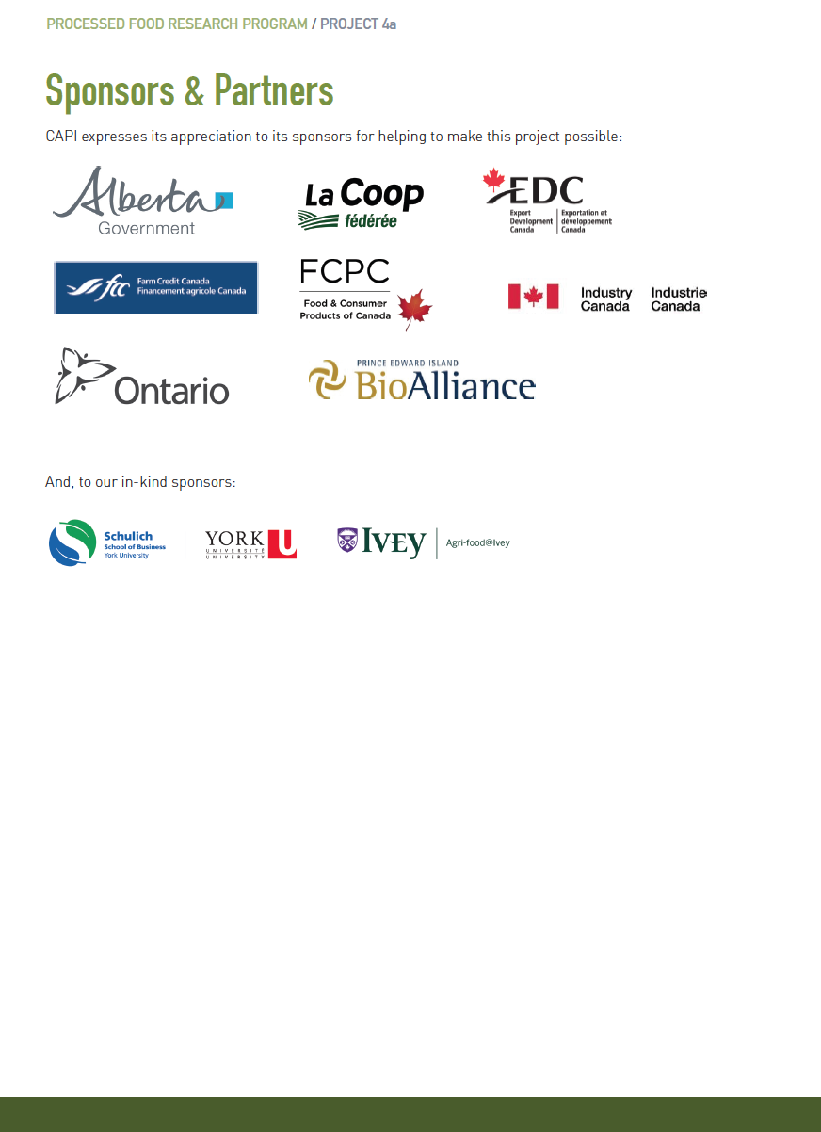

This case study is based on publically available information and an interview with, Rory McAlpine, Vice-President, Government & Industry Relations, Maple Leaf Foods Inc.
Burn, Doug. The transformation of Maple Leaf Foods under energetic, innovative leadership. Food in Canada. Jan. 2004.
Rory McAlpine, Vice-­‐President, Government & Industry Relations, Maple Leaf Foods Inc.
Rory McAlpine, Vice-­‐President, Government & Industry Relations, Maple Leaf Foods Inc.
Page 5, Jeffrey Gandz, Maple Leaf Foods Inc.: The Listeriosis Crisis. Ivey Publishing, 2011.
Jeffrey Gandz, Maple Leaf Foods Inc.: The Listeriosis Crisis. Ivey Publishing, 2011.

