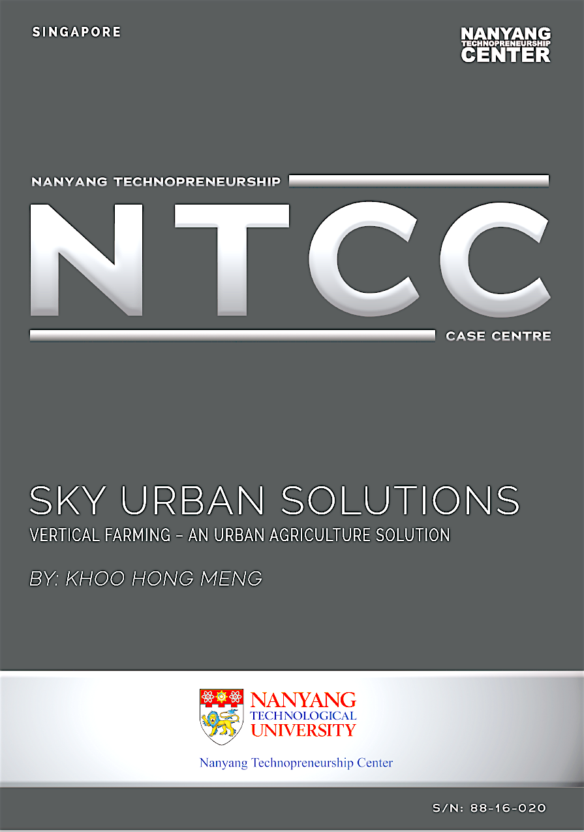
“By design, we are part of a very fragile and dynamic eco-system and the process of perfecting our system to meet ever-changing circumstances is never-ending. We’ve never stopped. I will not stop, and I hope that this recognition will inspire others, […] young designers, architects, engineers and entrepreneurs to continue on this intriguing and deeply satisfying journey to make this world a better place”.
Jack Ng, founder and CEO of Sky Urban Solutions (Sky Greens, 2015)
When Jack Ng was informed that his company, Sky Urban Solutions, had beaten 105 nominations from all over the world to emerge the winner of INDEX: Award 2015 under Work Category, he was probably not only surprised but also elated. He was the first ethnic Chinese in the world to win the prestigious INDEX: Awards. A more interesting fact was INDEX: Award Jury selected Sky Urban Solutions because the company had proven that vertical farming was not just a theoretical concept. Vertical farming could become a powerful solution that supports sustainable agriculture. Vertical farming is less resource-intensive compared to traditional farming. It requires less manpower, water, and electricity. Ng’s invention is supported by funding and R & D partnerships with government and research institutions. After its first year of commercialisation, Sky Urban Solutions was internationalised through sale of expertise while penetrating further into the locally-produced leafy vegetable market by expanding the scale of its local operations. However, market critics still believe that vertical farming is untested and traditional farming would take exigencies. Should Sky Urban Solutions expand its business so aggressively after only one year of commercialisation? There are marketing and operation challenges that might affect the company’s long-term business sustainability.

The company and its history
Sky Urban Solutions is a Singapore-based company that operates commercial vertical farms. Founded by Jack in 2011, the company developed a commercial vertical-farming system. Within a short span of three years, the company now occupies 3.65 hectares of farmland in Lim Chu Kang, housing more than 1,000 vertical-farming towers (Straits Times, 2015; Singapore Magazine, 2015). It has a pilot project in Bangkok and businesses in Hainan in China (IE Singapore, 2014). In 2014, talks on expansion had started in other parts of China — Tianjin, Beijing, Fujian, and Xian— and in other parts of the world — New York, Puerto Rico, and the Middle East.
Sky Urban Solutions has been marketing and operating urban sustainable farming technology through three wholly-owned subsidiaries, namely,
- Sky Urban Vertical Farming System Private Limited (VFS) manages consultancy and research, development, and design (R & D) work of vertical farms, and handles the company’s business expansion in Asia;
- Sky Urban Intellectual Property (IP), handles matters concerning the company’s intellectual property; and
- Sky Greens Private Limited manages the local operations of vertical farms (Sky Greens, 2015).
The story of Sky Urban Solutions actually began with Sky Greens in 2009 when Jack experimented with vertical farming. When he showcased his vertical-farming prototype A-Go-Gro in 2011 (Agritecture, n.d.), many investors believed that Ng’s farming system could overcome modern farming problems and expressed interest in collaborating with him. The A-Go-Gro was hailed as the high-tech solution for crop yields and food security concerns in densely-populated urbanized regions.
How did Ng conceptualise and create such an innovative and highly-lauded invention?
From ideation to prototype design
Jack knew it would be difficult to become a farmer in Singapore because of Singapore’s scarce natural resources. With a total land area of 718.3 square kilometres and nearly 40 per cent of potable water (Straits Times, 2010) and 60 per cent of fossil oil (Nanyang Technological University, n.d.) imported from Johor, West Malaysia, and the Middle East respectively, agriculture would not be economically viable in Singapore. In fact, Singapore produces only 12 per cent of local consumption of vegetables (Lim, 2015). More than 90 per cent of food consumption is dependent on imports (Ludher, 2015).
However, Jack was not deterred and he began looking for a systematic solution. He started with what he knew best — construction engineering. He thought of designing something inexpensive so that retirees in urbanised Singapore can grow vegetables indoors, without having to toil under the sun. His goal of having the “plant come to you, rather than you going to the plant” (Seneviratne, 2012) led to the construction of a three-tier structure of vegetable trays, one stacked on top of the other. Although he enjoyed planting, he had little farming experience. He attempted to make up for his lack of farming experience by learning from foreign workers who were working at his company. However, these workers’ tacit farming knowledge was limited to trial and error.
To achieve technological breakthrough, Jack needed scientific expertise and funds for in-depth R & D. He decided to seek professional advice and funding. In April 2010, in the capacity of managing director of DJ Engineering Pte Ltd, Jack signed a Research Collaborative Agreement (RCA) with the Agri-Food & Veterinary Authority of Singapore (AVA) with the aim developing a “basic vertical farm prototype for intensive leafy-vegetable production for the tropics” (Sky Greens, 2010). With an investment of SGD one million and after two years of working with AVA, he launched a six-tier A-Go-Gro (Seneviratne, 2012). The former Minister for National Development Mah Bow Tan was his guest of honour at the launch on 28 January 2011 (Sky Greens, 2011a).
The A-Go-Gro attracted a lot of media attention and received positive industry feedback. It had also clinched, among 800 participants, the Merit Award in Singapore’s first Urban Sustainability R & D Congress in June 2011 (Sky Greens, 2011b). When Jack received numerous queries from research institutes, investors, and non-government organisations, he knew his invention had enormous business potential. In Jack’s words,
The first burst of media coverage came on a Friday night. On Saturday morning, a man was sitting in my office. He had flown in from China. He was a farmer-cum-investor who wanted me to build a system for him, using my concept for not just a vegetable farm but also an animal farm (IE Singapore, 2014).
The man behind the invention
The idea of A-Go-Gro was borne out of a retirement plan and love for farming. Jack never dreamed that it could become a viable business worthy of worldwide recognition. Urban Sky Solutions produces vegetables commercially (via Sky Greens) and exports vertical-farming technology (via Sky Urban Vertical Farming System Private Limited) to other countries. More importantly, it has inspired budding entrepreneurs who are struggling to create value and find personal meaning in business.
Jack dropped out of school after Secondary Four. He started venturing into business at the age of 21 (Lim, 2015). Prior to Sky Urban Solutions, he was the managing director of an engineering firm, DJ Engineering, which provided customised products and manufacturing solutions for customers in the construction and engineering industry. By then, he had more than 27 years of experience in product design and had developed numerous building products such as glass-curtain wall, aluminium cladding systems, automated skylight canopy, and so forth. On the job, he was constantly challenged to solve problems through cost-effective designs and innovations.
During his helm as managing director of DJ Engineering, he had many foreign workers from India, China, and Bangladesh. During his meetings with the workers, he realised that they were homesick. Many of them were farmers before they came to Singapore, and because Jack also enjoyed planting, he felt that he could use farming to bring workers closer together. He converted the backyard of his factory in Kallang into a vegetable garden so that workers could have a common subject of interest outside work and exchange their “produce” of labour. Over time, workers shared farming tips with one another and office staff also joined in the activity.
When Jack shared his plan of becoming a vegetable farmer after retirement with his friends, they laughed and quickly dismissed his idea. They said that a farmer’s life would be tough and getting workers to farm would be even tougher. Jack took their comments seriously. He knew his personal weakness; he wanted an easy life after retirement so the idea of toiling in the fields, battling pest woes under the hot and humid Singapore weather was not at all palatable (IE Singapore, 2014).
Jack knew Singapore’s business environment well after running business for almost 30 years in the country. During the INDEX Award 2015 interview, he explained,
Singapore has limited land. Our farmland will [get] less [in future]. And we have even less […] farmers. So we must produce something that we can [not only] produce but also create jobs for our urban city people. […] During the financial crunch in 2009, food prices were going up because of supply disruptions overseas, so I had the idea of growing more food here (Casablanca Film, 2015).
After much contemplation, he figured out a solution. “Why not build a farm vertically? It’ll be perfect for land-scarce Singapore” (IE Singapore, 2014). He decided to use his engineering expertise to create a simple and yet sustainable farming system to address the food-shortage problem, and to increase farmers’ productivity and income. He started experimenting with vertical farming in 2009. He built a three-tier vertical farm in his factory backyard and home garden. In January 2011, he finally unveiled A-Go-Gro, an A-shaped vertical-farming tower comprising multiple rotating trays powered by water hydraulics.
“To me, it is not very different. Previously, I built houses for people to live in, now I build “houses for plants”. This was his reply when he was interviewed on how he felt about transiting from engineering and construction to agriculture business (Straits Times, 2015). He also said, “For the past five years, I’ve tried to be a farmer. It’s tough, challenging but I enjoy it” (Casablanca Film, 2015).
Jack has a vision of transforming the agriculture industry into one with low-carbon emission and low resource consumption. He has plans to leverage his technological innovation to lead and shape the agriculture industry beyond Singapore. Jack’s vertical-farming invention has a timely solution for the world’s most pressing issues in agriculture.
The concept of vertical farming
Traditional farming has always been resource-intensive. According to World Wild Life (n.d.), agriculture uses 70 per cent and wastes about 60 per cent of the world’s freshwater due to inefficient or defective irrigation methods, and the cultivation of water-thirsty crops such as cotton, rice, sugar cane, and wheat. In addition, anthropogenic water pollution causes water to be unfit for drinking and also leads to the extinction of flora and fauna. The problem is further exacerbated by climate changes that reduce the quality and yield of crops, livestock, fisheries, and aquaculture. The United Nations (2015) disclosed that climate changes would have threatened the food security of another 600 million people by 2080 (Parry, Rosenzweig, & Livermore, 2005). With the world’s population expanding at the rate that would add almost 2.3 billion more people to the world by 2050, and reaching a world population of 9.1 billion in 2060, global food production would need to be dramatically raised by some 70 per cent (FAO, 2009).
Traditional farming methods cannot produce enough food to feed the world’s population. There is insufficient land and labour for traditional farming. According to the United Nations Population Fund (2007), the number of people living in towns and cities would surge beyond 5 billion by 2030. This is a vicious cycle. With growing number of people staying in cities, more agricultural land will be sacrificed to accommodate urbanisation. With limited farmland and fewer farmers, the farming trade is not thriving. Very few people have the aspirations to be or stay on as farmers.
Vertical farming is the solution for urban, land-scarce cities, and countries like Singapore. But the concept of vertical farming is not new. Farmers in East Asia have been growing rice in vertical tiers (terraces) to conserve space and water. "Vertical Farming" was coined in 1915 by American geologist Gilbert Ellis Bailey. In 1950s, an attempt to integrate agriculture into the built-up environment was made in Denmark when a farmer grew cress in a factory on a mass scale. Since then, vertical farming has evolved into growing crops in a fully-controlled, indoor urban environment.
In vertical farming, plants are cultivated in multi-stacks or vertically-inclined surfaces of buildings, warehouses, or greenhouses located in cities or urban areas. The plants could be cultivated in three ways:
- a soil-based system in which plants are potted in trays of soil and sprayed periodically with a mist of nutrients, or
- an aeroponic system in which the roots of plants are sprayed periodically with a mist that provided the necessary nutrients, hydration, and oxygen for growth, or
- a hydroponic system in which plants were grown without soil by dipping the roots of plants in water containing nutrients.
Regardless of the cultivation technique, vertical farming based on resource-conservation principles is believed to be sustainable in the long run (Despommier, 2010). For example, growing plants in multistorey stacks reduces land space. Glass houses where natural sunlight can be augmented with artificial lighting such as LED lights reduce electricity consumption. Spraying or dipping the roots of plants with water reduces water wastage and pesticide use. Locating agriculture sites in cities minimises transportation needs and fuel consumption.
The A-Go-Gro System
The A-Go-Gro utilises the hydroponic technique of revolving trays of vegetables around an aluminium tower which is six to nine metres tall, occupying 5.5 square metres of floor space (Singapore Magazine, 2015). It can carry a maximum of 38 trays of vegetables. For a detailed description of the workings of the A-Go-Gro system, see Appendix A.
Resource saving features of A-Go-Gro
The A-Go-Gro system is designed with resource conservation in mind. The A-Go-Gro towers are constructed using easily-available aluminium. Each tower occupies 5.5 metres of floor space to produce 50 kilograms to 100 kilograms of vegetables for every 28-day growing cycle, yielding almost one tonne a year (Singapore Magazine, 2015). The system is capable of extracting energy from nature. The A-Go-Gro towers are kept in a greenhouse environment to save energy consumption of artificial lighting such as LED lights. Each tower is installed with a water-pulley system powered by flowing water and gravity to rotate the vegetable trays. In this way, each vegetable tray has access to nutrients every eight hours and receives 30 minutes of strong sunlight every day (IE Singapore, 2014). Furthermore, the vegetables are constantly exposed to changing atmospheric conditions during rotation — higher ambient temperatures on top, cool airy condition in the middle, and cold water at the bottom. The water powering the towers is recycled and filtered before returning to the vegetables through a sprinkler which mists the plants three times a day. All organic waste on the farm can also be composted and reused (CNN, 2012).
The A-Go-Gro system is also economical. Although each A-Go-Gro tower costs SGD 15,000 to manufacture, it has an annual yield of nearly 800 tonnes of vegetables per hectare. This is five to 10 times more productive than traditional farming (Wang, 2012; Singapore Magazine, 2015). Each tower consumes a mere 40 watts per hour of electricity per day. Using a sprinkler system to spray recycled water on the vegetable trays saves more than 95 per cent of water; traditional farming requires 400 litres of water per kilogram of vegetables produced (TVBS News, 2014). In other words, to produce one kilogram of vegetables, the A-Go-Gro tower requires only SGD 0.50 of electricity and 12 litres of water (Singapore Magazine, 2015). In addition, the A-Go-Gro system is mostly self-automated and can be operated with minimal manpower. Only three workers are needed to attend to 80 towers on a daily basis. See summary on the key operation variables of vertical and traditional farming in Table 1.

Table 1: Comparisons of vertical and traditional farming
Variables | Traditional Farming | Vertical Farming
Water consumption | 400 litres per kilo. of vegetables | 95 per cent less
Yield per day for 2500 square metre farm* | 10,750 heads of lettuce | 100 times more
Productivity | As standard | 5 to 10 times more
Electricity consumption | Not applicable | 43 watts per hour per day
* Data taken from “5 Ways Vertical Farms Are Changing the Way We Grow Food vertical farm in the U.S.”, by L. Chow, 2015, March 10, EcoWatch, http://ecowatch.com/2015/03/10/vertical-farms-grow-food/.
Since the launch of the A-Go-Gro system, there has been no shortage of attention from local and foreign investors. The challenge lies in separating the genuine and serious prospects from a huge pool of interested parties. Jack has a vision of A-Go-Gro playing a key role in transforming agriculture and enhancing liveable cities through the creation of urban-farming solutions. It was this vision that prompted the starting up of Sky Greens.
From start-up to commercialisation
The commercialisation of A-Go-Gro and start-up of Sky Urban Solutions was brought about by collaboration with external parties. Sky Greens was set up in 2011 with a SGD 26 million seed fund from SPRING Singapore (IE Singapore, 2014). Located in an open area designated by the government as an agro-technology park in Lim Chu Kang, Sky Greens began operations in 2011 to scale up and commercialise the A-Go-Gro. By October 2012, it opened its commercial vertical farm with 120 nine metres tall A-Go-Gro for producing three types of leafy vegetables — caixin, naibai, and kangkung (Oo, 2012). By 2015, Sky Greens already reached the production capacity of a total of 800 tonnes per hectare per year, that is, more than two tonnes per day of vegetables, or about 66 per cent of total local output of leafy vegetables (Singapore Magazine, 2015).
With the successful commercialisation of A-Go-Gro in Singapore, and a desire to deliver the A-Go- Gro solution to other countries, Sky Greens began its internationalisation journey with a grant under the Global Company Partnership Scheme from IE Singapore. The grant allows concessions for intellectual property protection in certain countries.
Intellectual property protection and international issues
Upon the advice of IE Singapore, Sky Urban Solutions set out to make use of its proprietary technology to become a global “modern urban agricultural solutions provider, not just an equipment seller” (IE Singapore, 2014). To realise this goal, two subsidiaries — Sky Urban VFS and IP — were set up. Sky Urban IP proceeded to trademark its Sky Greens brand name and patent its technology. The value of the A-Go-Gro system resides in its low energy and water consumption via the water hydraulics pulley system. According to Dr Nate Storey of Bright Agrotech, a company that invented the ZipGrow towers for growing hydroponics and aquaponics indoors and outdoors, vertical farms would at most break-even if not lost money above four tiers (Bright Agrotech, 2015). The four-tier system would block plants from accessing carbon dioxide and sunlight in enclosed spaces because solid roofs will cause sun rays to enter at an oblique angle. Additional resources are needed for monitoring pests and preventing diseases. The A-Go-Gro system surpasses the four-tier system because the pulley system rotated the plants for access food for growth, and for farmers to tend to them easily. To protect the unique feature of the pulley system, IE Singapore recommended lawyers to assist in the patenting of the A-Go-Gro system in selected markets where its grant applied.
Sky Urban VFS worked closely with IE Singapore to implement its internationalisation strategies. IE Singapore provides funding, administrative support, and the “know-who”. Sky Urban VFS relies on IE Singapore for thorough company checks on business prospects. It is looking for partners who genuinely want to make a difference to society. Jack emphasised,
We don’t want to just sell the system to a client […] without proper knowledge on maintenance and operations, including marketing […]. What is crucial is [his] motivation […] — he has to genuinely want to contribute to society. He must […] know his market inside out, so that we can learn and adapt the system accordingly (IE Singapore, 2014).
With Singapore’s support, business development manager Dan Caiger-Smith was recruited in 2014 to solicit business prospects that shared similar values and develop markets in Europe and the United States.
Growth strategies
Sky Urban Solutions adopted a three-pronged strategy to grow its business. First, it aimed to increase its share of leafy-vegetable market in Singapore by installing more A-Go-Gro towers. Sky Greens planned to increase its production capacity by more than 90 per cent. By 2016, its Lim Chu Kang premise was already operating at full capacity, with 2,000 towers producing five to 10 tonnes of vegetables a day (Straits Times, 2015).
Second, Sky Urban Solutions actively pursued R & D to expand its product line. By 2015, Sky Greens had added spinach and lettuce to its range of vegetables and was exploring the feasibility of growing organic produce (Lim, 2015). Although Sky Greens composts and reuses organic waste (Tan, 2015), its vertical farming technique is still not organic. Organic farming involves more than the use of organic fertilisers; it refrains from using synthetic pesticides. Organic farmers leveraged organic matter in soil to feed a wide array of soil organisms that could interact positively with plant roots. According to the US Department of Agriculture (n.d.), an organic farm is one that demonstrates ability to integrate cultural, biological, and mechanical practices that foster cycling of resources, promote ecological balance, and conserve biodiversity. In contrast, “vertical farms walled themselves off from nature and attempt to replace free ecosystem services with energy-intensive engineering” (Bomford, 2010). It would be a challenge to incorporate diversity and balance ecology into the A-Go- Gro towers.
Third, Sky Urban Solutions, perceiving itself as an agriculture solutions provider and equipment seller, has entered foreign markets by exporting technology. Sky Urban VFS is set up to promote the adoption of vertical farming in the regional (Sky Greens, 2015). With the help of IE Singapore, it has managed to clinch a deal worth a few millions in June 2014 to provide vertical-farming expertise to China's Hainan Lingshui Runda Modern Agricultural Science and Technology. At the same time, talks on collaboration are also taking place in other parts of China including Beijing, Fujian, Xi'an, and the Sino-Singapore Tianjin Eco-city. By late 2014, discussions were underway with French company Sodexo, a specialist in food services and facilities management. Some businesses in the Middle East, Puerto Rico, and New York have also affirmed keen interests in the A-Go-Gro Towers.
Jack expressed that he was not “out to make a quick buck” (IE Singapore, 2015). If the need to generate short-term revenue is not an immediate concern, will technology export be a suitable growth strategy for the company? Will other modes of internationalisation be more appropriate? Can Sky Urban Solutions control its destiny through the sale of expertise? Is the success of Urban Solutions a result of its ability to deliver a true value to close a market gap or simply a novelty effect that would eventually wear off? There are challenges that might undermine Sky Urban Solutions’ business sustainability in the long run.
Issues confronting Sky Urban Solutions
Sky Urban Solutions’ value proposition is a scalable, cheap, vertical-farming system that requires minuscule electricity, water, and manpower for land-scarce, urban cities. Its potential of urban regeneration appeared attractive. Locating A-Go-Gro towers in rooftops, barren land and run-down field sites (such as warehouses) for food production could revitalise neglected city areas and yield economic and social benefits, as well as promote employment and well-being. The selling point is that its vertical-farming technology has low-carbon footprint. For long-term sustainability, it might be more appropriate to evaluate the ecological footprint of the technology from a life-cycle perspective.
Novel technology at its infancy
Nirgunan Tiruchelvam, director of ASEAN Consumer, Global Equity Research Division of Standard Chartered Bank said in an interview (CNBC, 2013), “[V]ertical farming is an untested product. It is conceptually fairly novel therefore the traditional alternatives will have exigencies over such innovative opportunity.” According to Samantha Woods, cofounder of Time To Grow, a green enterprise promoting urban farming in Hong Kong, “Commercial [traditional] farming will always play an important role in the global food production system” (Tan, 2015). Urban farming can support food production at a local level. It can be part of but not the entire solution for the agriculture industry.
The need to consider total energy consumption
The commercial viability of vertical farming in the long run would be highly dependent on the ability to balance capital outlay against profitable crop sales at competitive wholesale market prices (Griffiths, 2014). The A-Go-Gro is not cheap (CNBC, 2013). For a farm with 2,000 A-Go-Gros, the construction cost of the towers can be in the range of SGD 30 million. LED lighting in vertical farms saves energy and improves productivity (GE Reports, 2014) but is more expensive compared to conventional lighting using fluorescent and high-intensive discharge bulbs.
The operation of vertical farms might not be as sustainable as reported. Kuswardhani, Soni and Shivakoti (2013) compared the energy consumption of vegetables that were produced in greenhouse and open field and found that the ratio of output to input energy varied for fruits and vegetables. Fruits such as tomato and chili grown in greenhouse had higher output to input energy ratios than those grown in the open field. However, vegetables such as lettuce grown in the open field had higher output to input energy ratio than those grown in the greenhouse. This would mean that though vertical farming such as the A-Go-Gro system might save energy in the tropics where vegetables could be vertically farmed without greenhouses, it might not apply to countries with seasonal changes. Perhaps it is more meaningful to evaluate the sustainability of using the A-Go-Gro from the total energy consumption perspective.
Marketing challenges
By 2015, Sky Greens produced five types of vegetables, namely, caixin, naibai, kangkung, spinach, and lettuce. Most of Sky Greens’ vegetables are sold under the brand Sky Greens at NTUC FairPrice Finest supermarkets. The vegetables are more expensive compared to similar produce from Malaysia and China. Two hundred grams of Sky Greens’ xiaobaicai costs SGD1.25 while 250 grams of Pasar xiaobaicai from a traditional farm in Singapore costs only SGD 0.80 cents (Lim, 2015). According to a shopper at NTUC FairPrice Finest (Bukit Timah Plaza), locally-produced vegetables are fresher than imported vegetables. Indeed, Sky Greens’ daily harvest takes at most four hours to reach the shelves of FairPrice whereas imported vegetables require three days to three weeks to deliver (Lim, 2015). TVBS News (2014) reported that one customer had commented that Sky Greens’ vegetables tasted fruity and sweet. From a diversity perspective, perhaps more varieties of vegetables should be added.
Is there a limit to the types of vegetables that can be produced by vertical farming? More importantly, how much more will consumers be willing to pay for the higher-perceived quality of vertically-farmed vegetables over traditionally-farmed ones? Lin, Smith and Huang (2008) showed that US consumers are willing to pay price premiums ranging from 17 per cent to 62 per cent for organic fresh produce. Although Sky Greens’ vegetables are fresh, they are not organic. Would vertically-farmed vegetables continue to command a 95 per cent price premium2 in the long run? Customers might be willing to pay for fresher local produce but are they willing to pay such a high premium once the novelty wears off?
Other operational concerns
Although the vertical-farming system is automated, foreign workers carry out harvesting and packing of vegetables manually. No doubt the business has generated employment but the issue of creating low-paying unskilled jobs remains a concern. How can Sky Urban Solutions contribute to the improvement of the quality of the labour force in Singapore?

Furthermore, the centralised and intensive nature of the farming operation suggests higher vulnerability to disease and agro-terrorism. As trays of vegetables are closely packed, pests, virus, bacterial, and fungal infestations can spread more rapidly in vertical farms than in traditional farms. If vertical farms were fully automated and computerised, hackers can simply sabotage by breaking into the computer systems and create havoc. Can such threats be mitigated? How can this be achieved?
The future
Despite the difficulties he might face, Jack is determined to carry out his expansion plan. He has a vision of an Agripolis — a high-tech plant research facility with large vertical-farming zones capable of producing 30,000 tonnes of leafy vegetables annually in Singapore in the next 50 years (Straits Times, 2015). In view of the prevalent issues, how should Ng lead Sky Urban Solutions towards this goal? Will the plan be a distant dream or a near reality?

Appendix A
The Working of the A-Go-Gro System
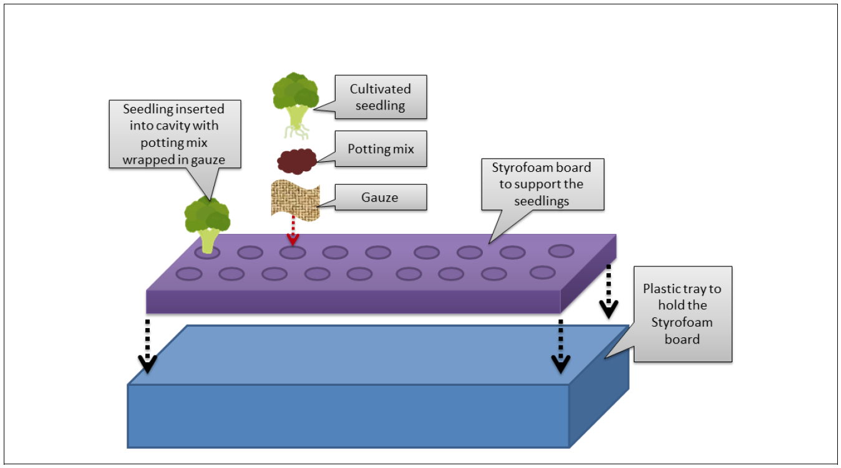
The vegetable trays contain seedlings that are wrapped in potting mix with pieces of gauze and supported by perforated Styrofoam boards (see Figure 1). A pulley system powered by water hydraulics rotated the vegetable trays in Ferris-wheel motion so that the upper trays can receive sunlight whilst the lower trays access nutrients from a water bath. Figure 2 shows the A-Go-Gro System.

Figure 1: Structure of Sky Greens’ vegetable tray
The towers are housed in buildings with translucent plastic roofs and walls to create a greenhouse environment (see Figure 3). By 2015, Sky Greens had installed 1,000 A-Go-Gro towers in its Lim Chu Kang premise, producing two and a half tonnes to five tonnes of vegetables annually (Straits Times, 2015).

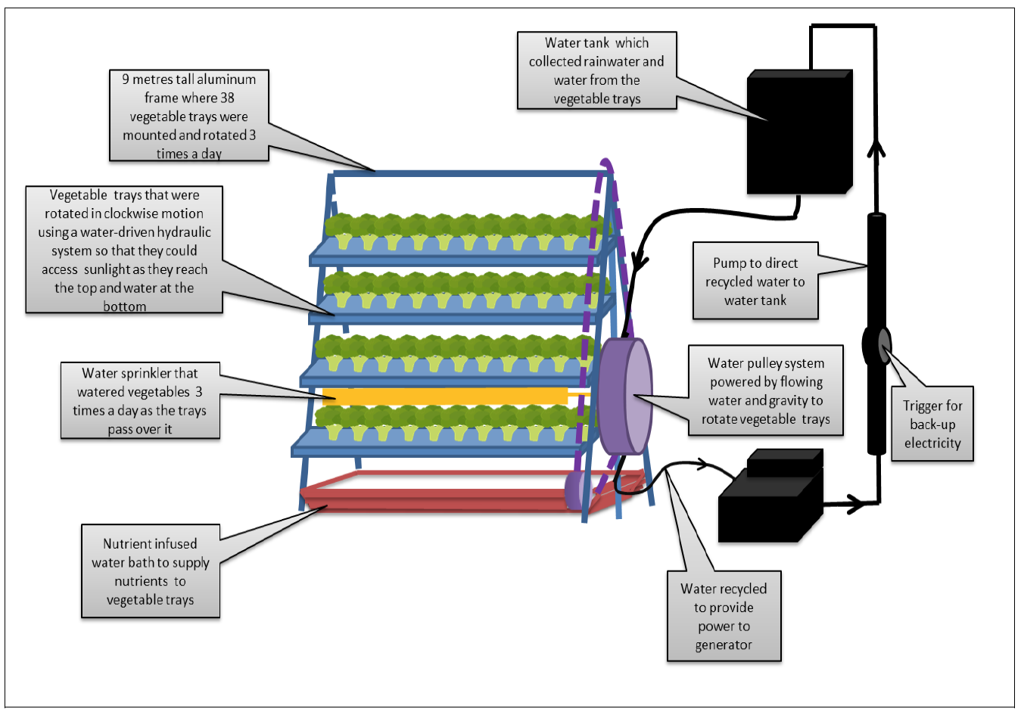
Figure 2: Sky Greens’ A-Go-Gro System

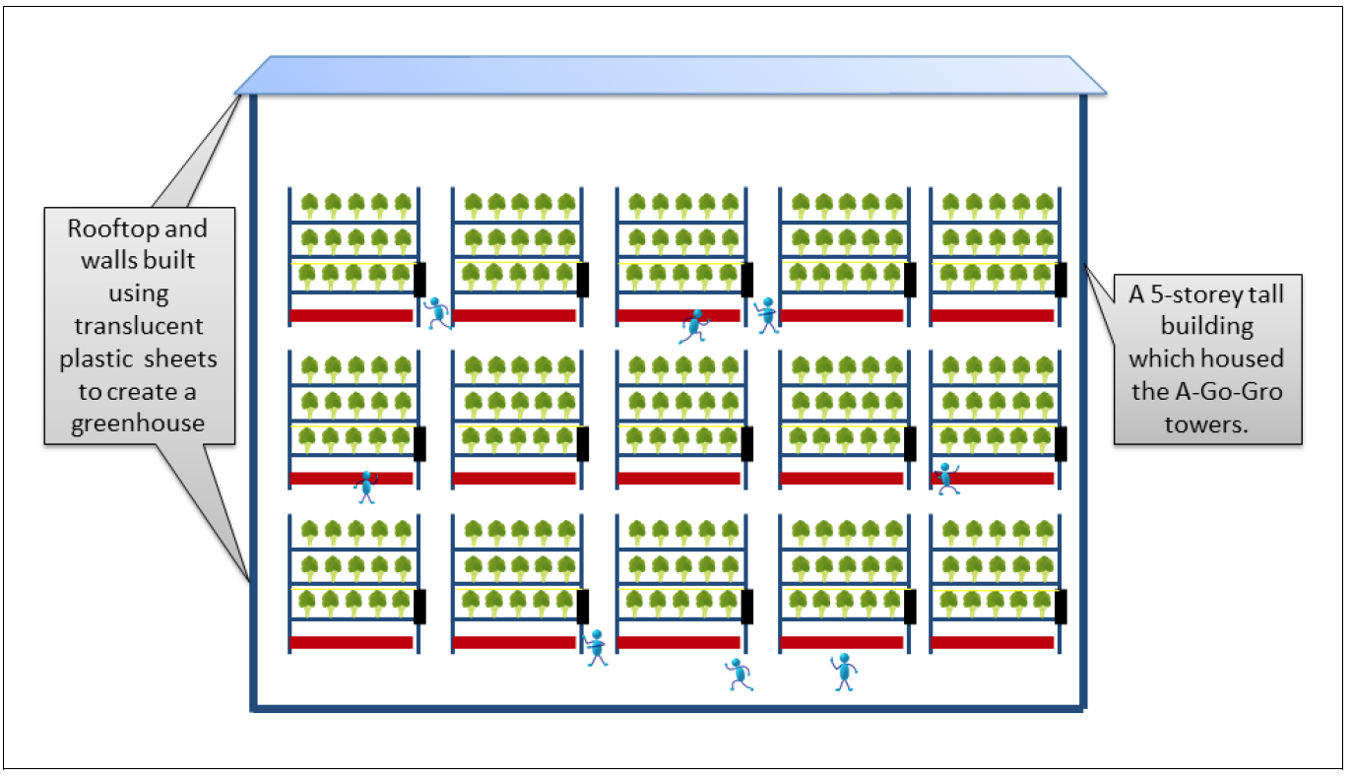

Figure 3: Sky Greens’ vertical farm structure in Lim Chu Kang

References
Abumhadi, N., Todorovska, E., Assenov, B., Tsonev, S., Vulcheva, D., Vulchev, D., Atanasova, L., Savova, S., & Atanassov, A. (2012). Agricultural research in 21st century: challenges facing the food security under the impacts of climate change. Bulgarian Journal of Agricultural Science, 18 (6), 801- 818.
Agritecture. (n.d.). First vertical farm capable of growing tropical vegetables showcased in Singapore. Retrieved from http://agritecture.com/post/27337093189/sky-greens
Bomford, M. (2010, December 2). Energy and vertical farms. Retrieved from https://energyfarms.wordpress.com/2010/12/02/energy-and-vertical-farms/
Bright Agrotech. (2015, October 6). Horizontal plane vs vertical plane production [Video file]. Retrieved from https://www.youtube.com/watch?v=f5VU2kSakx8
Carlsson-Kanyama, A. & Faist, M. (2000). Energy use in the food sector: A data survey. Retrieved from http://citeseerx.ist.psu.edu/viewdoc/download?rep=rep1&type=pdf&doi=10.1.1.205.8375
Casablanca Film. (2015). Sky greens (index award winner 2015) [Video file]. Retrieved from https://vimeo.com/137959029
Chow, L. (2015, March 10). 5 ways vertical farms are changing the way we grow food. EcoWatch. Retrieved from http://ecowatch.com/2015/03/10/vertical-farms-grow-food/
CNBC. (2013, October 13). Inside the world's first vertical farm [Video file]. Retrieved from http://video.cnbc.com/gallery/?video=3000213107
CNN. (2012, December 9). Urban farming looking up in Singapore. Retrieved from http://edition.cnn.com/2012/12/09/business/eco-singapore-vertical-farm/
Despommier, D. (2010). The vertical farm: feeding the world in the 21st century. Thomas Dunne Books. New York: St. Martin’s Press. (Original work published 2010)
Food and Agriculture Organisation of the United Nations. (2009, October 12-13). Global Agriculture towards 2050. Paper presented at How to Feed the World 2050 High Level Expert Forum. Retrieved from http://www.fao.org/fileadmin/templates/wsfs/docs/Issues_papers/HLEF2050_Global_Agriculture.p df
GE Reports. (2014, December 16). How LED is lighting the way toward indoor farming. Retrieved from http://www.gereports.com/post/105334562338/how-led-is-lighting-the-way-toward-indoorfarming/
Griffiths, S. (2014, December 1). Vertical and urban farming. Journal of Food Science and Technology. Retrieved from http://fstjournal.org/features/28-4/vertical-farming
IE Singapore. (2014). Sky urban: Sky farms take root all over the world. Retrieved from http://www.iesingapore.gov.sg/SgGoesGlobal/SkyUrban
Kuswardhani, N., Soni, P. & Shivakoti, G. (2013, May 1). Comparative energy input–output and financial analyses of greenhouse and open field vegetables production in West Java, Indonesia. Energy, An International Journal. Retrieved from http://www.sciencedirect.com/science/article/pii/S0360544213001461
Lim, J. (2015, August 28). Vertical farming invention wins global award. The Straits Times. Retrieved from http://www.skygreens.com/vertical-farming-invention-wins-global-award/
Lin, B., Smith, T. A., & Huang, C. L. (2008). Organic premiums of U.S. fresh produce. Renewable Agriculture and Food Systems, 23(3), 208-216.
Ludhler, E. (2015, September). A case study of Singapore’s smart governance of food. Paper presented at Governance of the Smart Cities Food Agenda Symposium, Milano, Italy. UK: Bicocca University, Italy & Edinburgh Napier University. Retrieved from http://www.clc.gov.sg/documents /books/Smart_food_governance_paper-SG_case_study_FINAL_Sept%2028_3.pdf
Nanyang Technological University. (n.d.). Singapore, energy, & sustainability. Blog@ntu. Retrieved from https://blogs.ntu.edu.sg/hp331-2014-62/?page_id=79
Oo, Florina. (2012, November, 3). Finest first to sell local vertically-farmed greens. Singapore Industrial & Services Employees’ Union. Retrieved from http://www.ntuc.org.sg/wps/portal/up2/home/searchresults details?WCM_GLOBAL_CONTEXT=/Content_Library/NTUC/Home/AboutNTUC/Newsroom/NewsHighlights /59f0ed804d50215abb34fb2780e3472d
Parry, M., Rosenzweig, C., & Livermore, M. (2005, October 24). Climate change, global food supply and risk of hunger. Retrieved from http://www.ncbi.nlm.nih.gov/pmc/articles/PMC1569580/
Seneviratne, K. (2012, December 12). Farming in the sky in Singapore. Our World, United Nations University. Retrieved from http://ourworld.unu.edu/en/farming-in-the-sky-in-singapore
Singapore Magazine. (2015, July – September). Farming in the sky. Retrieved from http:/ /singaporemagazine.sif.org.sg/farming-in-the-sky
Sky Greens. (2010, May 10). Sky Greens research collaborative agreement with AVA. Retrieved from http://www.skygreens.com/2010/05/
Sky Greens. (2011a, Jan 28). Sky Greens prototype launch on 28 Jan 2011. Retrieved from http://www .skygreens.com/sky-greens-prototype-launch/
Sky Greens. (2011b, June 27). MND sustainability congress. Retrieved from http://www .skygreens.com/mnd-sustainability-rd-congress-27-jun-2011/
Sky Greens. (2015, August 28). Singaporean company – Sky Urban Solutions wins INDEX: Award 2015, the world’s biggest design award. Retrieved from http://www.skygreens.com/singaporeancompany- sky-urban-solutions-wins-index-award-2015-the-worlds-biggest-design-award/
Straits Times. (2010, May 20). Singapore will cut water imports from Malaysia, pursue selfsufficiency. Retrieved from http://www.circleofblue.org/waternews/2010/world/singapore-will-cutwater-imports-from -malaysia-pursue-self-sufficiency/
Straits Times. (2015, December 15). SME Spotlight: Building vertical ‘houses’ for plants. Retrieved from http://www.straitstimes.com/business/building-vertical-houses-for-plants
Tan, E. (2015, March 20). Innovative city farms taking root. China Daily Asia. Retrieved from http://www.chinadailyasia.com/asiaweekly/2015-03/20/content_15241575.html
TVBS News. (2014, November 16). 在城市裡種菜 — 新加坡蓋垂直農場 [City farming — Vertical farming in Singapore].[Video file]. Retrieved from https://www.youtube.com/watch?feature=player_embedded&v =5vLIXmqQVf4
United Nations Population Fund. (2007). State of world population 2007 unleashing the potential of urban growth. Retrieved from http://www.unfpa.org/sites/default/files/pubpdf/ 695_filename_sowp2007_eng.pdf
UN News Centre. (2015, November 3). Climate change poses ‘major threat’ to food security, warns UN expert. Retrieved from http://www.un.org/apps/news/story.asp?NewsID=52454#.Vjv7eLGwqUk
USDA. (n.d.). Fact sheets . Retrieved from http://www.ams.usda.gov/publication-terms/fact-sheets
Wang, B. (2012, August 11). 4 Story tall vertical farm that is up to ten times more productive than regular farms. NextBigFuture. Retrieved from http://nextbigfuture.com/2012/11/4-story-tallvertical- farm-that-is-up.html
World Bank. (2015). Climate change overview. Retrieved from http://www.worldbank.org/en/topic /climatechange/overview#1
World Health Organisation.(2014). Progress on drinking water and sanitation. Retrieved from http://apps.who.int/iris/bitstream/10665/112727/1/9789241507240_eng.pdf
World Wildlife Fund. (n.d.). Soil erosion and degradation. Retrieved from http://www.worldwildlife .org/threats/soil-erosion-and-degradation

About Nanyang Technopreneurship Case Centre
With funding from both the National Research Foundation of Singapore and Nanyang Technological University, the Nanyang Technopreneurship Case Centre (NTCC) was one of the initiatives of the Nanyang Technopreneurship Centre (NTC) to enhance the quality of entrepreneurship education through the case pedagogy. These are part of NTC’s efforts to foster, promote and nurture enterprising mind-sets, skills and knowledge in entrepreneurship education.
There is a plethora of business cases but a general paucity of cases highlighting the specific problems faced by technopreneurs in growing their ventures. NTCC adds value to Technopreneurship education by developing a pool of cases on technology-based local and international enterprises. Through the cases, NTCC hopes to share the experiences, success stories and challenges faced by entrepreneurs/intrapreneurs in growing their organisations and how they overcome their problems to sustain growth.
The theme of this first compendium is “innovation through technology”. It features Singapore-based and global companies confronting issues and challenges due to technological shifts in the industry and changing market and competitive dynamics; when introducing new products in the marketplace; and in using technology to drive organizational change.
Online versions of these cases are available for complimentary downloads at www.ntc.ntu.edu.sg/ntcc .

Acknowledgment

The Nanyang Technopreneurship Case Centre (NTCC) was supported by the National Research Foundation (NRF) and the Nanyang Technological University (NTU). We would like to thank NRF and NTU for their funding support.
We would also like to show our gratitude to all the writers, reviewers and anyone who have contributed to the accomplishment of the NTCC.

Calculated by multiplying the unit manufacturing cost of SGD 15,000 per tower with total number of 2,000 towers.
Calculated by dividing the price difference of 100 grams of vertically and traditionally farmed vegetables with the price of 100 grams of traditionally farmed vegetables (i.e. [SGD 0.625– SGD 0.32]/SGD 0.32).

