Your group has | been designated to address the questions highlighted in yellow:
Alpha  Company | Α ₁ Explain how Apple operates its value chain to maintain its position as a differentiator. How does Apple use its position as a differentiator to defend against Porter’s five forces.
 | Α ₂ Apple has a reputation for linking technology to software in a way that makes applications readily accessible to users. The company is contemplating getting involved in the 3 D printer business. Should they? (a) Why or (b) Why not?
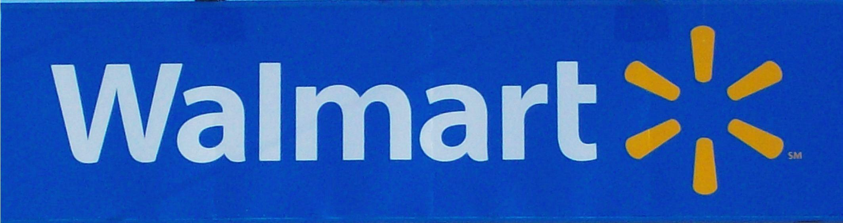  Band of  Betas | Β ₁ Explain how Wal-Mart operates its value chain to maintain its cost leadership position. How does Wal-Mart use its cost leadership position to defend against Porter’s five forces.
 | Β ₂ Wal-Mart is the world’s largest company. With its huge resources, it could become its own venture capital firm and supply upstart firms with much needed capital, or even support growing organizations. Should they get involved in becoming this kind of portfolio manager? (a) Why or (b) Why not?
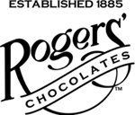  The Gamma  Group | Γ ₁ Beginning in Victoria, Rogers has been making chocolates for over 125 years. Explain how Rogers operates its value chain to keep its focused differentiator position. Explain how the company defends its focused differentiator position against Porter’s five forces in a market with huge players like Nestle and Hershey.
 | Γ ₁ Rogers Chocolates has been approached to buy a local toy maker who makes toys unique to this area. At first glance, it made no sense, but the more they thought about it, the more they thought that there may be economies of scope from sharing activities. Should they buy the business? (a) Why or (b) Why not?
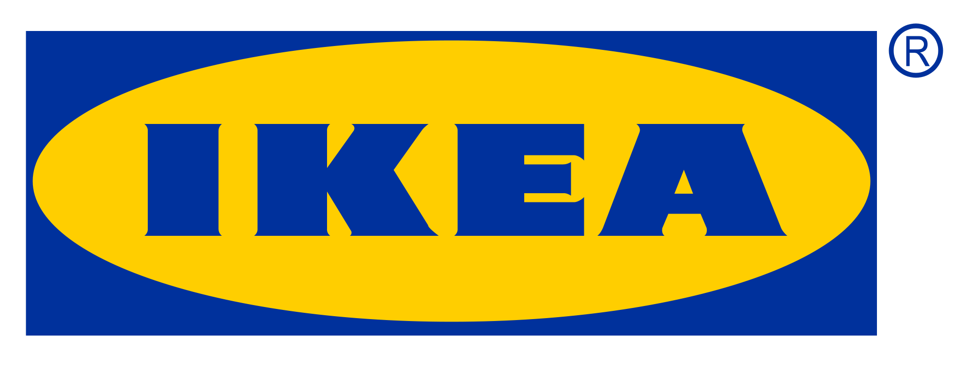  Delta  Force | Δ ₁ Explain how the Ikea operates its value chain to maintain its position as an integrated cost leader / differentiator. Explain how Ikea uses its position as an integrated cost leader / differentiator to defend against Porter’s five forces.
 | Δ ₂ Ikea has been offered the chance to buy a lumber business. The thinking is they may transfer core competencies in furniture design to aid in making the firm successful. Should they make the purchase? (a) Why or (b) Why not?
The Epsilon  Alliance | Ε ₁ Explain how the Jim Pattison Group operates its value chain to maintain its position as an integrated cost leader / differentiator. Explain how the group employees its range of businesses as an integrated cost leader / differentiator to defend against Porter’s five forces.
 | Ε ₁ The Group has been offered the chance to buy a major league sports team. Would this purchase make sense for them if the price is right. Should they make the purchase? (a) Why or (b) Why not?

Your group has | been designated to address the questions highlighted in yellow:
Alpha  Company | Α ₁ Explain how Apple operates its value chain to maintain its position as a differentiator. How does Apple use its position as a differentiator to defend against Porter’s five forces.
 | Α ₂ Apple has a reputation for linking technology to software in a way that makes applications readily accessible to users. The company is contemplating getting involved in the 3 D printer business. Should they? (a) Why or (b) Why not?
Band of  Betas | Β ₁ Explain how Wal-Mart operates its value chain to maintain its cost leadership position. How does Wal-Mart use its cost leadership position to defend against Porter’s five forces.
 | Β ₂ Wal-Mart is the world’s largest company. With its huge resources, it could become its own venture capital firm and supply upstart firms with much needed capital, or even support growing organizations. Should they get involved in becoming this kind of portfolio manager? (a) Why or (b) Why not?
The Gamma  Group | Γ ₁ Beginning in Victoria, Rogers has been making chocolates for over 125 years. Explain how Rogers operates its value chain to keep its focused differentiator position. Explain how the company defends its focused differentiator position against Porter’s five forces in a market with huge players like Nestle and Hershey.
 | Γ ₁ Rogers Chocolates has been approached to buy a local toy maker who makes toys unique to this area. At first glance, it made no sense, but the more they thought about it, the more they thought that there may be economies of scope from sharing activities. Should they buy the business? (a) Why or (b) Why not?
Delta  Force | Δ ₁ Explain how the Ikea operates its value chain to maintain its position as an integrated cost leader / differentiator. Explain how Ikea uses its position as an integrated cost leader / differentiator to defend against Porter’s five forces.
 | Δ ₂ Ikea has been offered the chance to buy a lumber business. The thinking is they may transfer core competencies in furniture design to aid in making the firm successful. Should they make the purchase? (a) Why or (b) Why not?
The Epsilon  Alliance | Ε ₁ Explain how the Jim Pattison Group operates its value chain to maintain its position as an integrated cost leader / differentiator. Explain how the group employees its range of businesses as an integrated cost leader / differentiator to defend against Porter’s five forces.
 | Ε ₁ The Group has been offered the chance to buy a major league sports team. Would this purchase make sense for them if the price is right. Should they make the purchase? (a) Why or (b) Why not?

Your group has | been designated to address the questions highlighted in yellow:
Alpha  Company | Α ₁ Explain how Apple operates its value chain to maintain its position as a differentiator. How does Apple use its position as a differentiator to defend against Porter’s five forces.
 | Α ₂ Apple has a reputation for linking technology to software in a way that makes applications readily accessible to users. The company is contemplating getting involved in the 3 D printer business. Should they? (a) Why or (b) Why not?
Band of  Betas | Β ₁ Explain how Wal-Mart operates its value chain to maintain its cost leadership position. How does Wal-Mart use its cost leadership position to defend against Porter’s five forces.
 | Β ₂ Wal-Mart is the world’s largest company. With its huge resources, it could become its own venture capital firm and supply upstart firms with much needed capital, or even support growing organizations. Should they get involved in becoming this kind of portfolio manager? (a) Why or (b) Why not?
The Gamma  Group | Γ ₁ Beginning in Victoria, Rogers has been making chocolates for over 125 years. Explain how Rogers operates its value chain to keep its focused differentiator position. Explain how the company defends its focused differentiator position against Porter’s five forces in a market with huge players like Nestle and Hershey.
 | Γ ₁ Rogers Chocolates has been approached to buy a local toy maker who makes toys unique to this area. At first glance, it made no sense, but the more they thought about it, the more they thought that there may be economies of scope from sharing activities. Should they buy the business? (a) Why or (b) Why not?
Delta  Force | Δ ₁ Explain how the Ikea operates its value chain to maintain its position as an integrated cost leader / differentiator. Explain how Ikea uses its position as an integrated cost leader / differentiator to defend against Porter’s five forces.
 | Δ ₂ Ikea has been offered the chance to buy a lumber business. The thinking is they may transfer core competencies in furniture design to aid in making the firm successful. Should they make the purchase? (a) Why or (b) Why not?
The Epsilon  Alliance | Ε ₁ Explain how the Jim Pattison Group operates its value chain to maintain its position as an integrated cost leader / differentiator. Explain how the group employees its range of businesses as an integrated cost leader / differentiator to defend against Porter’s five forces.
 | Ε ₁ The Group has been offered the chance to buy a major league sports team. Would this purchase make sense for them if the price is right. Should they make the purchase? (a) Why or (b) Why not?

Your group has | been designated to address the questions highlighted in yellow:
Alpha  Company | Α ₁ Explain how Apple operates its value chain to maintain its position as a differentiator. How does Apple use its position as a differentiator to defend against Porter’s five forces.
 | Α ₂ Apple has a reputation for linking technology to software in a way that makes applications readily accessible to users. The company is contemplating getting involved in the 3 D printer business. Should they? (a) Why or (b) Why not?
Band of  Betas | Β ₁ Explain how Wal-Mart operates its value chain to maintain its cost leadership position. How does Wal-Mart use its cost leadership position to defend against Porter’s five forces.
 | Β ₂ Wal-Mart is the world’s largest company. With its huge resources, it could become its own venture capital firm and supply upstart firms with much needed capital, or even support growing organizations. Should they get involved in becoming this kind of portfolio manager? (a) Why or (b) Why not?
The Gamma  Group | Γ ₁ Beginning in Victoria, Rogers has been making chocolates for over 125 years. Explain how Rogers operates its value chain to keep its focused differentiator position. Explain how the company defends its focused differentiator position against Porter’s five forces in a market with huge players like Nestle and Hershey.
 | Γ ₁ Rogers Chocolates has been approached to buy a local toy maker who makes toys unique to this area. At first glance, it made no sense, but the more they thought about it, the more they thought that there may be economies of scope from sharing activities. Should they buy the business? (a) Why or (b) Why not?
Delta  Force | Δ ₁ Explain how the Ikea operates its value chain to maintain its position as an integrated cost leader / differentiator. Explain how Ikea uses its position as an integrated cost leader / differentiator to defend against Porter’s five forces.
 | Δ ₂ Ikea has been offered the chance to buy a lumber business. The thinking is they may transfer core competencies in furniture design to aid in making the firm successful. Should they make the purchase? (a) Why or (b) Why not?
The Epsilon  Alliance | Ε ₁ Explain how the Jim Pattison Group operates its value chain to maintain its position as an integrated cost leader / differentiator. Explain how the group employees its range of businesses as an integrated cost leader / differentiator to defend against Porter’s five forces.
 | Ε ₁ The Group has been offered the chance to buy a major league sports team. Would this purchase make sense for them if the price is right. Should they make the purchase? (a) Why or (b) Why not?

Your group has | been designated to address the questions highlighted in yellow:
Alpha  Company | Α ₁ Explain how Apple operates its value chain to maintain its position as a differentiator. How does Apple use its position as a differentiator to defend against Porter’s five forces.
 | Α ₂ Apple has a reputation for linking technology to software in a way that makes applications readily accessible to users. The company is contemplating getting involved in the 3 D printer business. Should they? (a) Why or (b) Why not?
Band of  Betas | Β ₁ Explain how Wal-Mart operates its value chain to maintain its cost leadership position. How does Wal-Mart use its cost leadership position to defend against Porter’s five forces.
 | Β ₂ Wal-Mart is the world’s largest company. With its huge resources, it could become its own venture capital firm and supply upstart firms with much needed capital, or even support growing organizations. Should they get involved in becoming this kind of portfolio manager? (a) Why or (b) Why not?
The Gamma  Group | Γ ₁ Beginning in Victoria, Rogers has been making chocolates for over 125 years. Explain how Rogers operates its value chain to keep its focused differentiator position. Explain how the company defends its focused differentiator position against Porter’s five forces in a market with huge players like Nestle and Hershey.
 | Γ ₁ Rogers Chocolates has been approached to buy a local toy maker who makes toys unique to this area. At first glance, it made no sense, but the more they thought about it, the more they thought that there may be economies of scope from sharing activities. Should they buy the business? (a) Why or (b) Why not?
Delta  Force | Δ ₁ Explain how the Ikea operates its value chain to maintain its position as an integrated cost leader / differentiator. Explain how Ikea uses its position as an integrated cost leader / differentiator to defend against Porter’s five forces.
 | Δ ₂ Ikea has been offered the chance to buy a lumber business. The thinking is they may transfer core competencies in furniture design to aid in making the firm successful. Should they make the purchase? (a) Why or (b) Why not?
The Epsilon  Alliance | Ε ₁ Explain how the Jim Pattison Group operates its value chain to maintain its position as an integrated cost leader / differentiator. Explain how the group employees its range of businesses as an integrated cost leader / differentiator to defend against Porter’s five forces.
 | Ε ₁ The Group has been offered the chance to buy a major league sports team. Would this purchase make sense for them if the price is right. Should they make the purchase? (a) Why or (b) Why not?

