COURSE: BUS 478, Section D400 INSTRUCTOR: Jerry Sheppard
TITLE: Strategy Office: WMC 4387
SEMESTER: Spring 2024 (1241) Hours: Tuesday: 15:30 – 16:10
CLASSROOM: E100 AQ 3149 Tuesday, 16:30 Thursday: 10:40 – 11:20 D400 WMC 3250 Thursday, 11:30 Phone: 778-782-4918
E-mail: sheppard@sfu.ca

Pre-requisites:
Bus. 207, (or Econ. 201 or Econ. 301), Bus. 312, 343, 360W & 374 or 381, all with a grade of C- or better, & 90 credits.
Objectives
- Develop a capacity to think strategically about a firm, its business position, how a firm can gain a competitive advantage.
- Conduct strategic analyses in a range of industries, firms and situations to develop a grasp of the competitive trials of a global environment.
- Get acquainted with managerial tasks related to strategy formulation, and what managers can do to promote competent implementation.
- Integrate knowledge from other courses to see how business functions fit together and why all parts of a firm need to be managed in harmony.
Textbook
Hitt, Ireland & Hoskisson, Strategic Management, Competitiveness and Globalization, Concepts, 12th edition or later. Cengage. ISBN: 9781305502208.
Grades
 |  | Individual Written Grades
 |  |  | Strategy Formulation . . . . . . . . . . . . . . . . . . . |  | 16%
 |  |  | Integrate- Recommend- Implement . . . . . . . |  | 16%
 |  |  | Written Executive Summary . . . . . . . . . . . . . |  | 16%
 |  | Individual Participation Grades
 |  |  |  | Participation . . . . . . . . . . . . . . . . . . . . . . . . . | 11%
 |  |  |  | Presentation Performance . . . . . . . . . . . . . | 7%
 |  |  |  | Peer Evaluated Group Contribution . . . . . . | 6%
 |  | Group Work Grades
 |  |  |  | Written Case Synopsis . . . . . . . . . . . . . . . . . | 8%
 |  |  |  | Case Presentation . . . . . . . . . . . . . . . . . . . . | 10%
 |  |  |  | Written Executive Summary . . . . . . . . . . . . | 10%
Class participation
Group participation and a positive contribution to class discussion are integral parts of the course; coming to class is not enough! Attendance accounts but contribution to discussion accounts more. The best way to contribute is to be prepared by reading the material in advance and saying something in class. Keep in mind that the quality of your contribution will also be evaluated.
Individual Analyses & Executive Summary
Individual firm strategic formulation and implementation analyses, along with an Executive Summary are on the Coop case. The case is an introduction to the firm; you should do additional research to update and complete, as much as possible, information on the business. Your analyses should use the doc. files linked to “Blank strategy formulation template” and “Blank integration, recommendation and implementation template” available on the class Bus. 478 Canvas website.
Scale Conversions
Scale conversions on all assignments are as follows:
GPA Grade = [ % Grade / 7] ^ .5
% Grade = [GPA scale ^ 2] X 7
Group work
You’ll form groups of four to six people in the first week. Groups should have folks who have a range of skills, and can work well together. You will be evaluating others in the group. The average grade for the group is to be 3.1. If you choose not to fill out a grade form, all group members will receive a 3.15.
Groups also write a 5-8 page synopsis of a firm of your choice covering firm history, environment, current state & main strategic challenges. At term’s end groups present a 30-min. analysis of the firm. Groups then have two days to complete a written Executive Summary of their analysis.
Session Breakdown
Most sessions include a short ‘Essentials’ lecture on main chapter points, a strategy based exercise and / or a case (a 20%, 40% 40% split).
If you want them more in-depth coverage of the concepts, you can find full concepts chapter lectures. These are Power Point presentations with audio that plays once you start the slide show & when prompted you have to click ‘NEXT’ to get to the next point.
Ethical Considerations
You must do your own work on individual assignments. Failure to do so, plagiarism, or insufficient citation may result in a zero for the assignment.
Course Coverage
The onus is on students for discussion; the professor’s role is to facilitate. To this end the goal is to expose you to many organizations and strategies.

Schedule

 | Class | Topic Detail | Tasks | Hand in
Formulation & Integration | Thur. Jan. 11 | Intro. to Strategic Management. Strategy Case Analysis. | Read Chapter 1. Look over the Case PowerPoint Slides.
 | Thur. Jan. 18 | External & Internal Environment. | Read Chapters 2 and 3. Prepare to discuss The IMI Case.
 | F r i . Jan. 19 | Group lists. | Hand in Group lists. | Group Lists
 | Thur. Jan. 25 | Business Level Strategy. Corporate Level Strategy | Read Chapters 4 and 6.  Prepare to discuss the in class Exercises A & B on the RV Industry.
 | Thur. Feb. 01 | Competitive Rivalry & Dynamics. International Strategy. | Read Chapters 5 and 8  Prepare to discuss The Tom’s Case.
 | Thur. Feb. 08 | Cooperative Strategy. | Read Chapter 9  Prepare to discuss the Carlsberg Case. Devise a critique of the Carlsberg slides.
 | Sat. Feb. 10 | Formulation Analysis. | Hand in Individual Formulation Analysis. | Formulation analysis for Coop
 | Thur. Feb. 15 | Organization Structure and Controls. | Read Chapter 11. Prepare to discuss the Deepwater Horizon Case.
 | Thur. Feb. 29 | Restructuring. | Read Chapter 7. Prepare to discuss Exercise C: A to Z.
Implementation | Sat. Mar. 02 | Individual Integration, Recommendation & Implementation Analysis. | Hand in individual Integration, Recommendation and Implementation Analysis. | Coop integration, recommendation & implementation
 | Thur. Mar. 07 | Corporate Governance. | Read Chapter 10. Prepare to discuss Exercise D: Bayer.
 | Thur. Mar. 14 | Leadership. | Read Chapter 12.  Prepare to discuss the Vestas Case
 | Sat. Mar. 16 | Individual Executive Summary | Hand in Individual Executive Summary. | Coop Exec. Sum.
 | Thur. Mar. 21 | Strategic Entrepreneurship. The Future. | Read Chapter 13 and the article How to do Strategic Planning like a Futurist.∗ Prepare to discuss Exercise E: Futures.
 | Sat. Mar. 23 | Group Case Synopsis | Group Case Synopsis. | Group Synopsis
Ends | Thur. Mar. 28 | Case Presentations | Case Presentations
 | Sat. Mar. 30 | Group Executive Summary | Group Executive Summary | Group Exec. Sum.
 | Thur. Apr. 04 | Case Presentations | Case Presentations
 | Sat. Apr. 06 | Group Executive Summary | Group Executive Summary | Group Exec. Sum.
 | Thur. Apr. 11 | Case Presentations | Case Presentations
 | Sat. Apr. 13 | Group Executive Summary | Group Executive Summary | Group Exec. Sum.

Bus 478 Group Selection

COURSE: BUS 478-3 INSTRUCTOR: Dr. J. Sheppard
TITLE: Strategy Office: WMX 4387
E-mail: sheppard@sfu.ca

NOTES: http://www.sfu.ca/~sheppard/index.html Phone: 778-782-4918
Title | Name | Last 4 Digits of Student ID # | Concentration
Chief Executive Officer
Chief Operations Officer
Chief Marketing Officer
Chief Financial Officer
Chief of Human Resources
If you have one
Chief Information Officer
If you have one

Preferences
First Choice | March 28 / 30 | April 04 / 06 | April 11 / 13
Second Choice | March 28 / 30 | April 04 / 06 | April 11 / 13
Third Choice | March 28 / 30 | April 04 / 06 | April 11 / 13

Comments

- - - - - - - - - - - - - - - - - - - - - - - - - - - - - - - - - - - - - - - - - - -

Formulation Analysis Evaluation

Section of report Range is 0.0 –4.4 | Form | Content
Mission, Objectives, Goals, stakeholders | - Updated Information  - Current Mission  - Goals & Objectives  - Stakeholders | - If case info. needs updating, update it and bring the audience/reader up to speed.  - Provide the firm’s current Mission & Goals.  - Who’re the stakeholders & what do they want?
General and Industry Environment | - Macro Environment (Demographics, Economy, etc.)  - Industry Environment (Porter’s 5)  - Competitors (top 3 or so)  - What are the industry dynamics | - Clearly outline these elements.  - Industry dynamics include the likelihood of competitor attach and response and the form these attacks and responses are likely to take given conditions in the environment
Resources and Capabilities / Core Competencies | - Resources (Tangible / Intangible)  - Capabilities (by Functional Area)  - Core Competencies (VIRO)  - Performance | - Details will be needed (e.g. you should say “Their physical plant is the most modern and efficient in the industry and it allows them to….” rather than simply listing “physical Plant” under a list of tangible resources).
Business, Corp. and International Strategies | - Business Level Strategy  - Corporate Level Strategy  - International Strategy  - Cooperative Strategy | - Tell me what is their:  - Generic Bus. level strategy is (Cost Leadership, Diff, Focus, etc.)  - Corp. level strategy (Conglomerate, Vert. Integration Single bus., etc.)  - International Strategy (Global, Transnational, Multidomestic).  - Any Joint Ventures, etc.
Average

Integration, Recommendation and Implementation Analysis Evaluation

Section of report Range is 0.0 –4.4 | Form | Content
Synthesis | Firm Strengths & Weaknesses  Enviro. Opportunities & Threats  SWOT Matrix  Does the strategy fit the SWOT | - Summarize not only the strengths & weaknesses / opportunities & threats but relate them to each other – how does all that you’ve said so far fit together.
Selecting a Course of Action | - Criteria by which you will evaluate a good recommendation.  - Recommendation.  - Targets and Goals  - Evaluation of Recommendations. | - Tell me what challenges a good recommendation will address.  - Have a definitive recommendation.  - Tell me what are the targets of your recommendations.  - Tell me how your recommendations meet your criteria and potential targets.
Implementation | - Describe an Action Plan for implementation  - Discuss the logic of Action Plan  - Are any new organizational structure or controls needed  - Criteria to evaluate change success. | - Logical & appropriate Action Plan for implementing your recommendations (1st this, then)  - Review any new organizational structure or controls needed  - Criteria by which you will evaluate whether the change was successful.
Remaining Considerations | - Cover  - References  - Figures (like organization charts or time lines)  - Tables. | - Cover has all the relevant elements (ID’s, Art).  - Sufficient consistently properly presented alphabetical references.  - Sufficient labeled clearly presented figures.  - Sufficient labeled clearly presented figures.
Average

Executive Summary Evaluation

Section of report Range is 0.0 –4.4 | Form | Content
Introduction |    Format allows quick access to info.     Compelling statement of interest.     Analysis goals and objectives.     Recommended strategy. | - Explains what the firm does.  - There’s a compelling interest statement.  - Does it note goals of the analysis?  - Does it include a recommended strategy?
The Problem or Challenge |  Opportunities & threats (competitor, industry and macro environment).   Strengths & limitations (resources, capabilities & core competencies). | Clearly discuss these elements:   •• Opportunities & threats (competitor, industry and macro environment).  •• Strengths & limitations (resources, capabilities & core competencies).
The Solution |    Obvious & clear action statements.     Clear outline of action steps.     Clear timeline.     Clearly stated goals. | • What do you want to the firm to do?  • What steps need to be taken (logical & appropriate action plan for implementation).  • How soon do we start; with what steps?  • How will we measure success (criteria by which you evaluate success of changes).
Why Now |  External circumstances driving change.     Internal resources for recommendation.     Compelling statement of urgency. | Explain:  •• External circumstances driving change.  • Internal resources for recommendation.  • Why change now?
Average

Executive Summary Outline

No more than one page, no cover, citations, or table of contents, no less than 11 point, New Times Roman, no less than ½-inch margins, and 1.25 spacing (in Word, Home Paragraph Line Spacing Multiple type in 1.25 ). Mix any tables and figures into the text as they are mentioned.

INTRODUCTION

- Explain what the firm does.
- There’s a compelling interest statement.
- Does it note goals of the analysis?
- Include a recommended strategy?

The Problem / Challenge

Clearly discuss these elements: 

- Opportunities & threats (competitor, industry and macro environment).
- Strengths & limitations (resources, capabilities & core competencies).

The Solution

- What do you want to the firm to do?
- What steps need to be taken (logical & appropriate action plan for implementation).
- How soon do we start; with what steps?
- How will we measure success (criteria by which you evaluate success of changes).

Why Now

Explain:

- External circumstances driving change.
- Internal resources for recommendation.
- Detail the need for change now.

Group Presentation Evaluation

Sections | Comments / Questions | — Grade —
 |  | Form | Content
1. Describe the main challenges /
problems for the organization.
(A get-to-the-point overview.)
2. Show an analysis backing how you
arrived at your conclusion of what
the organizational challenges are
(Mainly an external analysis.)
3. Tell me what resources &
capabilities the organization has
that help address the challenges /
problems for the organization.
4. Tell me what restraints the
organization has to limit its actions.
5. Sum-up the above by telling what
a good recommendation does.
(Criteria for good recommendation.)
6. Make a recommendation that is
clear and achievable.
7. Explain an implementation schedule,
showing a sense of urgency.
8. Show me what things will look
like when you are done.
(i.e. how you measure success).
9. Address the questions raised.
Average

Individual Presentation Grade is based on:

Cogent Content . . . . . . . . Did what you discuss make sense and support the analysis?
Confidence . . . . . . . . . . . Did you seem self-assured about what you were saying?
Enthusiasm . . . . . . . . . . . I'm not looking for cheerleading but at least seem interested!
Volume and Clarity . . . . . Were you loud & clear enough to be heard & understood in the back?
Attention to Audience . . . Did you make eye contact with the whole audience, not just the prof.?
Rehearsed . . . . . . . . . . . . You can use notes but look up occasionally and keep your place.

STUDENT INPUT FOR CLASS Name ________________________ PARTICIPATION GRADE (Due last Class) Student # ________________________

General attendance A+ A A- B+ B B- C+ C C- D F
(Missed Classes) Comments: _____________
________________________________________________________________________________________ ________________________________________________________________________________________ ________________________________________________________________________________________
On-time attendance A+ A A- B+ B B- C+ C C- D F
(Late Classes) Comments: _____________
________________________________________________________________________________________ ________________________________________________________________________________________ ________________________________________________________________________________________

Minutes of Sleep or work A+ A A- B+ B B- C+ C C- D F
on other class classwork Comments: ______________
________________________________________________________________________________________ ________________________________________________________________________________________ ________________________________________________________________________________________

Contribution Quantity A+ A A- B+ B B- C+ C C- D F
Comments: ______________
________________________________________________________________________________________ ________________________________________________________________________________________ ________________________________________________________________________________________

Contribution Quality A+ A A- B+ B B- C+ C C- D F
Comments: _____________
________________________________________________________________________________________ ________________________________________________________________________________________ ________________________________________________________________________________________

Other (Specify) A+ A A- B+ B B- C+ C C- D F
Comments: _____________
________________________________________________________________________________________ ________________________________________________________________________________________ ________________________________________________________________________________________ ________________________________________________________________________________________ ________________________________________________________________________________________

Bus 478 Group Evaluation
Group _________________________

Grades range from 0.0 - 4.4. | Fill in only the column that applies to your group |  |  | Comments
Title | 4 Person Group | 5 Person Group | 6 Person Group
CEO:
COO:
CMO:
CFO:
CHR:
CIO:
Total: | 12.4 | 15.5 | 18.6

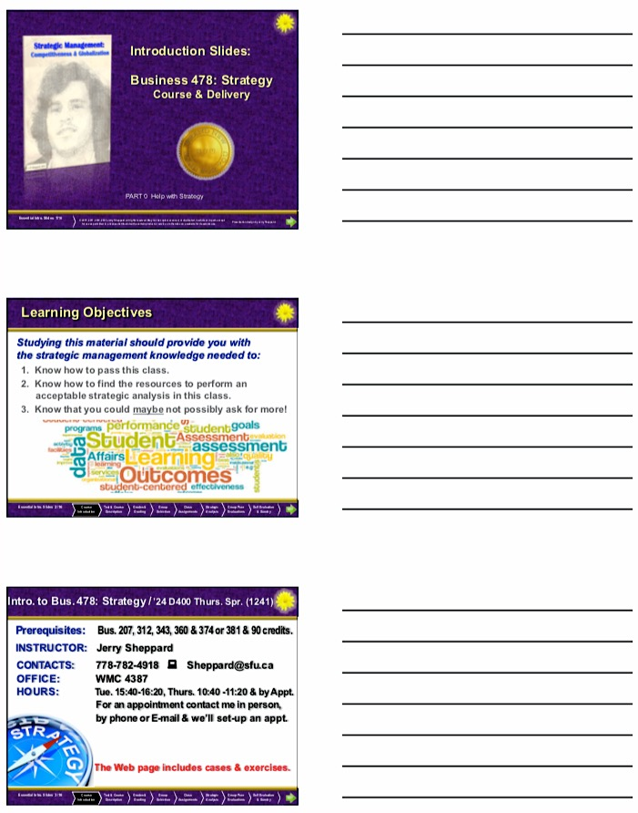
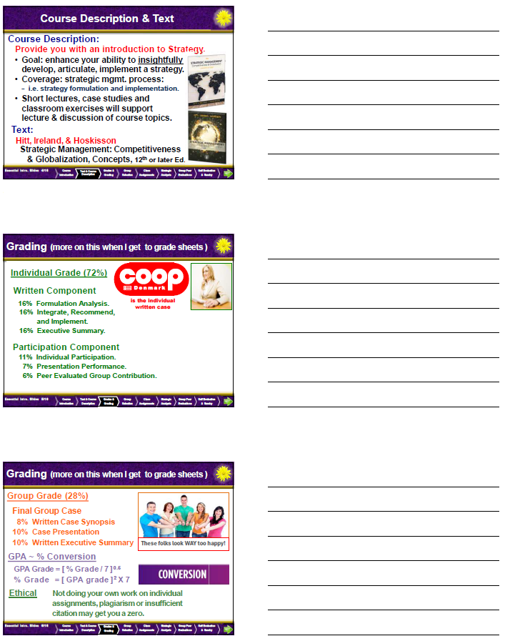

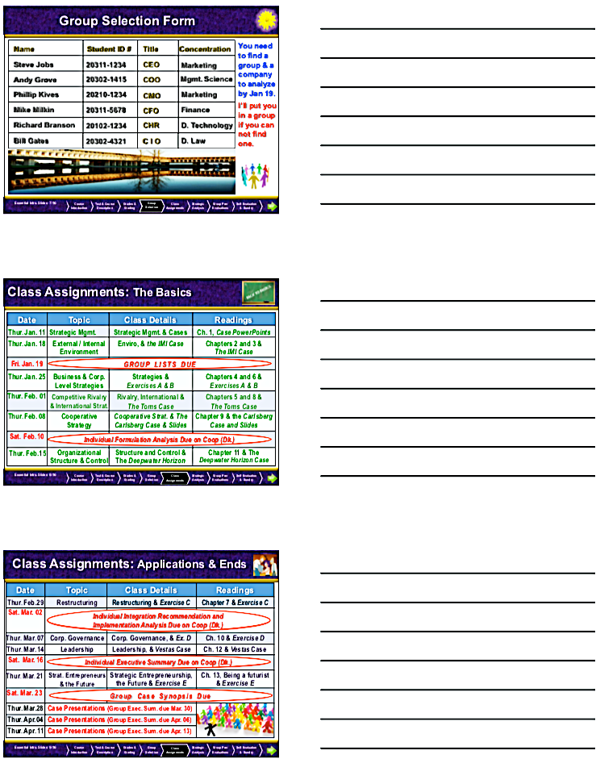

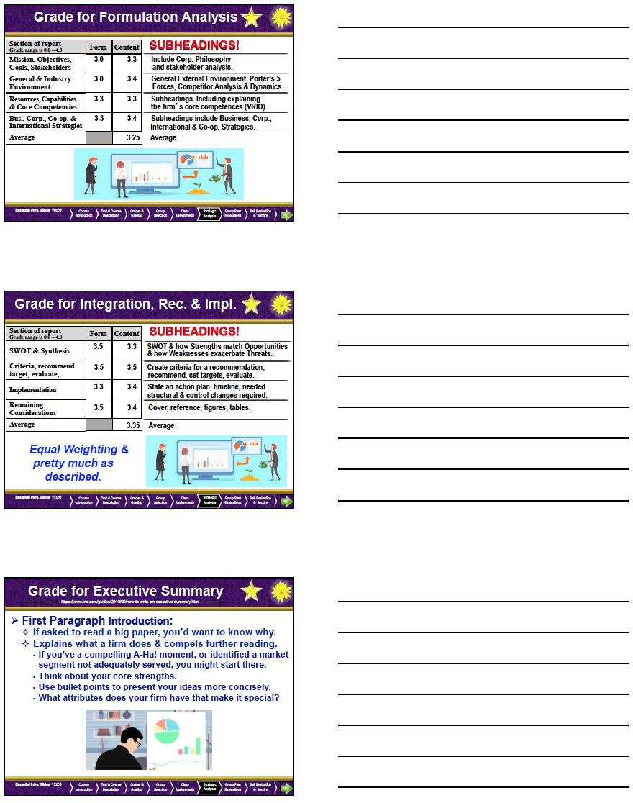

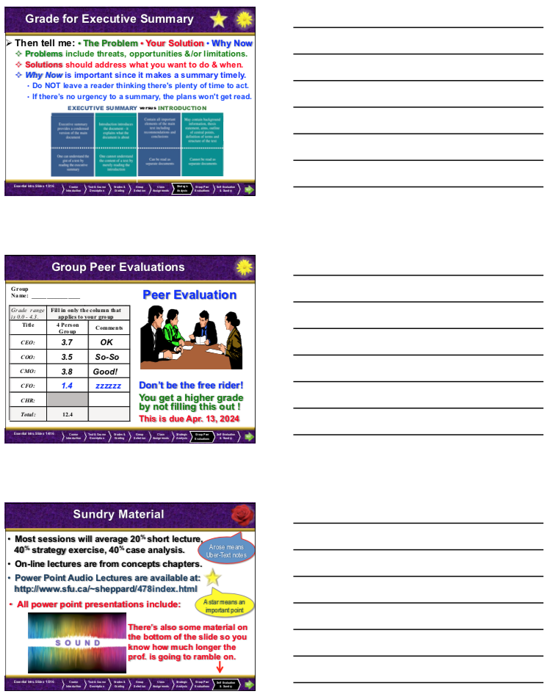

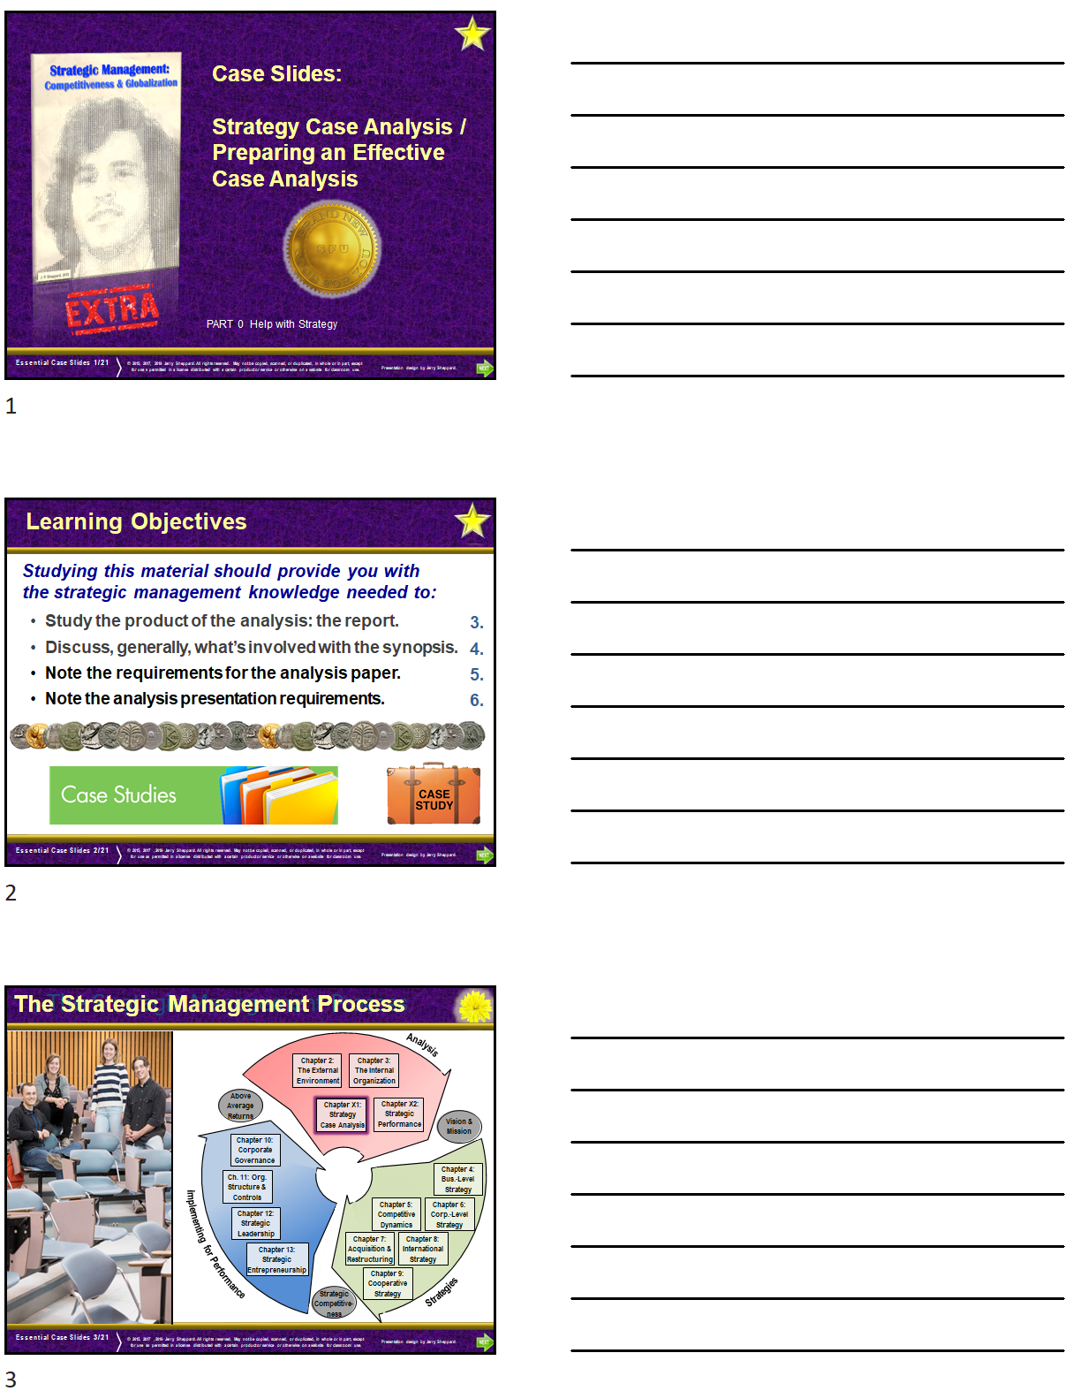

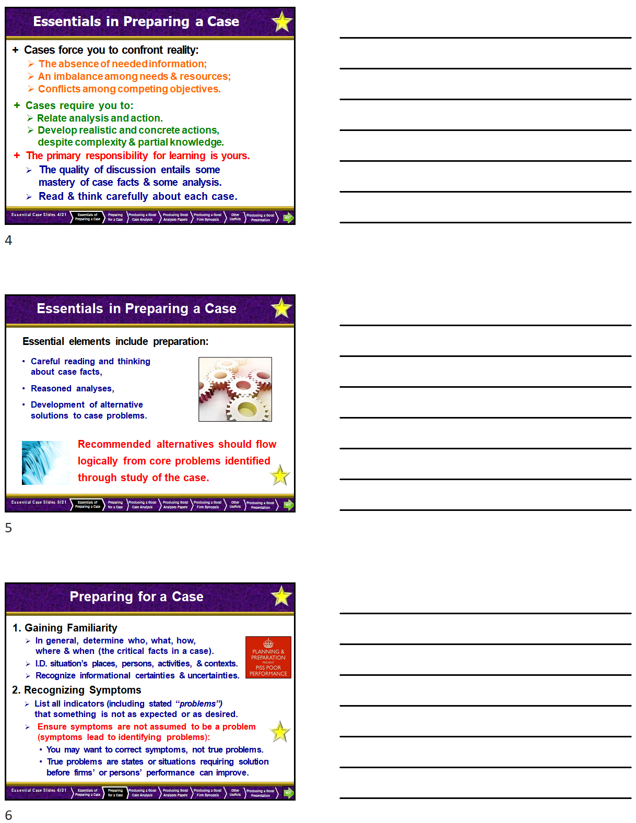

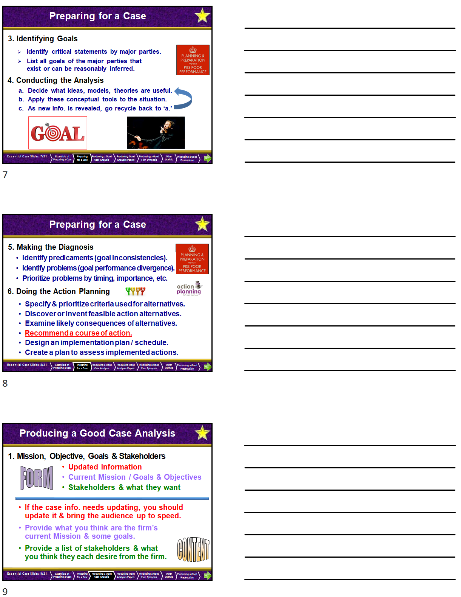

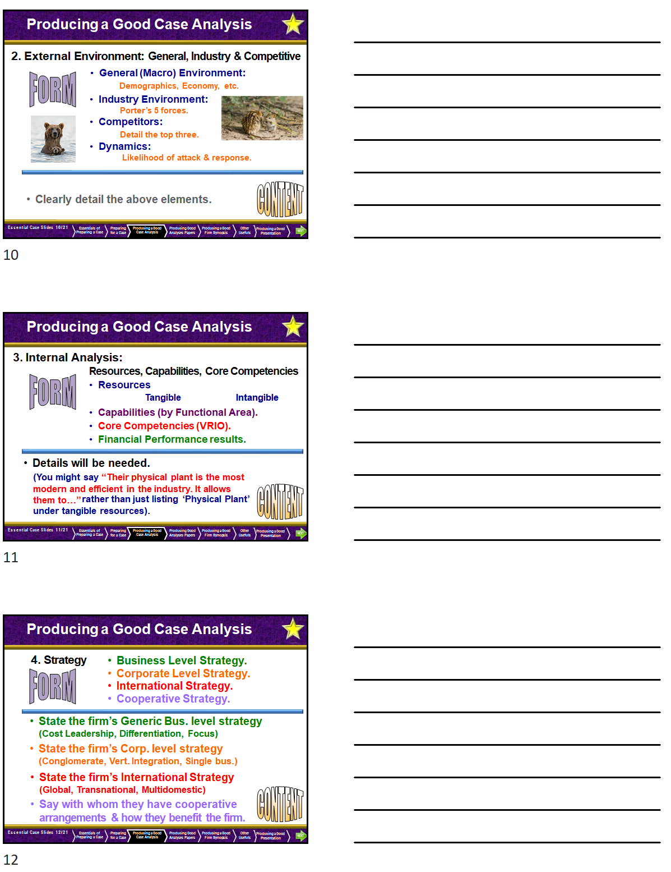

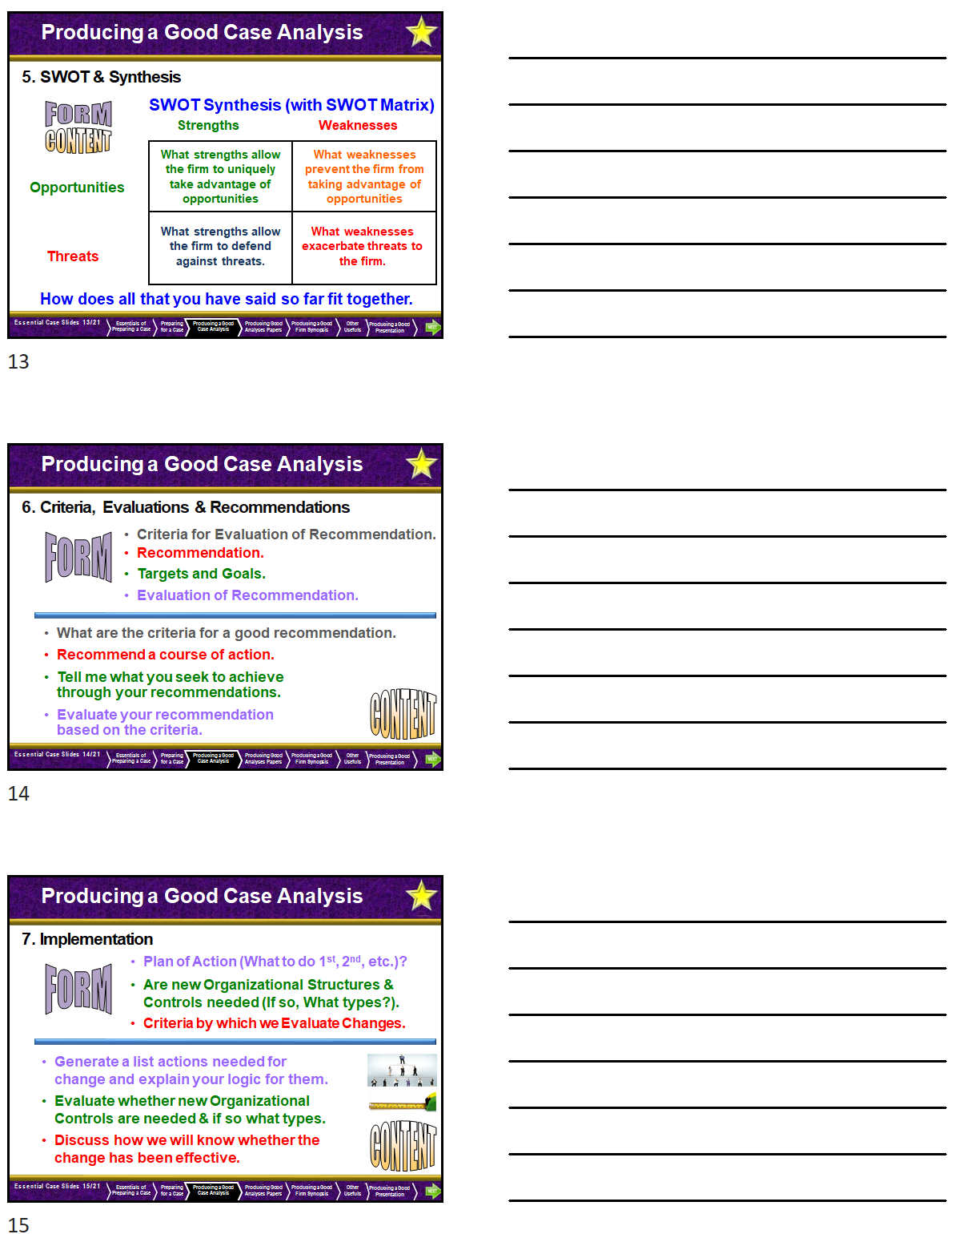

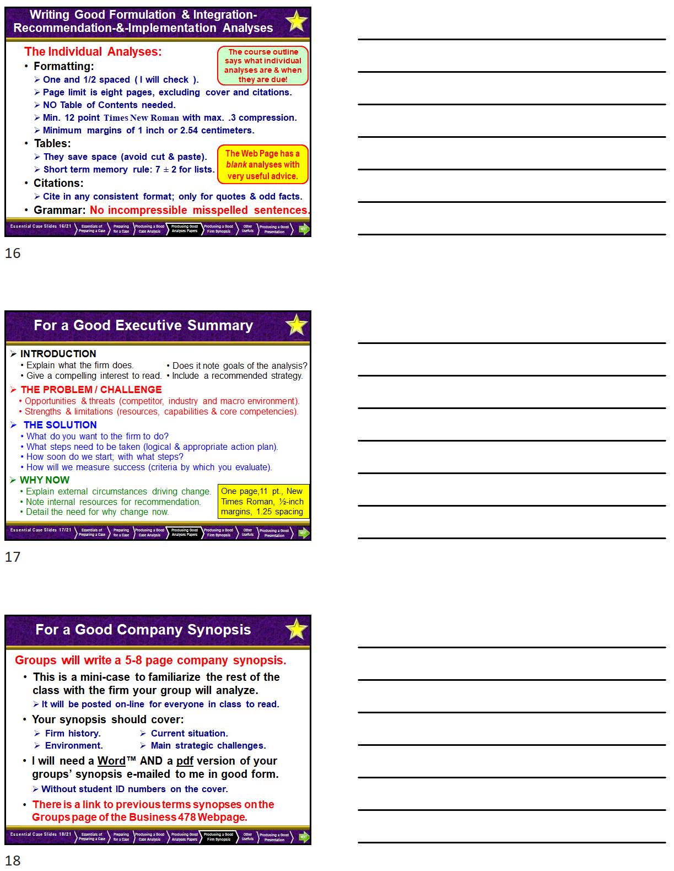

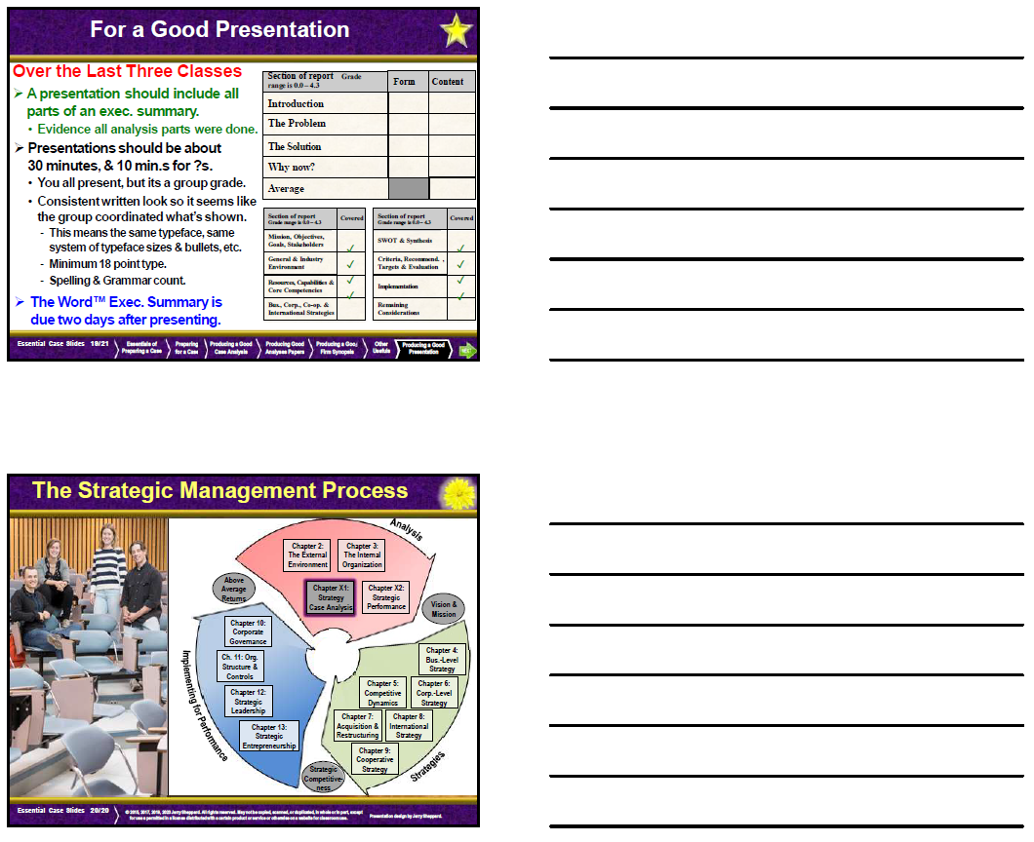

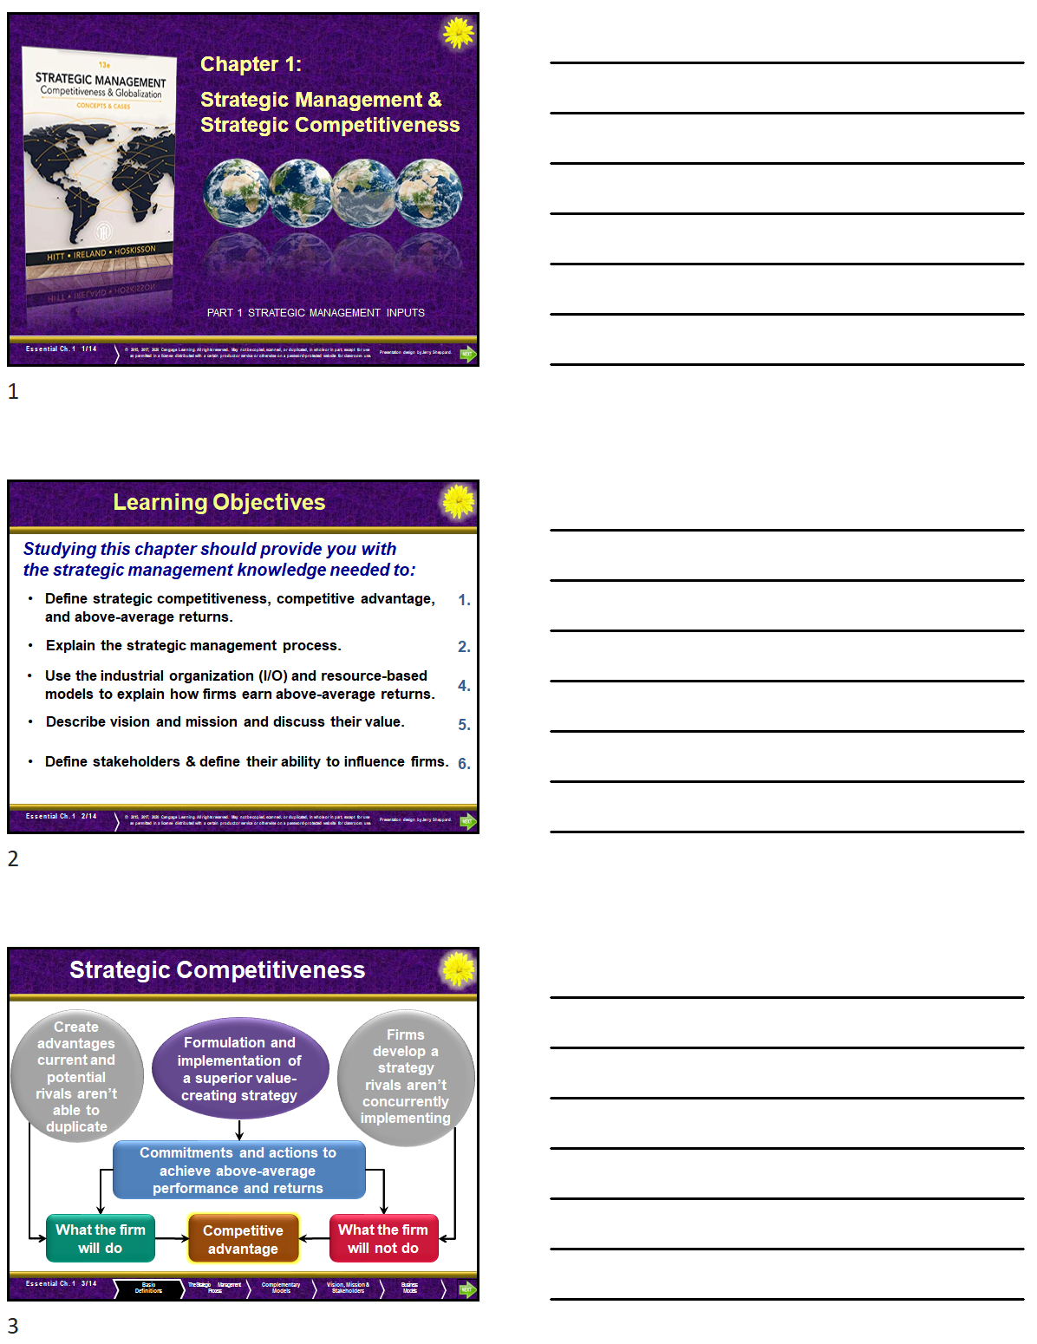

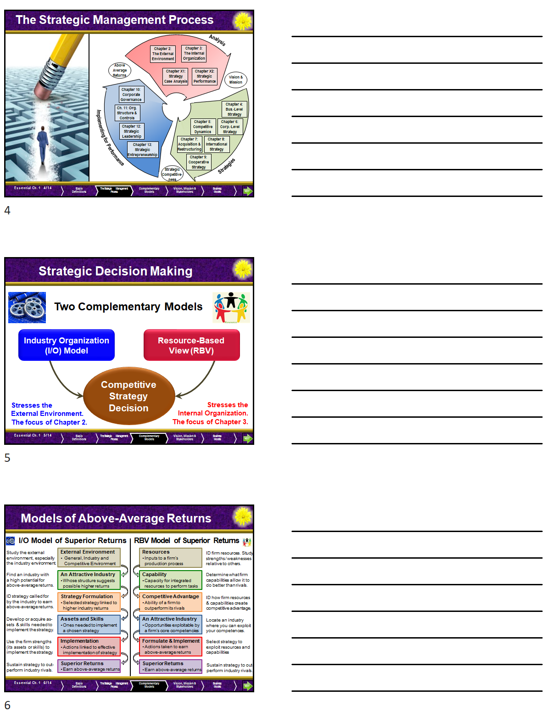

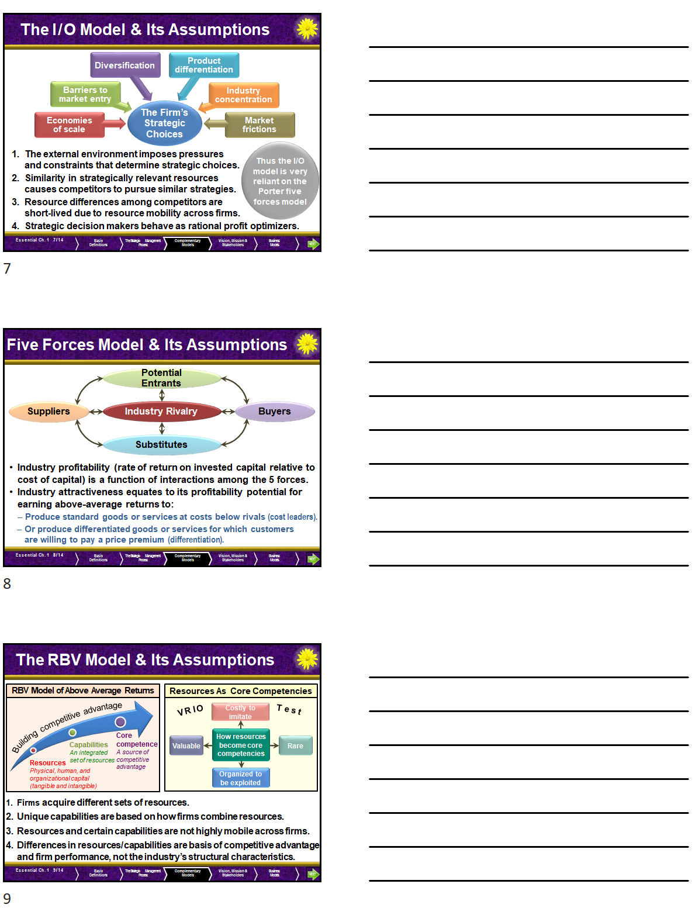

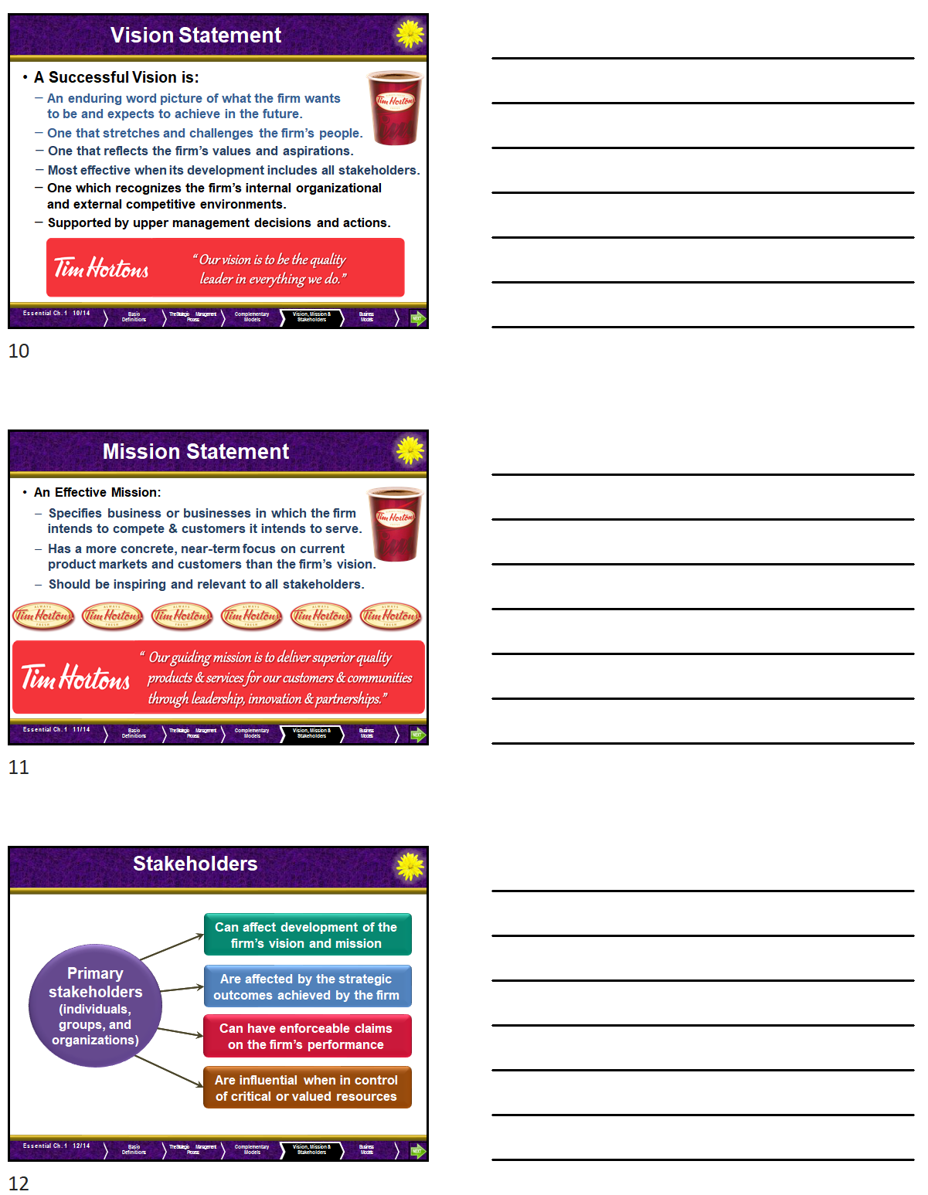

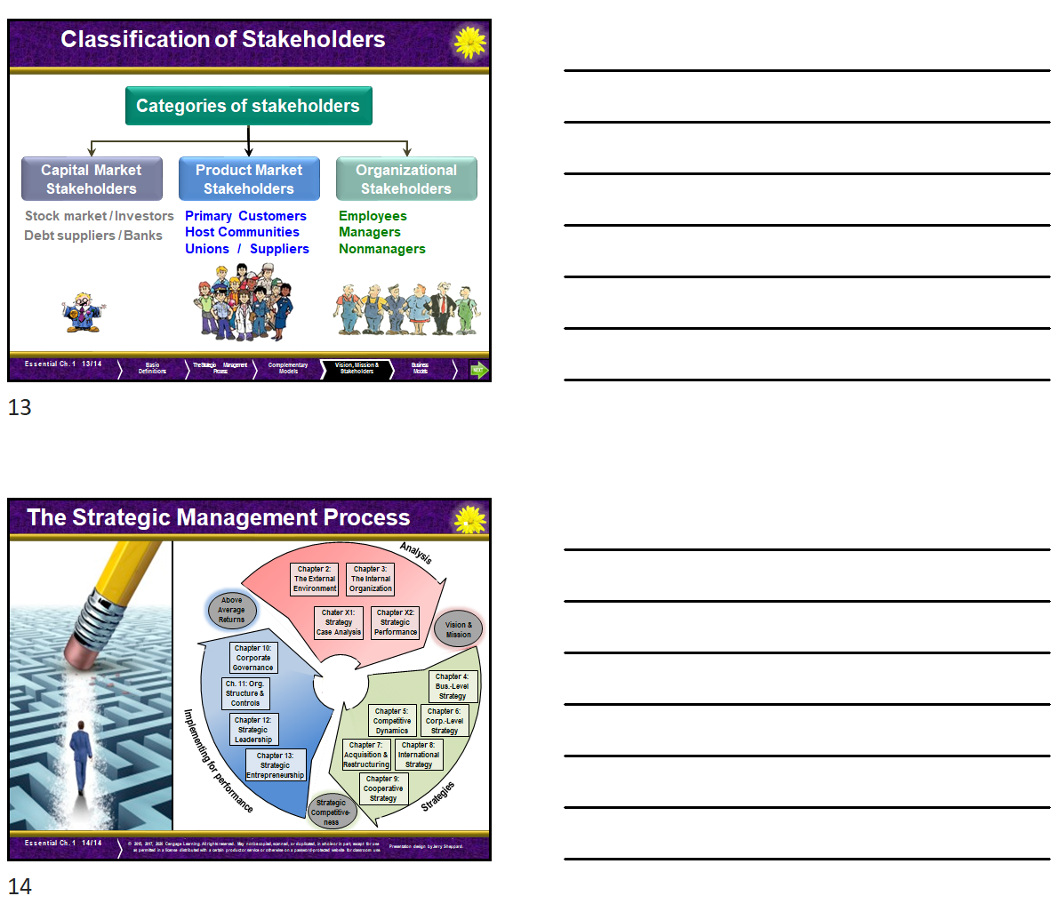

∗ This can be found at https://hbr.org/2019/07/how-to-do-strategic-planning-like-a-futurist

