IAT 339 – P3 Week 1 Deliverables
- Draft your ethos. To start doing so answer these questions in words or sketches:
  - What is the job you want?
Web developer / web and mobile developer / front-end developer / front-end software engineer
  - What are the qualifications for this job?
- Computer Science graduate or equivalent
- Proficiency in HTML, CSS, JavaScript, etc.
- Familiarity with modern JavaScript frameworks (e.g., React, Next.js, Vue.js)
- Understanding of responsive web design principles
- Experience in creating visually appealing and user-friendly websites
- Capability to design the appearance, layout, and flow of websites
- Ability to optimize web applications for user experience
- Ability to balance functional and aesthetic design
- Skills in optimizing websites for speed, usability, and accessibility across devices
  - What kind of verbal language would people hiring for this job expect?
- Good verbal and written communication skills
- Spoken languages: Fluent English
- Public speaking (ex. pitching ideas)
  - What kind of visual language would people hiring for this job expect?
- Being able to express ideas through design, using images, graphs, animations, videos.
  - How does your experience prepare you for this job?
I have completed multiple web and mobile development projects in SIAT, collaborating with other designers and developers on various projects while also working independently on some.
  - What characteristics do you have that make you well suited for the job?
- I have strong problem-solving abilities developed during the study of my degree
- I am accountable as I can manage priorities and meet deadlines
- I am self-motivated and passionate about my work
- I am dependable and reliable
- I have a keen attention to detail
- I value and respect all opinions from my team
- Based on your answers to the questions above, select a prior project and complete a process analysis which helps support why you are qualified for the job. The process analysis should:
  - Show your ability to think through a problem from start to finish.
  - Show how you iterate over the course of a project.
  - Have accompanying artifacts — images, video, audio — that support what the text is saying.
  - Be approximately 250-300 words in length.
Project: Soul Waves Vinyl Records company website (from IAT 339 Project 2)
Detail about the project
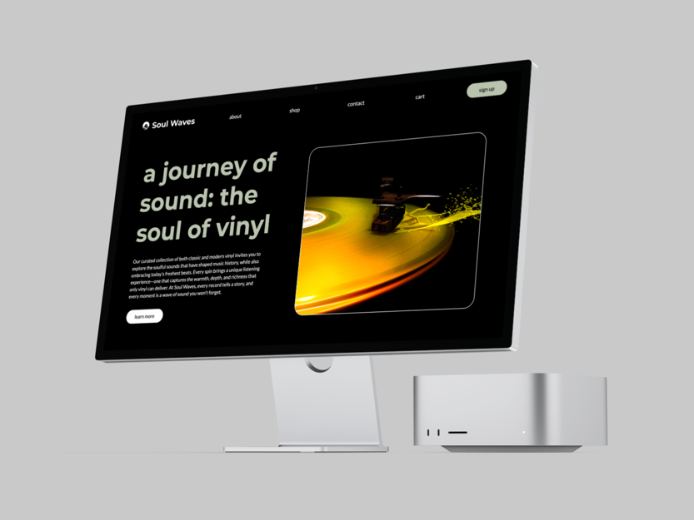
The Soul Waves website is a web application created in a 300-level Web Design and Development course. With another junior developer, Ariel Tsang, we designed a fully functional and responsive product site that prioritizes accessibility and aims to enhance the purchasing experience of vinyl records. My role in the team is a project director and a front-end developer.

Challenge encountered
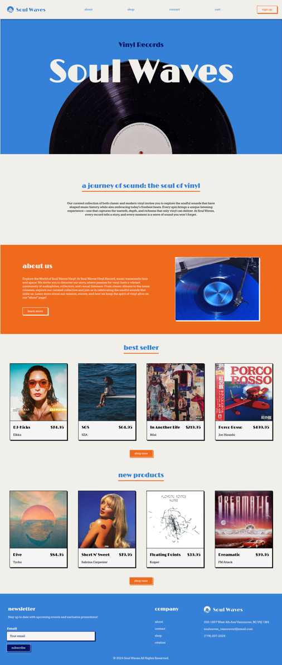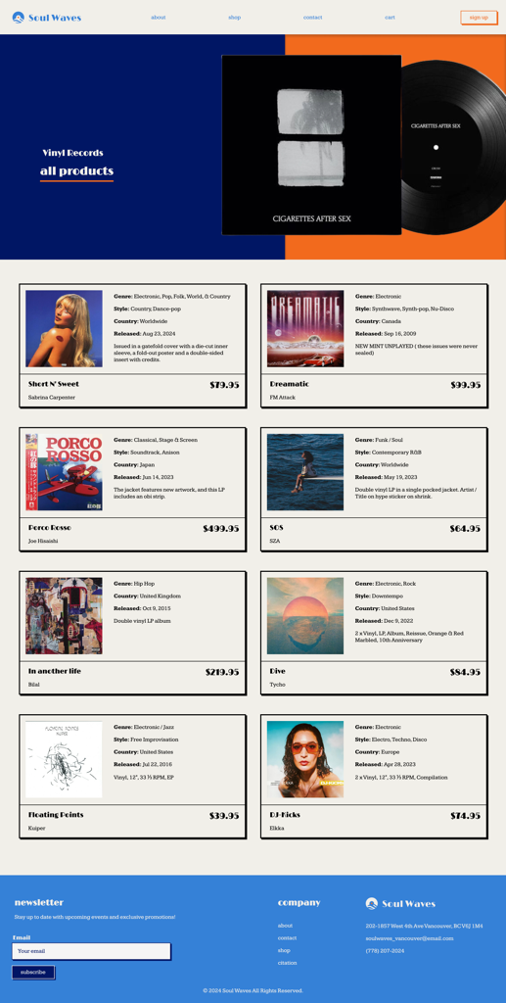
One of the challenges we encountered was that our original playful concept using a colour palette of bright orange and blue didn’t work out on the website. While we initially believed this approach would create an engaging experience for users, it ended up looking unprofessional, especially on the cart and payment form pages. We realized that the playful elements detracted from the site's overall credibility and usability, which may affects users’ purchasing decisions in the company’s products.
How to solve?
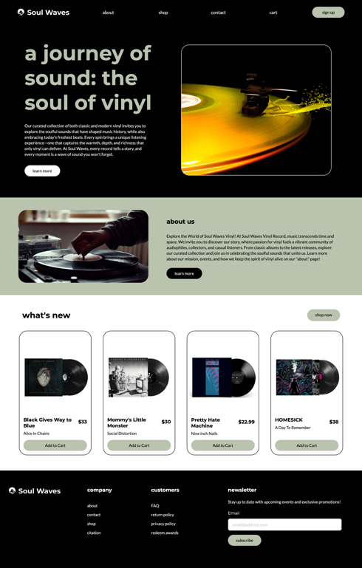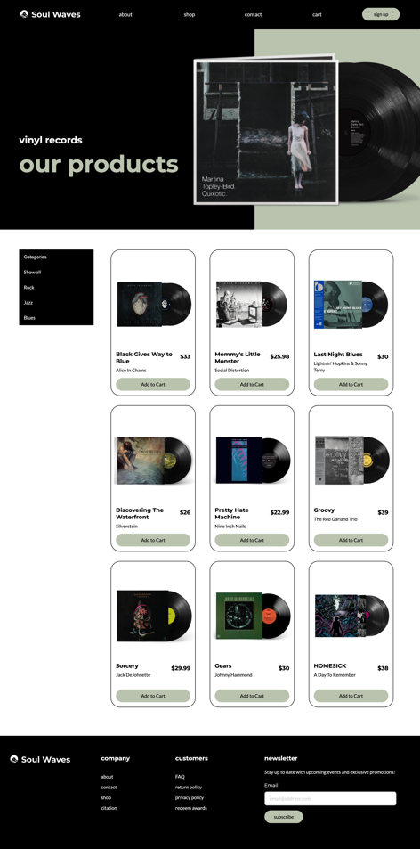
Therefore, we decided to completely change the art direction while ensuring we could still meet our deadline. We opted for a black and white theme, accented with touches of green. This is to provide the website a modern and professional look, as well as to enhance the site’s credibility and overall user experience. Additionally, we improved the website’s accessibility and responsiveness by implementing aria labels and media queries, making it more inclusive for different users to navigate through the site.

What was the result?
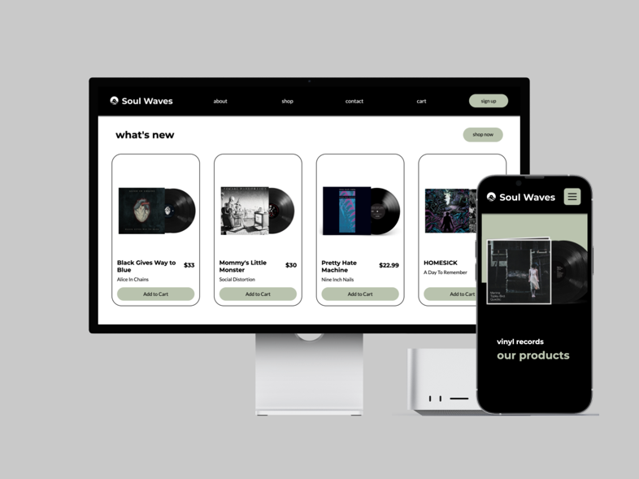
The new design significantly strengthened the brand’s identity and user experience. We are very satisfied with the outcome and are confident that we made the right decision in changing the website, as it has set us up for greater success in creating a more professional platform. This experience has taught us the importance of balancing creativity with functionality, leading us to refine our design to better align with user expectations and enhance the overall purchasing experience.

- Write a draft bio using no more than 100 word to introduce yourself.
My name is Stephy Wong, and I am a junior web and mobile developer who has a passion in creating intuitive interfaces and seamless interactions that connect with users in a meaningful way. At the core of my design approach is the idea that all digital applications should balance functional and aesthetic design. I see each project as an opportunity to create connections, provoke thought, and inspire change. My technical skillsets include proficiency in HTML/CSS, JavaScript, React, Python, Adobe Creative Suite, and Figma. These tools empower me to bring my ideas to life, turning concepts into reality. (97)

