Section 5 – Slope Processes
- In this section we will deal with the various mechanisms and morphological expressions of slope processes. We’ll consider slopes composed of rock, rock and regolith and rock and regolith with vegetation.
- The section begins with a discussion of slope strength including the driving and resisting forces keeping slopes in place and causing them to move and change. We’ll then progress through slope measurement techniques, how to identify different types of mass wasting processes and finish off with slope stability analysis and natural hazards.

5-1 Strength of soil and rock
- Slopes, just like any other object may undergo different kinds of stress: 1) tensile (stretching); 2) shear (deformation by unaligned forces); or 3) compressive (Fig. 5-1). However the main independent and quantifiable factors which play a significant role in deformation due to the stresses mentioned above are cohesion and friction.
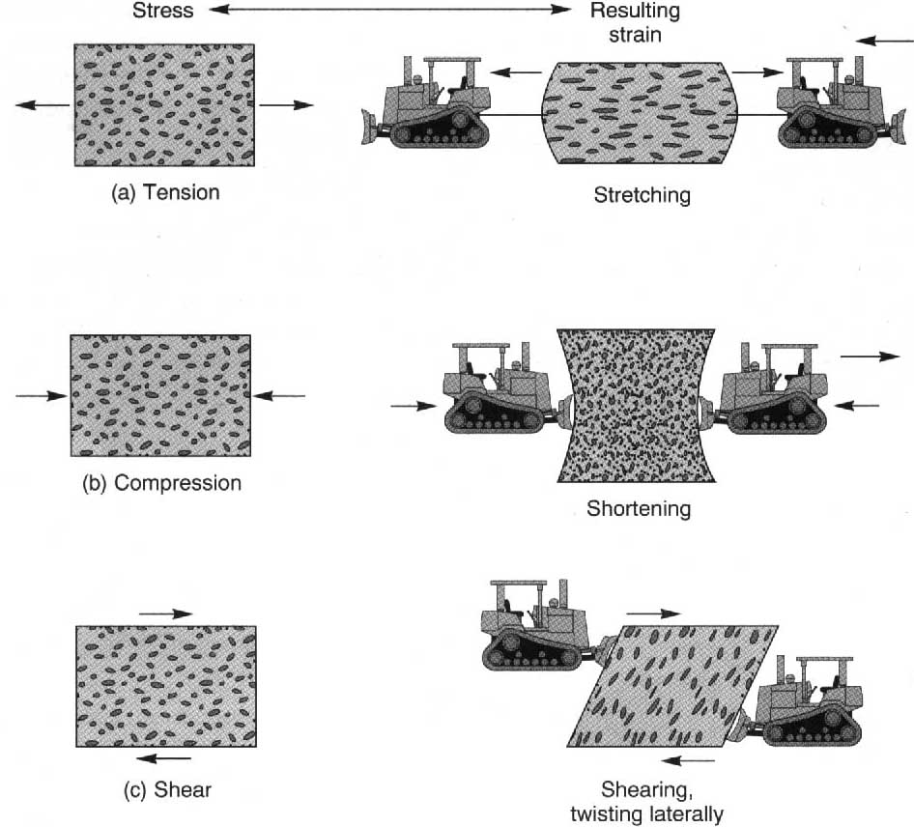
Figure 5-1. (a) tensile loading of a rod which fractures in a brittle manner; (b) compressive stress; and (c) shear deformation due to unaligned forces (Selby, 1982).
- Shear strength is the collective sum of forces which resist stresses generated by gravity on any object or material. Shear strength of soil or rock is a function of the internal angle of friction, effective normal stress, and cohesion within the material.
- Cohesion between individual rock and soil particles is due to chemical bonding through sharing of ions between crystal units, electrostatic and electromagnetic forces. Apparent cohesion on the other hand is a function of capillary action and interlocking of grains due to surface roughness.
- The frictional resistance between mineral particles in contact is what controls the strength of most rock and soil slopes. The higher the number of contact points between grains, the higher the friction (Fig. 5-2).
(a)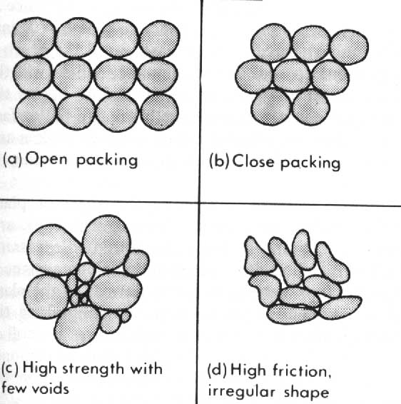(b)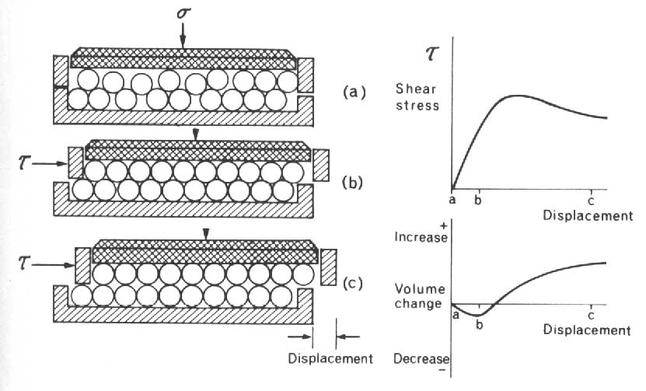
Figure 5-2. (a) The effects of packing (sorting), filling, and shape on friction; and (b) the relationship between shear stress and displacement (Selby, 1982).

- Friction angle ($φ$)is the maximum angle at which the forces keeping an object in place (stress normal to the plane, σ) are in balance with the forces promoting downslope movement (shear stress, τ).
- Water modifies the total cohesion between grains within soil or rock and typically results in a decrease in the total stress acting on a material. This is called effective stress and it depends mainly on porosity and permeability of the rock or soil.
- Measurement of strength can be carried out in laboratories or in the field. Laboratory conditions allow stricter control over dependent variables than is possible in the field where as field experiments are generally more representative of actual conditions.
- Strength can be tested using a shear box or triaxial test in the lab. In the field, shear vanes, penetrometers, or field shear boxes may be used.
- The strength of pieces of rock (intact rock strength) can be measured using a point-load test or the more favored Schmidt hammer test. Intact rock strength differs considerably from the strength of a rock mass.
- Rock mass strength represents the resistance to erosion of the whole rock slope. The main parameters used to estimate rock mass strength are summarized in Table 5-1 below.

Table 5-1. Geomorphic Rock Mass Strength Classification and Ratings (Selby, 1982).
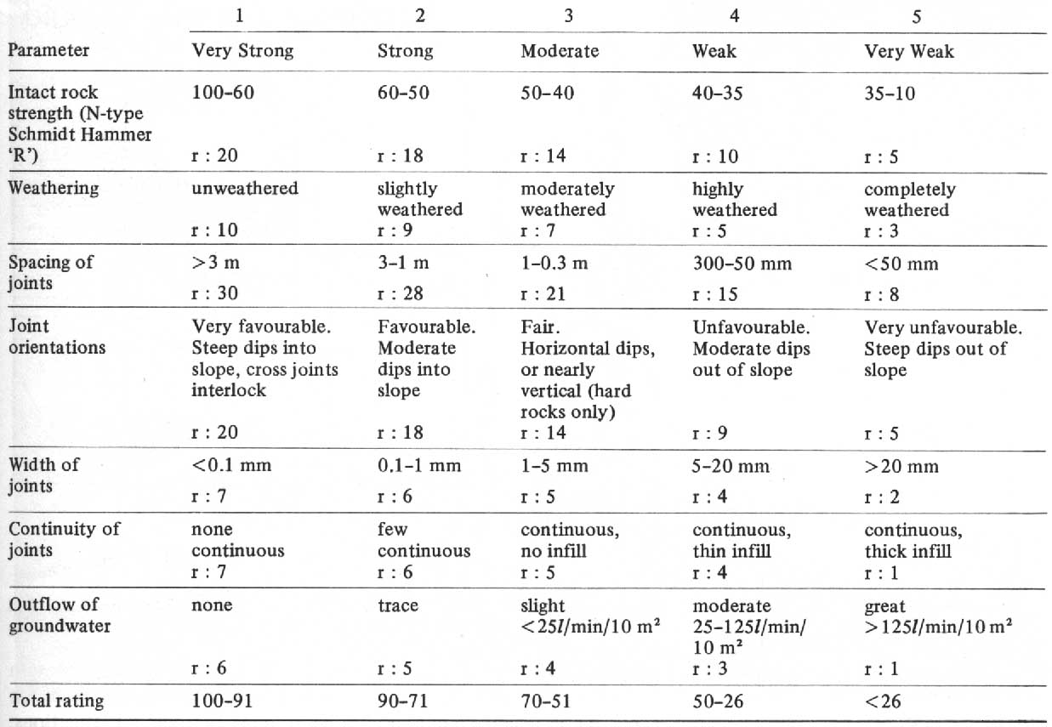
- The strength of soils is closely related to the liquid limit, percentage of clay present in the oil, and the plasticity index. These parameters can be determined in labs but generally shear stress declines with increasing moisture at different rates for soils with different clay content (Fig. 5-3).
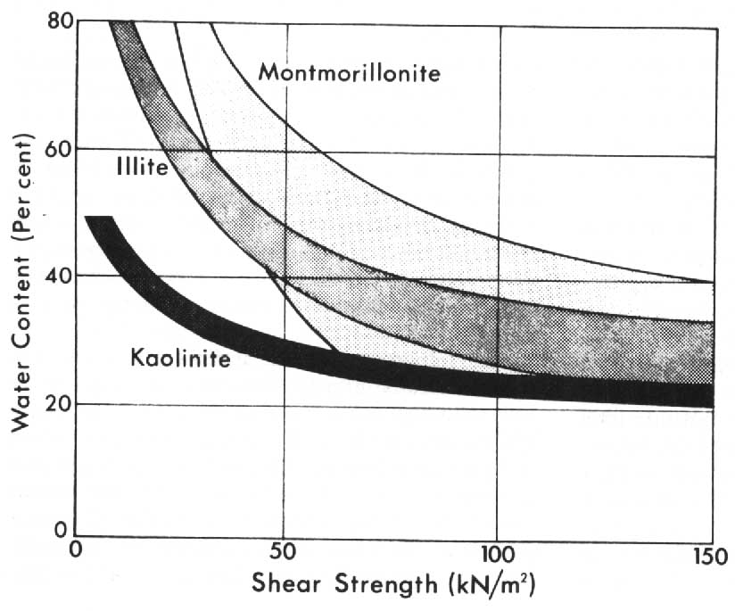
Figure 5-3. The relationship between shear strength and water content for various clay minerals (Selby, 1982).

5-2 Mass Wasting
- Mass wasting is the downslope movement of rock or soil mainly under the influence of gravity although in most cases, water or are ice are major contributors in terms of breaking down the material and initiating motion.
- Mass movements can generally be distinguished based on velocity and mechanism of movement, material involved, mode of deformation, geometry of the moving mass, and water content.
- Although the attempt of most classifications (there are several) is to differentiate between the various types of mass wasting, in reality many slope failures are composite in nature, grading from one type of movement to another (Fig. 5-4).
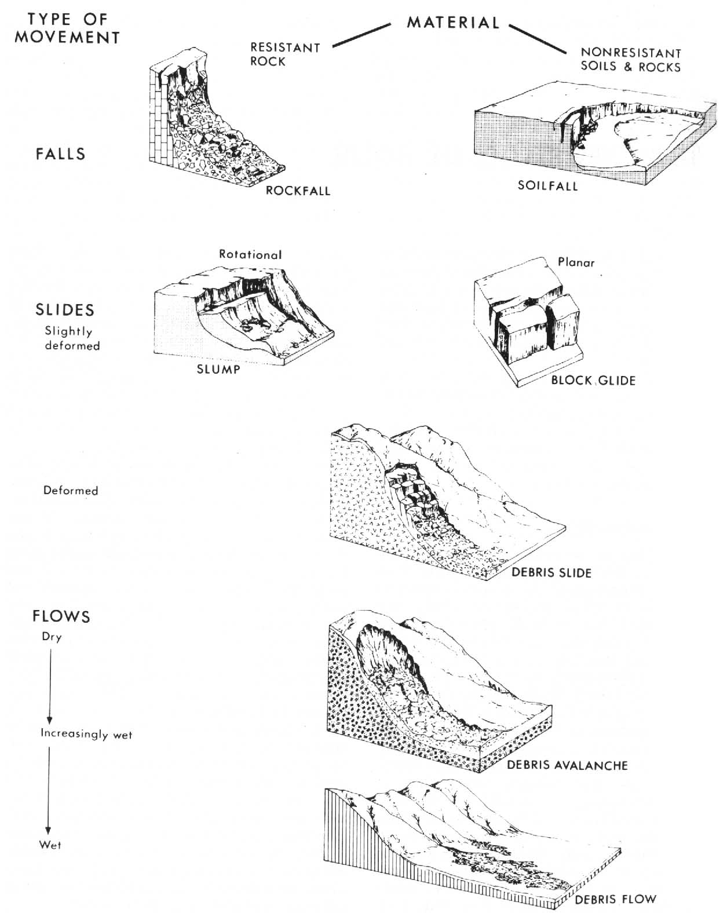
Figure 5-4. Mass wasting types according to the classification of Varnes (1958), Selby (1982).

- Soil creep involves the very slow deformation of soil or rock material within the upper 10m of the slope. Mainly due to episodic processes including heaving and settling, freeze-thaw, wetting-drying, warming-cooling cycles (Fig. 5-5).
(a) 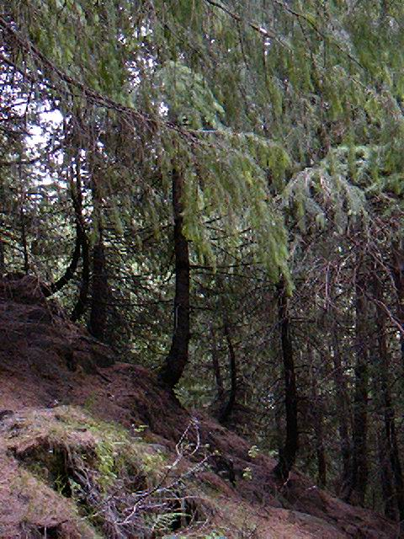(b)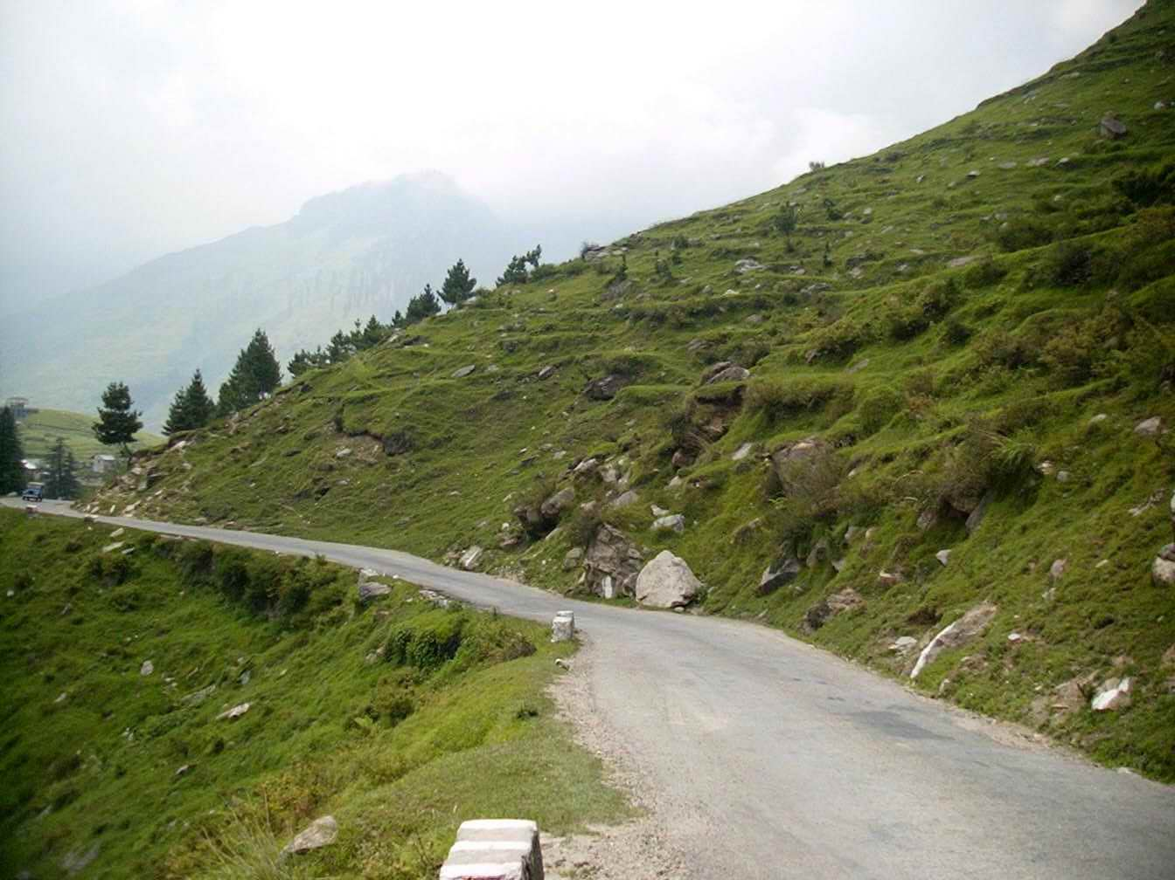
(c) 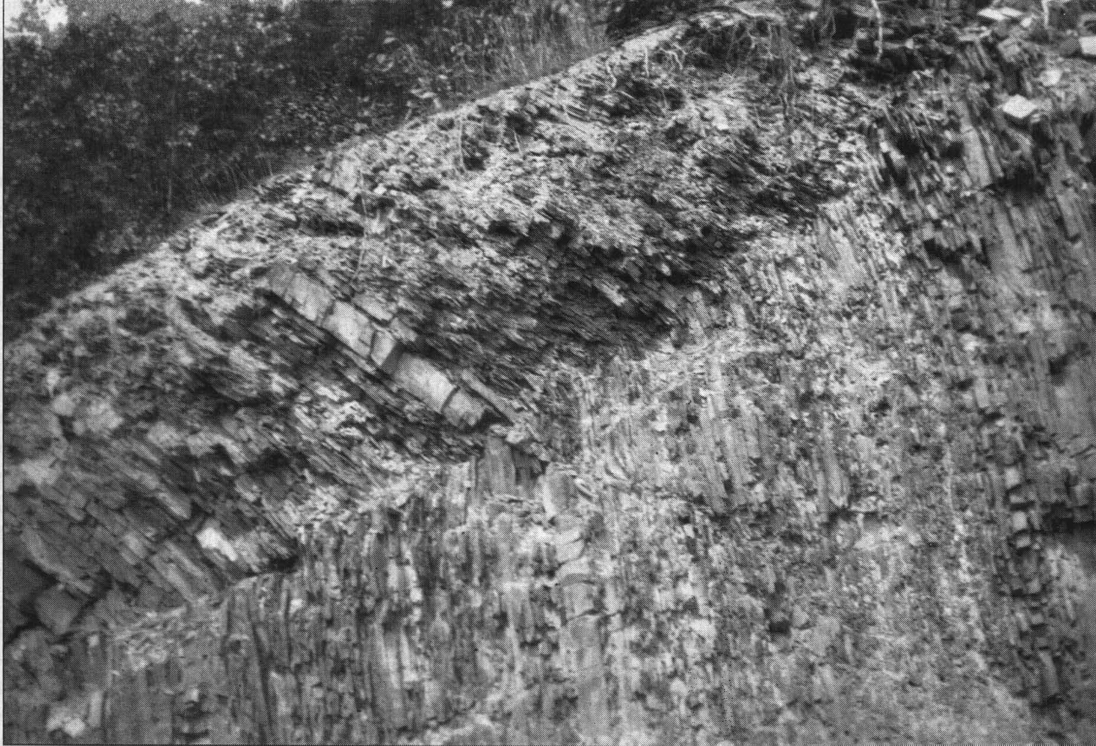
Figure 5-5. (a) Soil creep on a moderate, well forested slope in India (b) Soil creep on a cleared slope in India. Terracettes are a common landform expression of soil creep. (c) Creep in vertical Romney shale (G. W. Stone, U.S. Geological Survey, in Ritter et al., 2002).

- Falls are rare in soils because easily eroded slopes don’t last very long in disequilibrium with driving forces. They are much more common in rock slopes (rock falls) but both types involve a single mass of material that travels through mainly air.
- Although the exact conditions which lead to failure of a slope by rock fall are still not well understood, the main controlling factors seem to be; 1) intense rainfall; 2) steep hillslope angle; 3) debris in shallow hillslope hollows or chutes, and 4) intersecting joints with orientations parallel to valley strike.
- Slumps are a type of rotational failure where the sliding plane is curved. They are often initiated by the removal of toe support either by rivers or human activity which promotes downslope movement due to increased shear stress (Fig. 5-6).
(a)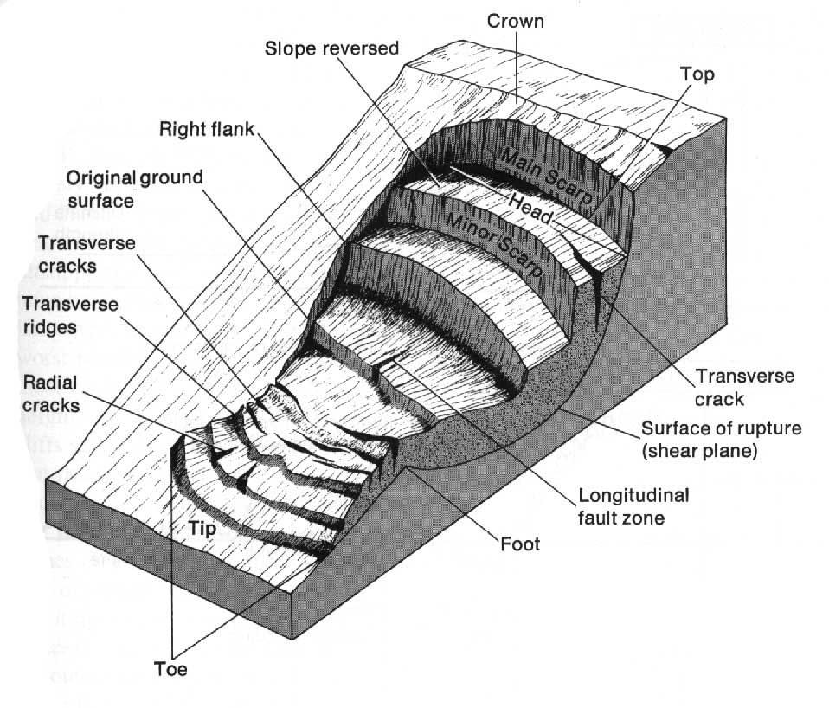(b) 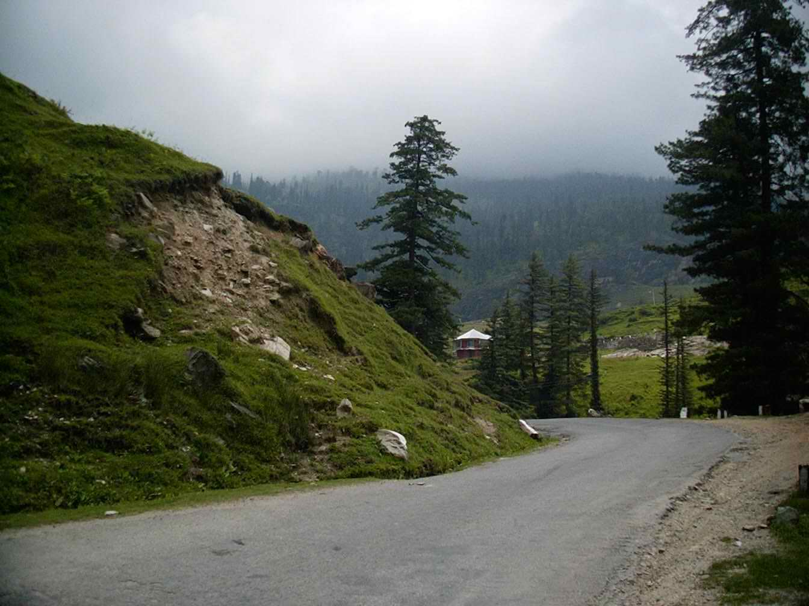
Figure 5-6. (a) A block diagram showing the main components of a slump or rotational slide (Ritter et al., 2002). (b) Slump failure in India. (R p111)

- Lateral spreads are mostly confined to sensitive clays which have high compressive and shear strengths if undisturbed. The removal of supporting material or low-frequency ground shaking however causes them to remould and liquefy almost instantly (Fig. 5-7).
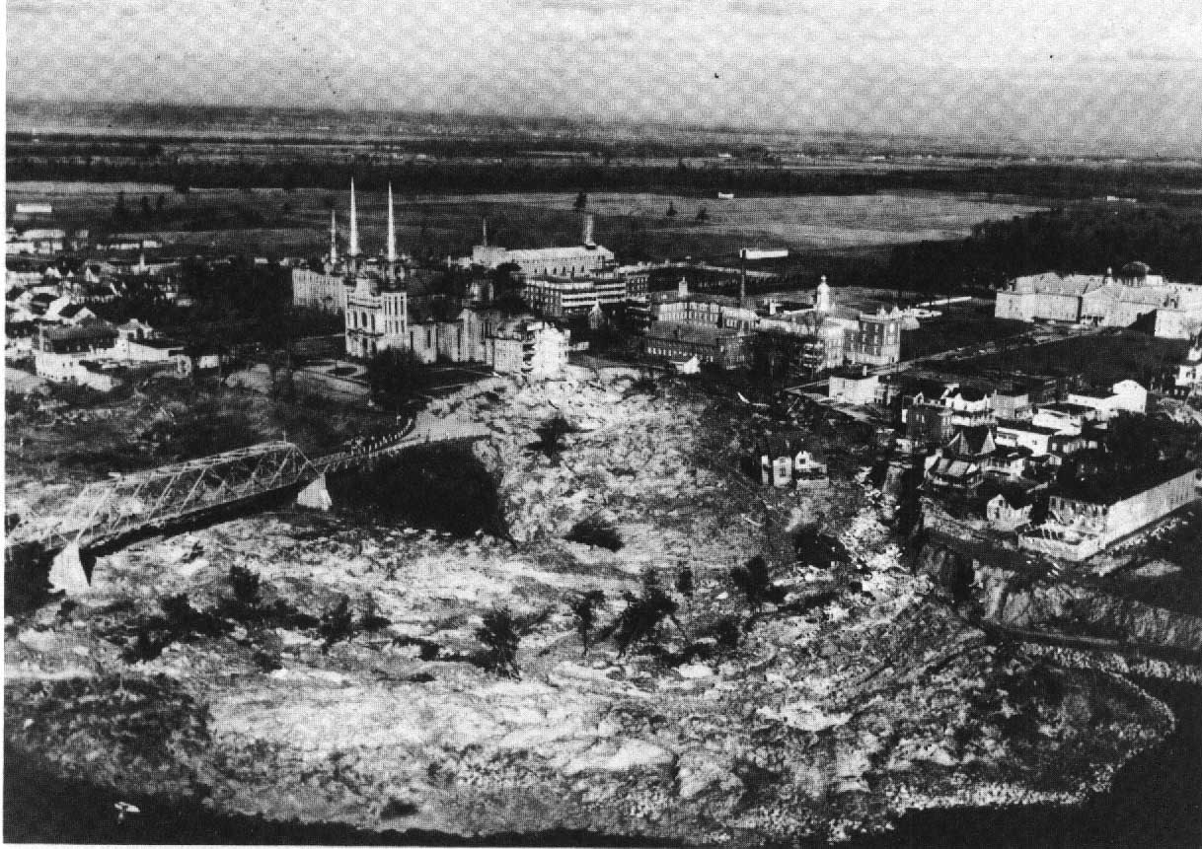
Figure 5-7. A large spreading failure in sensitive soils; the Nicolet landslide of November 1955, Quebec, Canada in Selby, 1982).

- Transaltional slides are the most common type of landslide occurring in soils. These encompass debris slides, debris avalanches, debris flows as well all other shallow slope failures in soil. The type of landslide that will occur in any given area is strongly influenced by structure and lithology (Fig. 5-8).
(a) 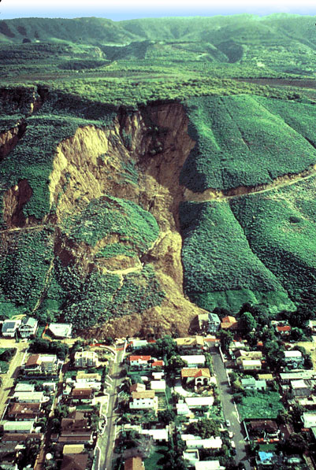 (b) 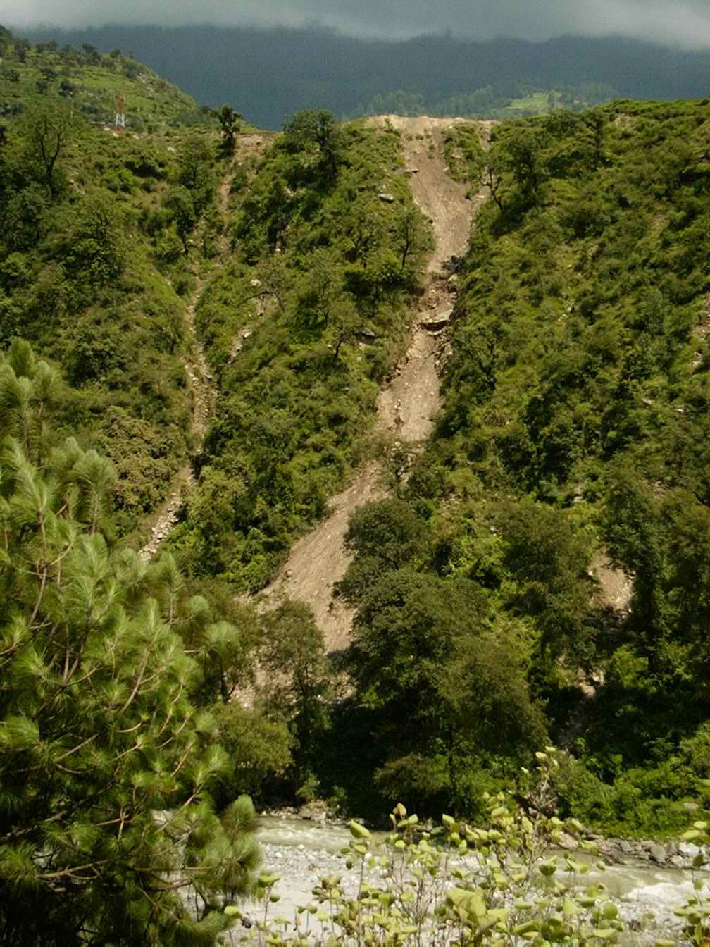
(c) 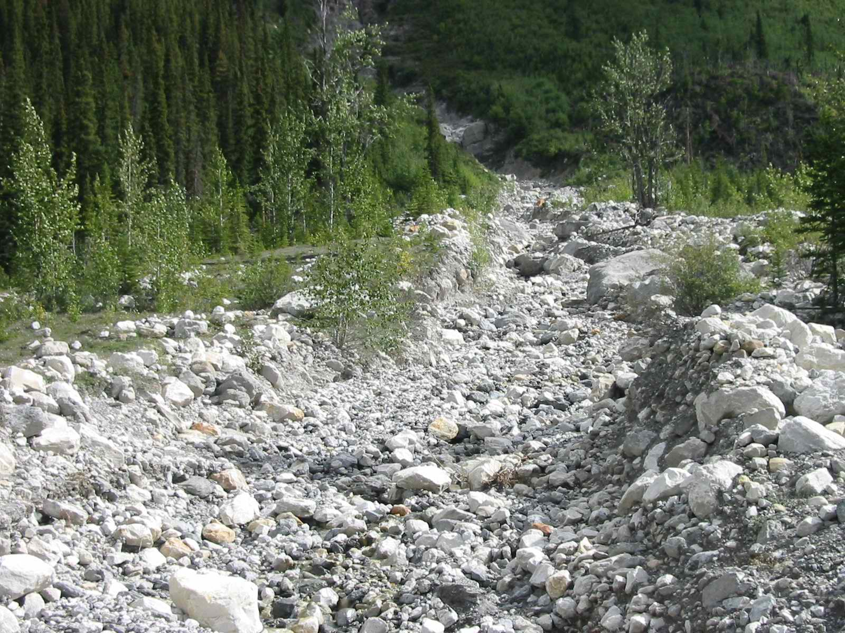(d)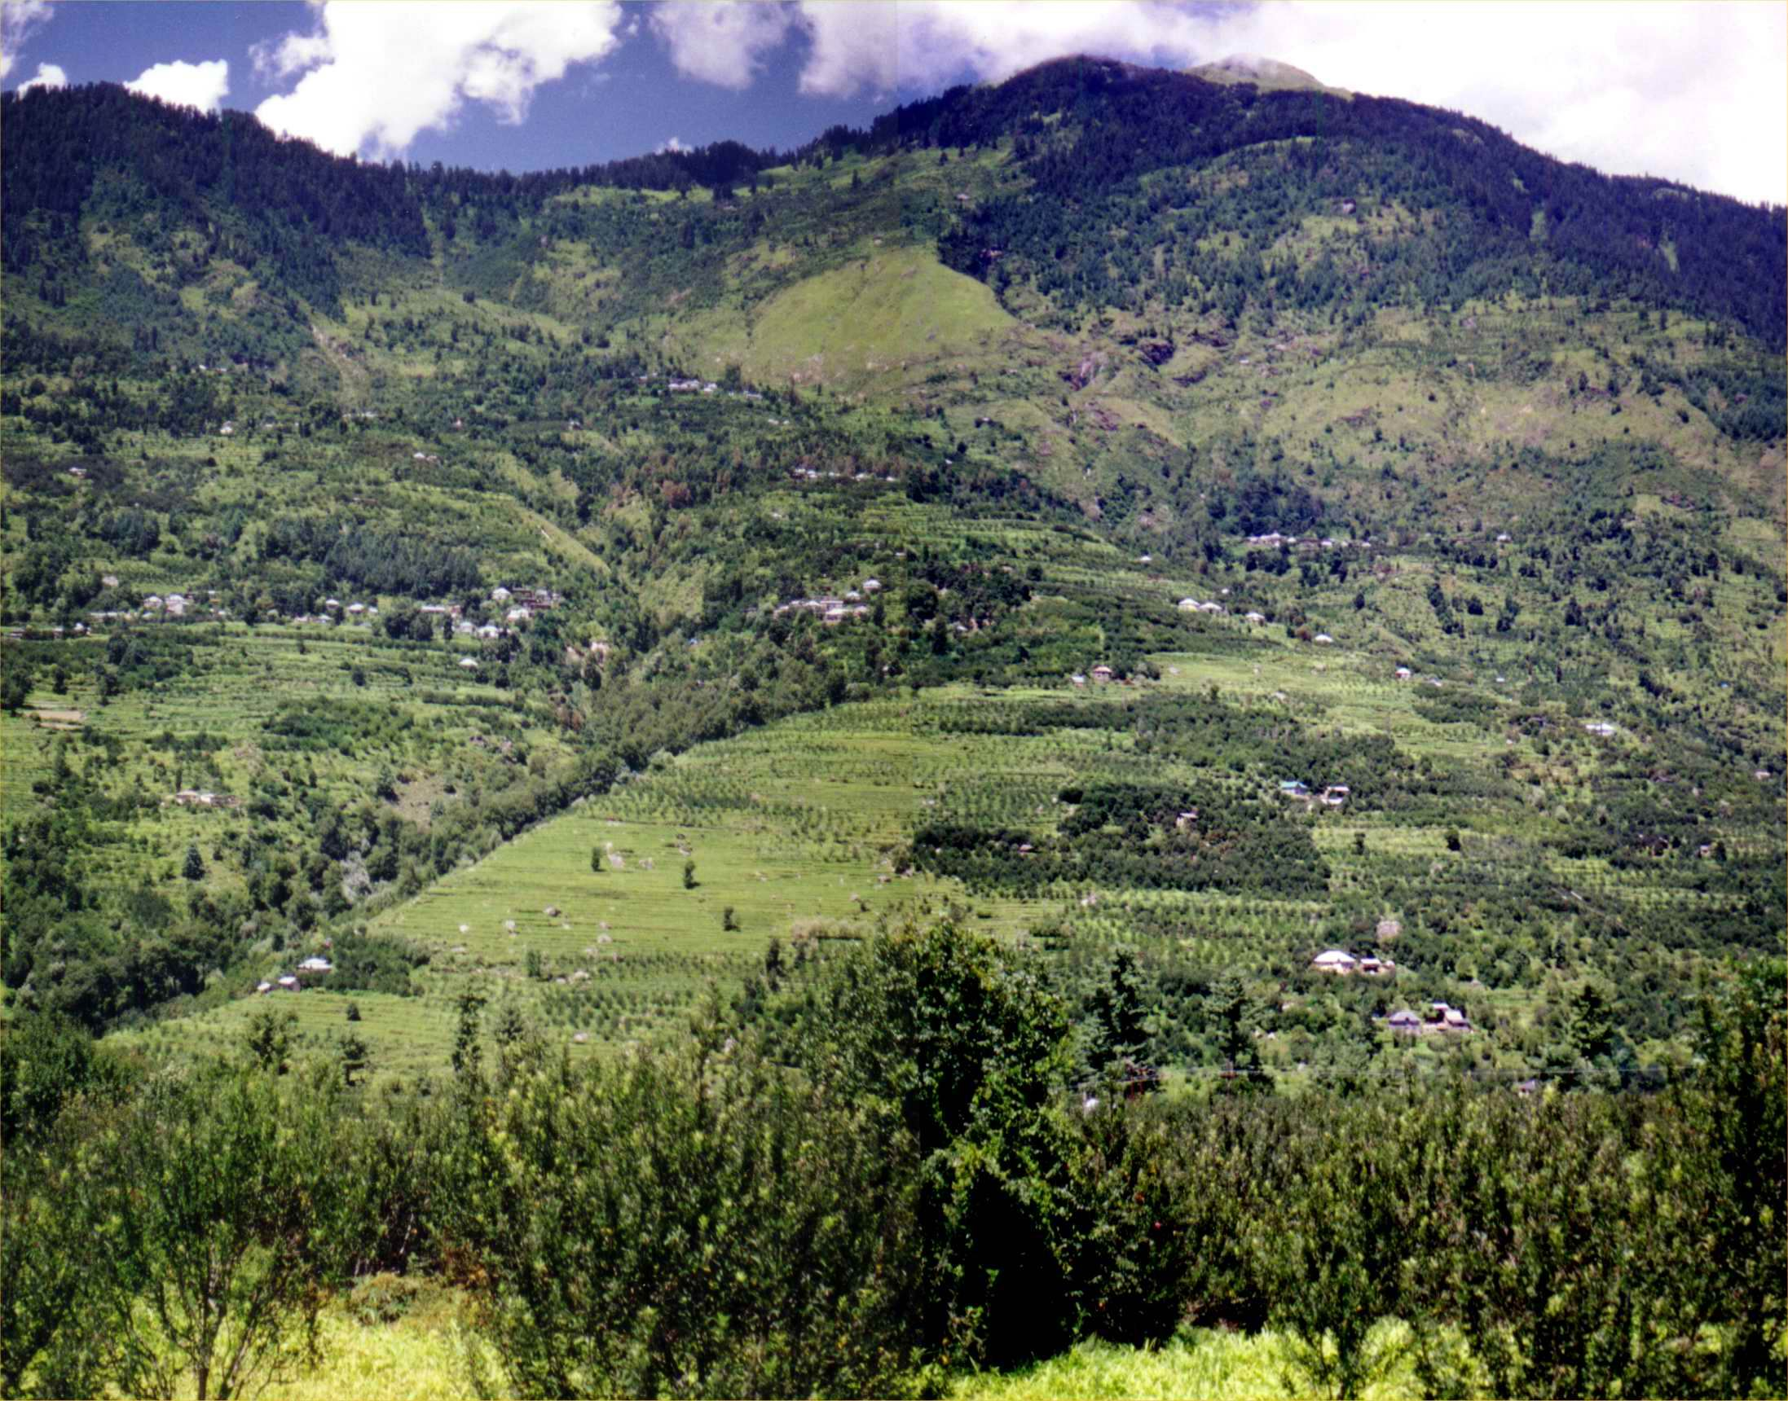
Figure 5-8. (a) Typical landslide scar and deposits. (b) Debris slide. (c) Debris flow. (d) Ancient landslide landform.

- The density and orientation of joints and bedding planes can be used to differentiate between planar failures and rotational movements. The depth of weathering and influence of relict landforms also appear to play a role.
- The failure plane is often parallel to the slope and the failed mass moves as a fairly coherent unit at least in the initial stages of failure. The main causes of failure include any forces which decrease shear strength or increase shear stress and include the usual suspects; 1) water; 2) horizontal or vertical acceleration (i.e. earthquakes); 3) removal of supporting material (toe erosion, bank undercutting, road cuts); 4) top loading (i.e. adding weight to the slope through engineering works or water).
- Failure by rocksliding is common in massive rock faces that have been exposed to prolonged weathering and are characterized by a dense network of fractures and joints whose orientation is either parallel or perpendicular to the slope (Fig. 5-9).
(a)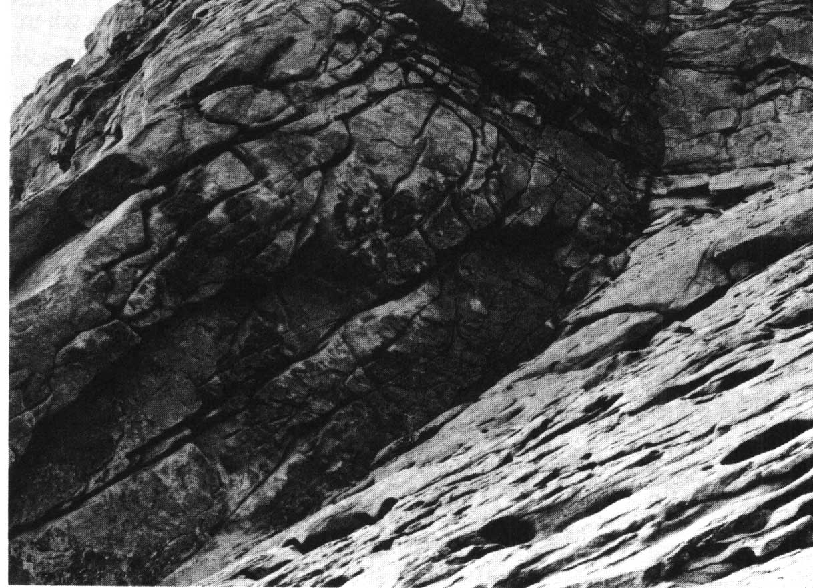(b) 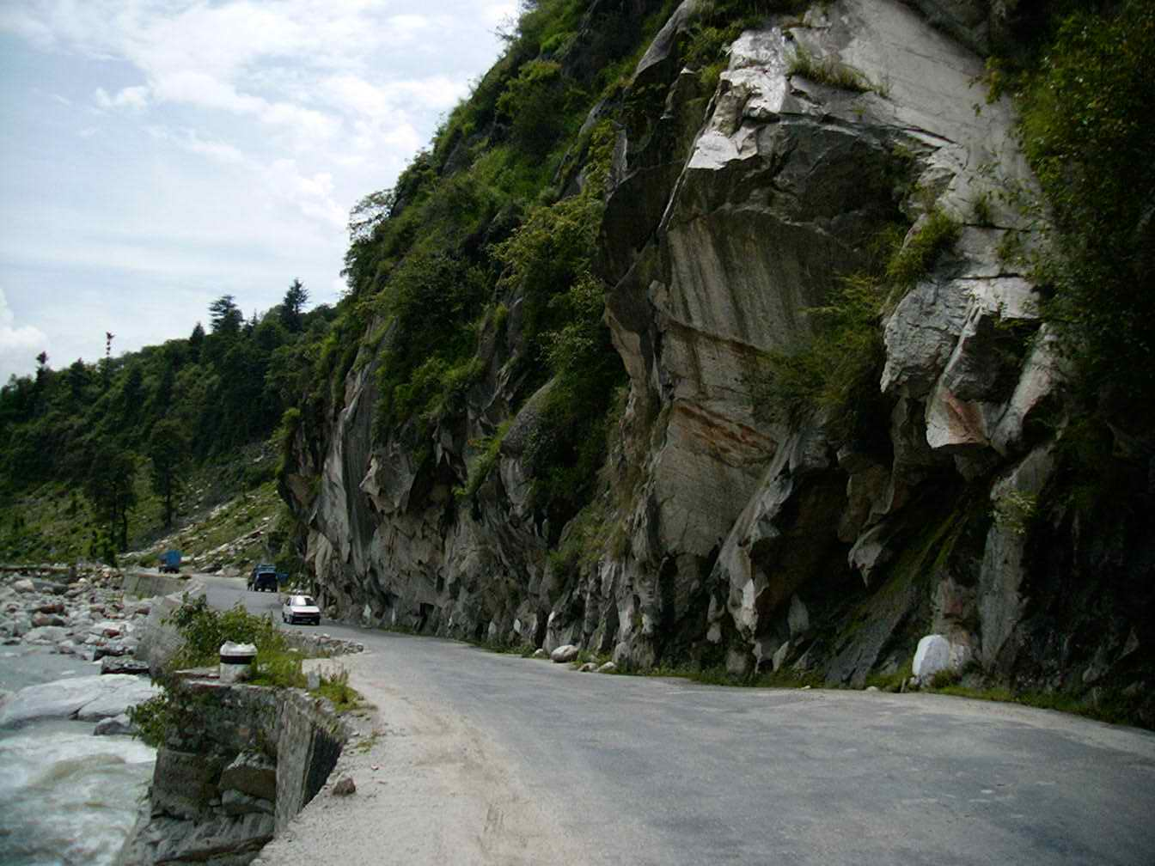
Figure 5-9. (a) Granites in Antarctica. Major joints trending parallel to the slope surface even where there is a sharp change of slope angle (Selby, 1982). (b) Over-steepened rock cliff adjacent to the Beas River in the Kullu Valley, India.

- Rock avalanches occur when a rock slope has been thoroughly weathered down to a major failure plane. These can be small, isolated events or large-scale rock “flows”. Their causes and exact mechanism of movement are poorly understood because of the huge volume of material that can be transported over long distances and shallow slopes. (Fig. 5-10).
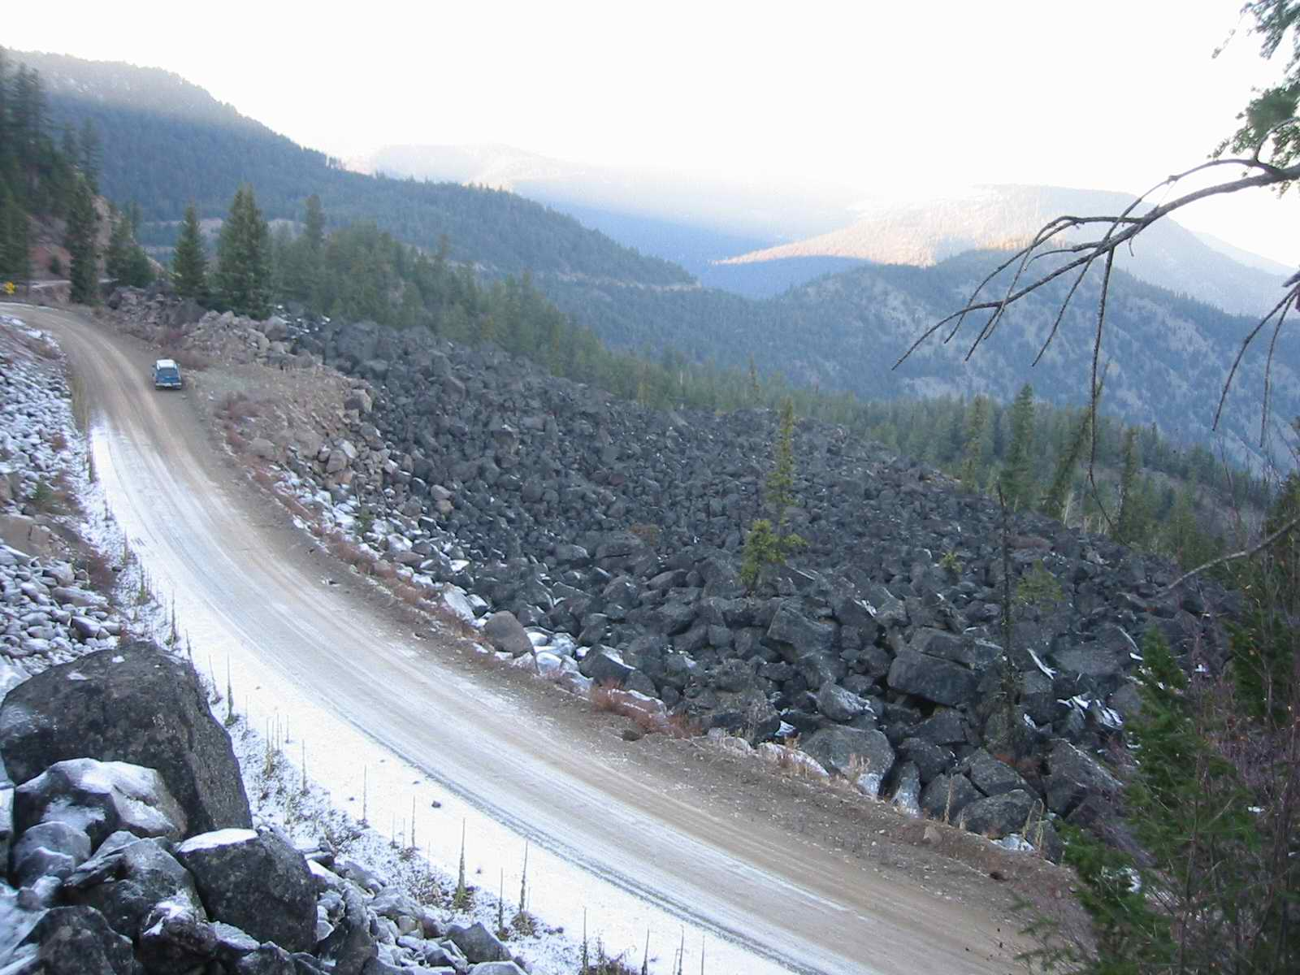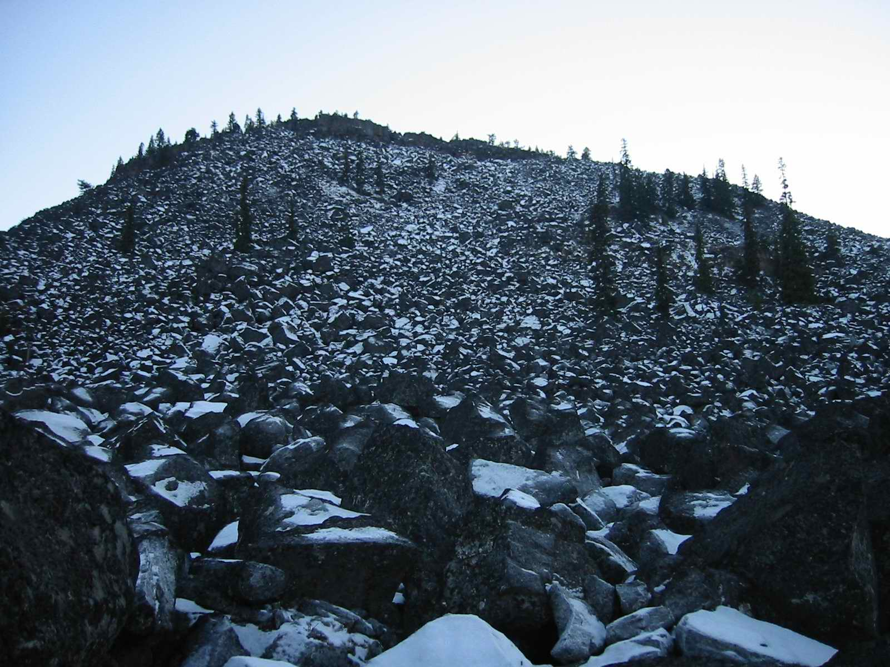
Figure 5-10. Rock flow north of Lilooet. The size of the boulders near the camera are upto 3m across.

- In some cases landslides will accumulate sufficient water volume to completely saturate the moving material and turn it into a viscous fluid. At this point the transition between sliding and flowing has been made where the material begins to deform freely during flow.
- These are still shallow, translational failures but they differ from typical landslides because they are saturated and resemble rivers in that the velocities are greatest near the top and center of the flow.
- Debris flows are surging mixtures of organic and inorganic debris flowing down steep low-order (1st or 2nd) confined channels. Material within the channel brought down by other mass wasting processes is mobilized by a high discharge of water (Fig. 5-11).
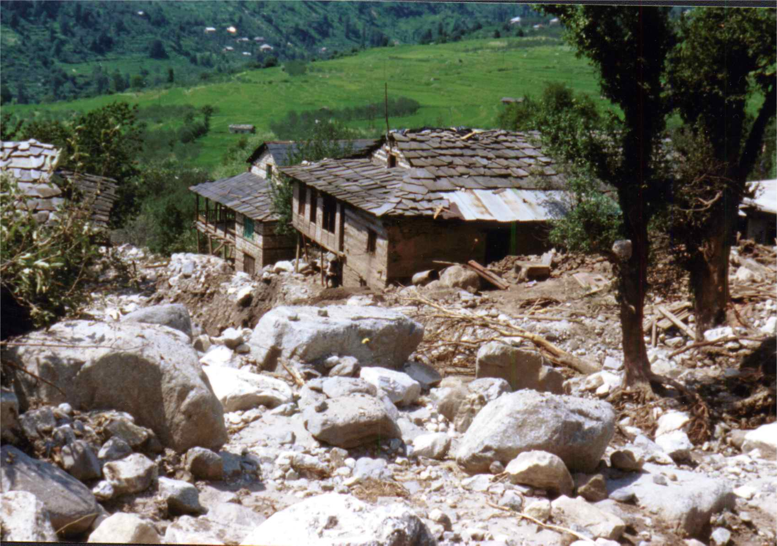
Figure 5-11. Debris flow through a village in the Kullu Valley.

- Earth flows, mud flows and debris avalanches are gradations of debris flows with the main difference being the coarseness of entrained material, volume of water and degree of channelization. Debris avalanches, for example tend to occur on open slopes.

5-3 Morphology and Field Study of Mass Movements
- Why should we be concerned about trying to decipher what type of mass wasting process might threaten an area? What difference does it make if a highway, for example is at risk from a landslide or debris flow or rock fall failure? How important is it for us to be able to interpret past deposits in order to infer the process that created them?
- What has traditionally been the domain of civil engineers has now been transferred into the hands of the geomorphologist, that is, the deciphering of slope morphology in order to determine what type of process is most likely to occur, what are the chances of failure within a given time frame and what threat does it pose to existing or current infrastructure?
- Studies of slope processes occurring in remote areas provide us with the theoretical and quantitative data we need to solve problems associated with more populated areas. What are some of the techniques used to determine the mass wasting potential of a slope?
- Crozier (1973) found that depth/length of deposited material provided a reasonable basis for a distinction between fluid flow, viscous flow, slide-flow, planar slides, and rotational slides. Predictably, fluid flows had the lowest ratio because they are generally able to flow farther so the index is inversely proportional to water content (Fig 5-12).
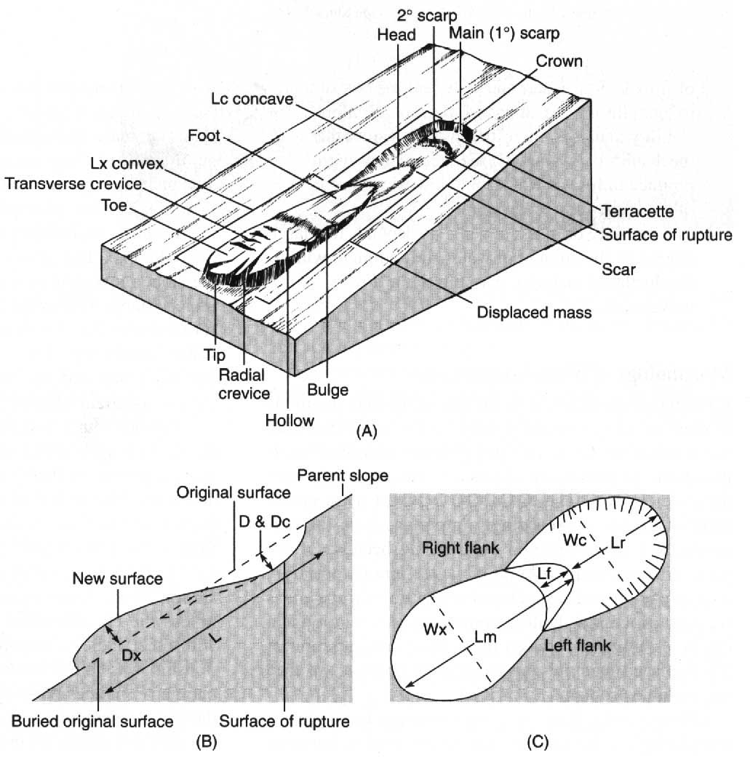
Figure 5-12. Different morphometric indices shown in diagram can be used to describe and distinguish the processes of movement: (a) landslip terminology; (b) longitudinal section; (c) plan view. (Crozier, 1973, in Ritter et al, 2002).

- The ability to distinguish between active and inactive landslides is important. The main characteristics of active slides are tension cracks on upper slope, tilted trees/vegetations, rapid colonizers on mid-slope, and fresh debris, disturbed vegetation on lower slope.
- In preparation for a field study of landslides it is beneficial to create a map of known landslide sites in relation to lithology, slope gradient, hydrological conditions, and locations on the slope.
- These inventory maps are an important first step in the analysis of landslide stability. Climatic and seismic conditions as close to the time of known failures as possible is also beneficial in determining triggering factors.
- A complete list of influential factors might look like the table 6.5 on page 129 in Selby 1982. In most cases however, due to differences in reporting techniques, availability of equipment, time and resources, only a fraction of these are collected. This leads to a serious gap in knowledge in terms of relating the processes operating in one area to other areas.
- Shear strength testing of the soil comprising a suspected landslide site can be carried out in a laboratory where an attempt is made to simulate the magnitude of loads, loading rates, and drainage conditions which occur in the slope (from Selby, 1982, p. 128).
- In any case once slopes that are potentially unstable have been identified through field interpretation and mapping, the next step is to evaluate their actual potential for failure using quantitative stability analysis.

5-4 Slope Stability Analysis
- Recall our earlier discussion of driving forces promoting downslope movement (shear stress) and those which oppose motion (shear strength). In stability analysis the aim is to mathematically evaluate the most pertinent factors which control these forces using the basic equation F = sum of resisting forces/sum of driving forces.
- Thus if F < 1, the slope is likely to fail whereas if F > 1 the slope will likely remain stationary. These values do not indicate absolute stability because even slopes with high F values may be subjected to forces which decrease the ratio beyond stability.
- Common minimum acceptable factor of safety values for seepage failure types are much less precise than for shearing failures because of the large role water plays in slope stability. It not only acts as erosion agent, but also affects the weight of material, the pore pressure between grains, the buoyancy, and of course viscosity.
- Considering all the driving and resisting forces, the factor of safety equation, using an infinite slope model takes the expression:

$F=\frac{c'+(γ−{mγ}_{w})z{\text{cos}}^{2}β\text{tan}φ'}{γz\text{sin}β\text{cos}β}$

where c’ is the effective cohesion, as reduced by loss of surface tension;
γ is the unit weight of soil at natural moisture content;
m is the height of the water table above the sliding plane expressed as a fraction of the thickness of sliding material;
γ_{w} is the unit weight of water
z is the thickness of the sliding material;
β is the slope angle;
φ’ is the internal angle of friction

- Which of the factors above has the strongest effect on the factor of safety? Furthermore which of the variables are prone to rapid changes without changing the slope angle or other morphological slope properties (Fig. 5-13)?
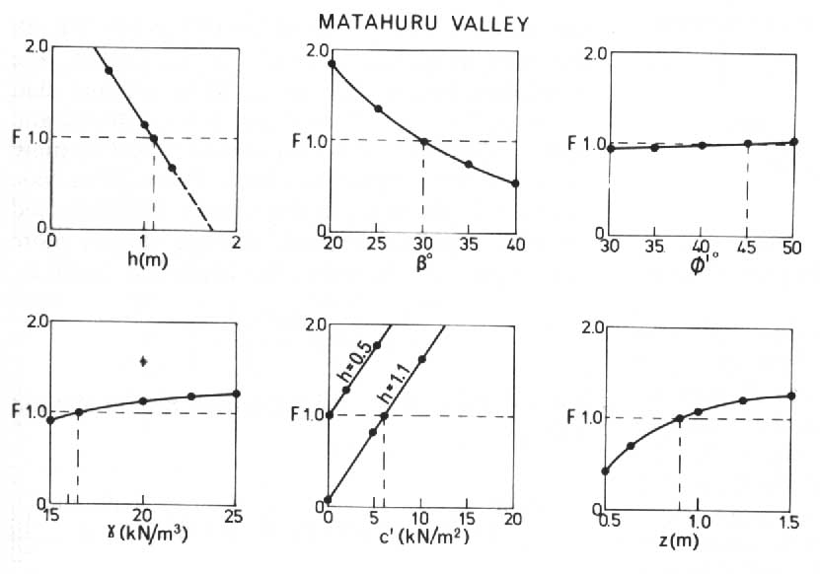
Figure 5-13. Variation in the factor of safety against shallow landsliding as one parameter only varies. Parameter values are as given except where one parameter is varying (Selby, 1982).

- The figure above clearly demonstrates that based on the research by Rogers and Selby (1980), the factor of safety is very sensitive to changes in c’ , β, and h where h is the piezometric head computed as the thickness of material (z) times the proportion of the water table above the sliding plane (m) times the unit weight of water (γ_{w}).
- The piezometric head can be varied through proper drainage techniques (i.e. pipes) but c’ (the effective cohesion) and β are much more difficult to control or change. These studies however are a great benefit in figuring out what effects changing the land use, drainage, or vegetative cover might have on the stability of a slope.
- Slope stability for rotation failures with curved sliding planes proceeds in a similar manner but the failure surface is decomposed into a number of small wedges and the forces are computed separately then summed together.
- Slope stability analysis is not perfect. First of all they are two-dimensional solutions to three-dimensional problems. Soil sampling, the timing of water table measurement and defining the thickness of material above a sliding plane are all major sources of error.
- In cases where the exact potential of slope failure is not required, a susceptibility map may provide more information about the general slope stability in an area. Knowing which factors have promoted failure in the past can help identify potential failure sites.
- The concentration of processes which may initiate failure such as undercutting of toe material by rivers, disturbance of a slope by engineering work, deforestation, improper maintenance of agricultural fields, especially terraces, and the presence of old landslide colluvium often indicate that a slope is at least somewhat predisposed to future failure.

5-5 Factors Affecting Slope Stability
- Care must be taken when trying to determine the cause of a landslide. Many factors go into setting up a slope for failure, though there may only be one triggering mechanism or event which actually initiates movement.
- All of the factors affecting slope stability can be classified into either those that contribute to high shear stress or those that contribute to low shear strength as those are the basic forces acting on any slope (refer to Table 6.8 on p. 140 in Selby, 1982).
- The factors listed in table 6.8 in Selby (1982) are manifested through changes in vegetation, earthquakes, ice, weathering, and water on slopes. Out of these 5 factors, water and vegetation are perhaps the most influential. Let us examine them in turn.
- Vegetation, particularly trees have a clear and demonstrable impact on slope stability. Firstly it is well documented that the removal of large tracts of forest on moderate to steep slopes induces frequent shallow landsliding.
- Secondly, tree roots are known to act as anchors in the soil, increasing shear strength as long as their depth is sufficient compared the height/weight of the tree. Very tall trees on steep slopes with a shallow root network may actually decrease slope stability.
- Finally, trees tend to lower the height of the water table as a result of transpiration and interception, reducing soil saturation (Fig. 5-14). Landslides are far less common on forested slopes than adjacent slopes under cultivation of grass.
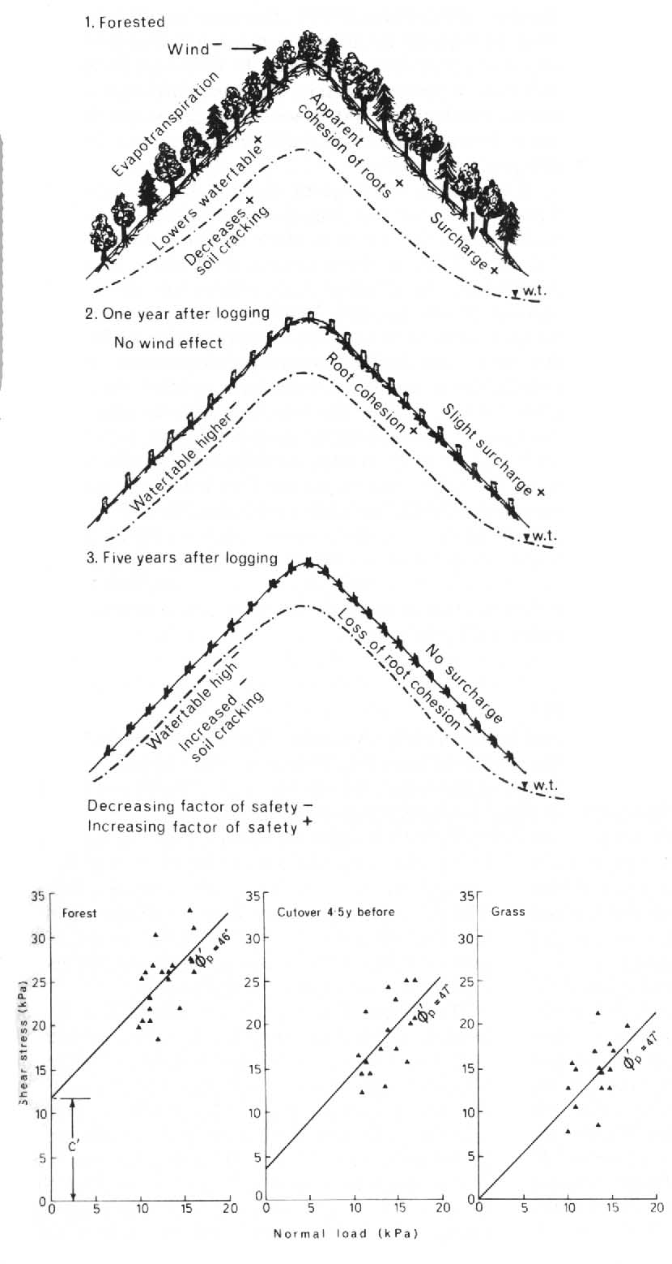
Figure 5-14. The decline of shear strength of a soil caused by a loss of apparent cohesion. The scatter of the data is caused by the high variability of structure and texture in steepland soils (supplied by D. Parker, in Selby, 1982).

- Earthquakes cause very sudden but very brief accelerations within a slope. These accelerations affect the internal cohesion of soils, particularly sensitive clays and unconsolidated sediments composed of sands, but the effects are not confined to these soil types as large rock falls are also common following major earthquakes in tectonically active regions.
- The influence of ice is mostly confined to periglacial environments and include processes such as solifluction. Though ice may not be a critical factor in slope processes today (apart from potential rapid melting of ice which generate high discharges) many landscapes throughout Europe and place in North America were created by ice-related mass wasting following deglaciation.
- Weathering must be considered as a factor because it is the primary mechanism of breaking down solid rock into a weaker form making it more susceptible to mass movement. Weathering often induces jointing in over-consolidated clays which promotes infiltration and reduces stability.
- The effect of water on slopes is ubiquitous. It affects all aspects of slope stability from undercutting of toe material, adding weight as rain, to an agent in weathering, buoyancy effects, and increasing pore pressures (Fig. 5-15).
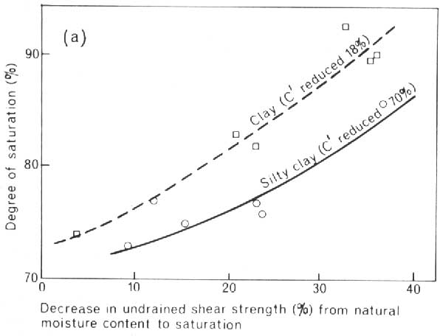
Figure 5-15. Decrease in effective cohesion as the moisture content of a soil increases (data supplied by N. W. Rogers in Selby, 1982).

5-6 Slope Profiles
- Geomorphologists are still search for the key that will tell them which process is/was dominant in shaping a particular slope. This is an extremely difficult puzzle because in reality any one slope will be subject to a variety of processes which vary in time.
- Given that the slope profile at any location is governed by such broad controlling factors as climate, rock type and structure, time, and process it unlikely that a certain slope profile will ever be linked without question to a certain hill slope process.
- Nonetheless there has been some revealing research into an apparent connection between clusters of slope gradients and the dominant processes operating on them. These gradient clusters are thought to represent dynamic-equilibrium conditions between the major geomorphic factors and the processes operating on them.
- These gradient clusters are more frequently found in nature because they seem to represent a condition where in order to disrupt the dynamic-equilibrium a major threshold-crossing event must occur, such as climate change or alteration of parent rock material.
- Slopes which are a reflection of the parent material are referred to as weathering-limited slopes because the rate of regolith or soil production is slower then the rate of erosion and its removal. These slopes tend to be found in dry climates or mountain terrain.
- Transport-limited slopes on the other hand are characterized by a faster rate of weathering than the rate of erosion or rate material removal. These slopes are more tied to the type and rate of processes operating in the area.
- There are several hypotheses regarding how slopes evolve over time and what the main controlling factors are at any given point in time. Selby (1982) presents the concept of a strength equilibrium envelope developed from data acquired in a variety of rock types (Fig. 5-16).
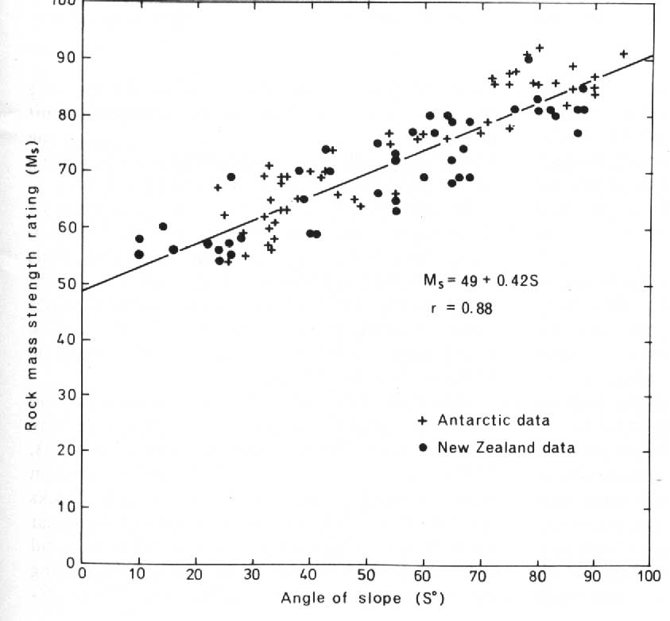
Figure 5-16. The relationship between rock mass strength and slope angle for all measured Antarctic and New Zealand slopes (after Selby, 1980, in Selby, 1982).

- No single universally-accepted model of slope evolution has yet been presented.

