Section 3 – Sediment Budgets and Controls on Channel Shape

- Near the end of the previous section, we talked about the supply of sediment into a river channel. In this section we will briefly review the 3 main types of sediment load within a river and the mechanics by which the river transports and deposits this material.
- We will also explore the patterns of erosion and their resulting morphological expressions. These morphological patterns can help us deduce the processes operating in the field.

Sediment in Channels

- Streams continuously wear down the land and transport the eroded material towards the ocean basins. They accomplish this using the remaining energy available after the resistance to flow has been overcome.
- For example, the Mississippi removes approximately 517 million tons of rock material annually! The material supplied to rivers depends on such factors as:
  - Topographic relief
  - Lithology of slope material
  - Climate
  - Vegetation
  - The processes acting on the drainage basin

- In essence, the type of material and speed with which it enters the channel depends heavily on the exogenic processes operating on the surrounding slopes and the parent material.
- Although the total volume of material entering and being transported by the channel is important, of even more relevance to the operation of individual streams, is the caliber or dominant size of material.
- The size of material being supplied into a channel directly affects the ability of that channel to transport the material and also determines the main mechanism of transport.
- The composition of a stream beds is directly related to the characteristics of the material being supplied into the channel as well as subsequent processes of sorting and abrasion. Most stream beds comprise of cohesionless grains.
- The material being entrained, transported, and deposited through river channels is derived through bed erosion, bank erosion and the surrounding slopes. In many rivers, bank erosion is the principal means of sediment supply to streams (Fig. 3-1).

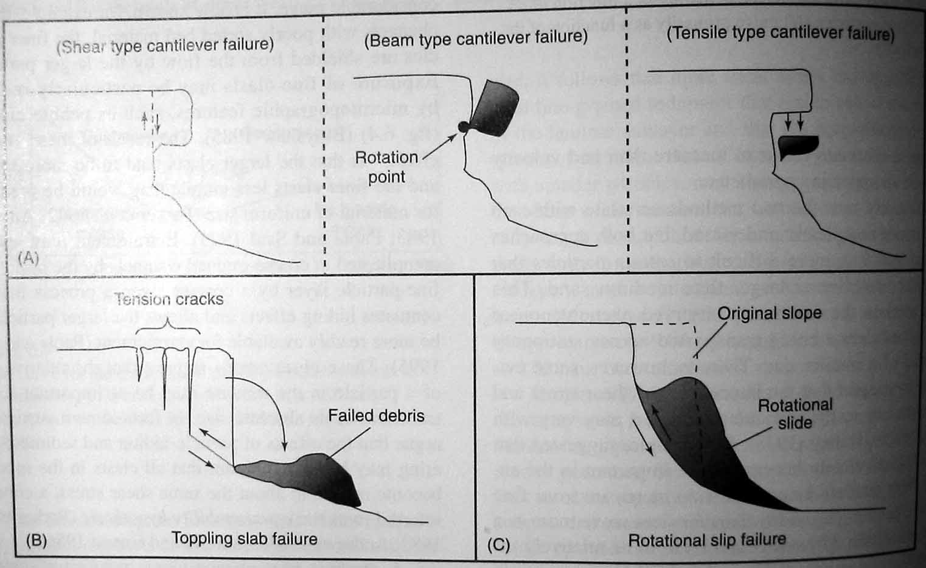
Figure 3-1. Types of bank failure mechanisms commonly observed along rivers with cohesive banks (Adapted from Thorne, 1982, in Ritter et al, 2002).

- Eroded material may be transported as dissolved load, suspended load, or bedload. Let us examine the transport mechanisms for each of these load types.
- Dissolved load represents the portion of material introduced into the channel through processes of chemical weathering. Thus rivers flowing through humid, densely vegetated basins underlain by easily dissolvable rocks (eg. Carbonates) carry upto 90% of their sediment load in solution.
- Although dissolved load is an important component in terms of the fact that human activity is increasing the volume of material carried in solution by rivers to the ocean, it has a rather negligible impact on the flow regime of a river.
- Suspended load or wash load comprises mainly of silt and clay-sized particles, is generally carried within the water column and rarely comes into contact with the channel bed.
- It moves at a slightly slower velocity than that of the water and turbulence, particularly the upward components of turbulence play a major role in this transportation mechanism.
- The velocity or power of a stream required to keep a given particle in suspension depends on many factors but grain radius is one of the most important (see Stokes’ law, p. 119). The relationship between suspended discharge and water discharge is fairly well defined (Fig. 3-2).

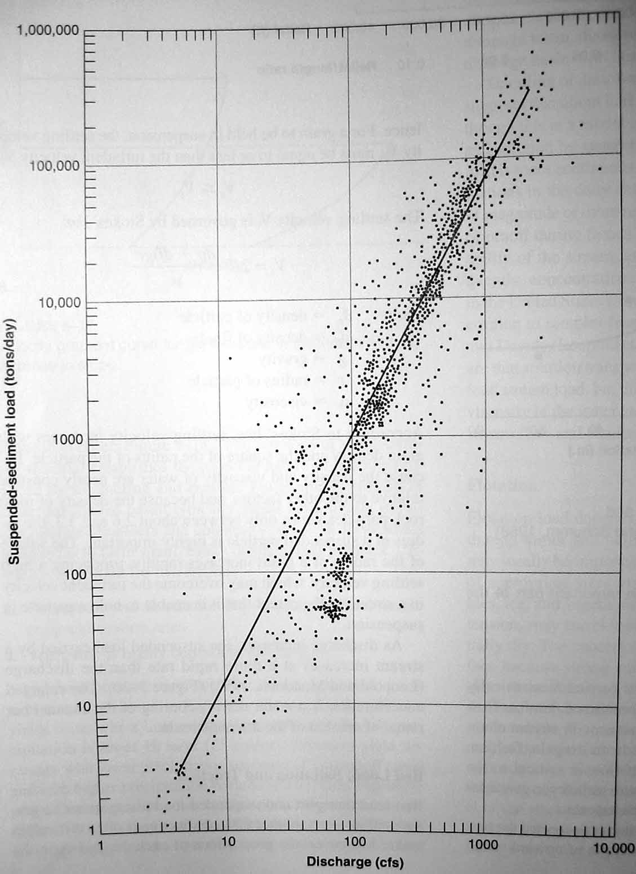
Figure 3-2. Increase in suspended load and discharge (From Leopold and Maddock, 1953 in Easterbrook 1999).

- The gradation between material transported in suspended load and as bed load is often very fuzzy and undefined as slightly larger particles will periodically travel in suspension and then be deposited as bed load only to be entrained, or picked up later.
- Bed load is the material that is transported close to or along the channel bottom by saltation (i.e. skipping or bouncing) or traction (rolling or sliding) (Fig 3-3).

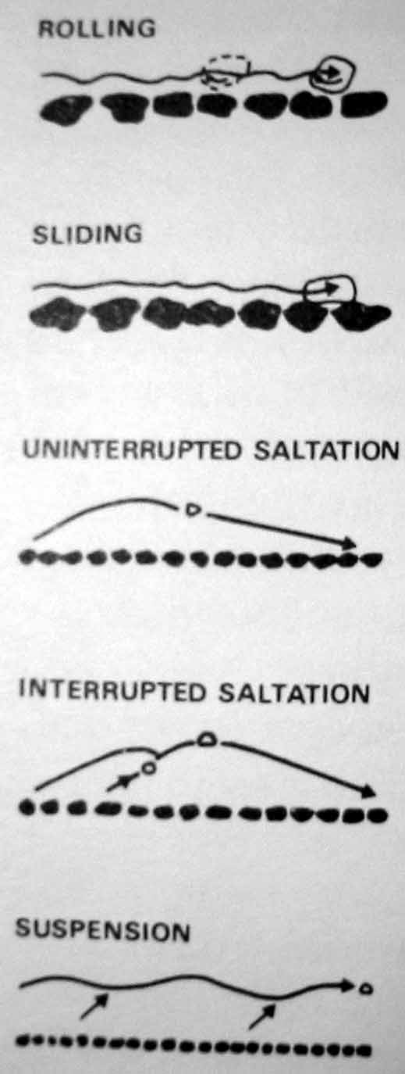
Figure 3-3. Modes of transport of bed material load (Knighton 1984).

- Under “normal” conditions (i.e. not floods) most streams carry less fine grained bed material than they are capable of and this makes establishing a relationship between bed load and discharge difficult.
- Coarse material, on the other hand, is more abundant so typically only a small fraction is being transported by the river. This creates the opportunity to correlate coarse bed load concentration with discharge however measuring this concentration has proven problematic.
- Problems associated with measuring bed load include:
  - Interference with the flow by a necessarily large sampler
  - Difficulties with placing a device upon an uneven channel bed
  - Sampling efficiency
  - Irregular movement of bed material.

- Empirical formulas can be used to determine the capacity of a stream or the maximum amount of sediment that river can carry for a given set of channel, sediment and flow conditions. None of the developed formulas however are entirely adequate.
- For example Rubey’s research (1938) revealed that a small increase in velocity will result in the entrainment of much larger particles because the relationship between grain size and flow velocity is given by the equation

r³ = kv⁶
where r = radius of the particle, k = constant that includes gravity, grain density, and other variables that don’t change very much relative to v = flow velocity.

- However the relationship between velocity, grain size and erosion is not as simple as it may appear. Hjulstrom’s diagram (Fig 3-4) demonstrates that higher velocities are required to entrain particles smaller than about 0.1mm. The main reason for this is the strong intergranular cohesion between particles of this size and smoother flow.

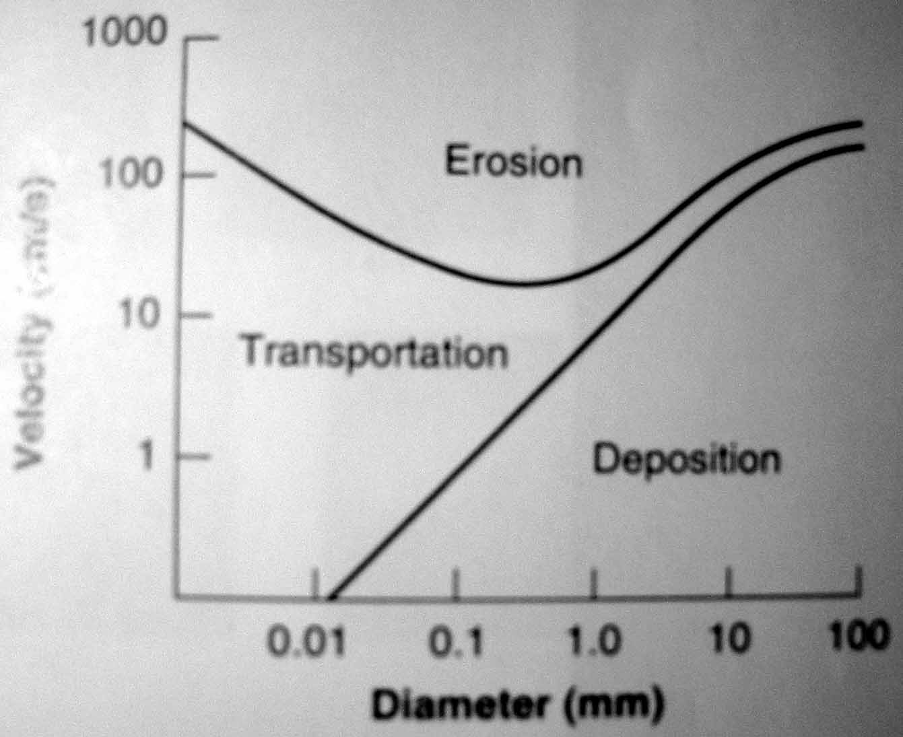
Figure 3-4. Hjulstrom’s diagram showing mean velocity at which uniformly sorted particles of various size are eroded, transported, and deposited (Ritter et al, 2002).

- The initiation of movement of particles depends largely on the hydraulic shear stress available and the grain diameter (refer to Figure 5-22 on p. 122 in your textbook). Generally, larger particles require more shear stress in order to initiate movement. Entrainment refers to the processes that initiate particle motion.
- Critical shear stress is calculated as

τ_{c} = γRS
where γ = the specific weight of water, R = hydraulic radius and S = slope.

- The critical shear stress equation is appealing because hydraulic radius and slope are relatively easier to measure in a stream than bed velocity (as in Rubey’s equation).
- If capacity is the maximum amount of sediment that a river can carry then competence refers to the size of the largest particle a stream can entrain. Difficulties associated with measuring competence include;
  - The entrainment of particles by different processes and under variable flow conditions
  - Variability of flow velocity, especially under flood conditions
  - Conditions surrounding particle affect the amount of energy required to initiate motion.

- Large rivers are competent enough to transport almost all of their bed material through the lower reaches so even the larger particles are being moved through the system. In smaller rivers, however, competence quickly determines which particles can be sustained in motion during regular flow.
- Thus sorting is controlled by competence in small rivers and capacity in large rivers. Furthermore, an increase in capacity in a large river will result in the transfer of sediment from bed load to suspended load.
- The net effect of the sometimes simultaneous action of deposition and entrainment is referred to as scour or fill and is heavily dependent on local, short-term conditions rather than average or long-term hydraulic or climatic conditions.
- Over long periods of time, deposition leads to aggradation and results in landforms that reflect distinct periods of geomorphic history.

