Geography 313 – Lab 2: River Mechanics

Instructions and notes:
- The lab is worth a total of 170 marks. Numbers in the square brackets indicate the value of each question.
- The lab will be due at the beginning of the lab on Feb. 3rd, 4th, or 5th.
- The written portion of the lab is to be typed up. Be sure to include all required work (i.e. calculations).
- Include your student number, lab section, and date on your lab report.

Questions:
Part A. Refer to the cross-sectional profiles to answer the questions below.
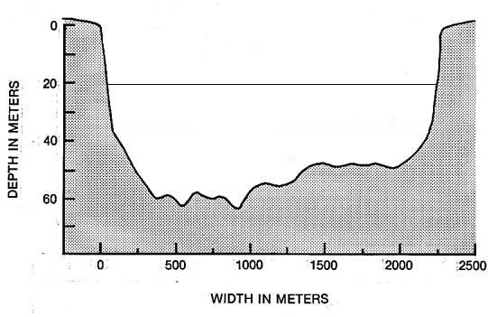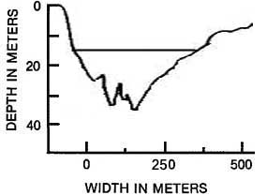
Amazon River Mississippi River
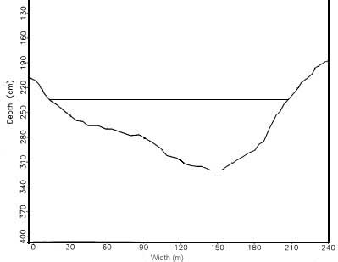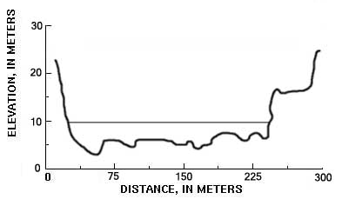
Fraser River North Fork Toutle River

- Divide each cross-section into 5 sections of equal width and measure the water depth in the middle of each section. Determine if this value accurately represents the depth and adjust it if necessary. [20]
- Calculate the total cross-sectional area for each channel. [8]
- Measure the “mean” depth and width of water and compute a “mean” cross-sectional area. [8]
- Compute the wetted perimeter (P) for each channel. [6]
- Compute the hydraulic radius (R) using both the sum of all cross-sectional areas and the “mean” cross-sectional area. Assuming that the sum of cross-sectional areas provides a more accurate representation of the actual area, does the “mean” area provide a reasonable cross-sectional estimate for each channel? For which channel are the two cross-sectional area measurements the closest? From this point on, use the sum of cross-sectional areas in subsequent equations unless otherwise stated. [15]
- Given the information in the table below, compute the slope for each river. [8]
River | Length | Drop in water surface
Amazon | 800m | 24cm
Mississippi | 1,200m | 24cm
Fraser | 700m | 21cm
North Fork | 1,000m | 30cm

- Using Table 2-2 and figure 2-6 in the lecture notes as well as any additional information you can find, determine Manning’s n value for the lower reaches of each river. What are some of the important factors you need to consider when estimating Manning’s n? [12]
- Compute velocity (v ) for each river using both the cross-sectional area computed as the sum of all cross-sections and the area computed using mean width and depth. What are some of the highest flow velocities recorded on actual rivers? (Hint: Check out Luna Leopolds work on the Internet or in the library). How do your velocity measurements compare to these extreme values and are they reasonable? Which of the variables used to calculate velocity are most and least accurate? [25]
- Draw in an isovel showing where the highest flow velocity would be in each channel. [8]
- Compute Reynolds number (R_{e}) for each river using R_{e} = VR / v where v = 0.001m²/s (i.e. kinematic viscosity of water). What does the Reynolds number define and how would you classify the nature of flow in each river based on the Reynolds number you computed? What influences the kinematic viscosity of water? [16]
- Compute Froudes number (F_{r}) for each river using F_{r} = V / (gd )^{0.5}. How would you classify the nature of flow in each river based on the Froude number you computed? [12]
- Describe the relationship between the Froude number and channel shape for each river. [12]
- Compute the discharge for each river. Find the actual average discharge of each river. How do your computed discharge values compare with actual discharge volume and what are some of the obvious reasons for any major discrepancies between the values? [20]

