Geography 313 – Lab 4: Slope Processes and Mass Movement

Instructions and notes:
- The lab is worth a total of 110 marks. Numbers in the square brackets indicate the value of each question.
- The lab will be due at the beginning of the lab on Mar. 24th, 25th, or 26th.
- The written portion of the lab is to be typed up and be sure to include all required work (i.e. calculations).
- Include student number, lab section, and date on your lab report.

Questions:
Part A. Refer to the attached map and set of equations to answer these questions.

- Discuss in detail the components of Coulomb’s equation. [20]
- Refer to the photograph below and determine whether this rock face is relatively unstable or relatively stable. Without being able to inspect the cliff first-hand, explain what evidence you can to arrive at your answer. [15]
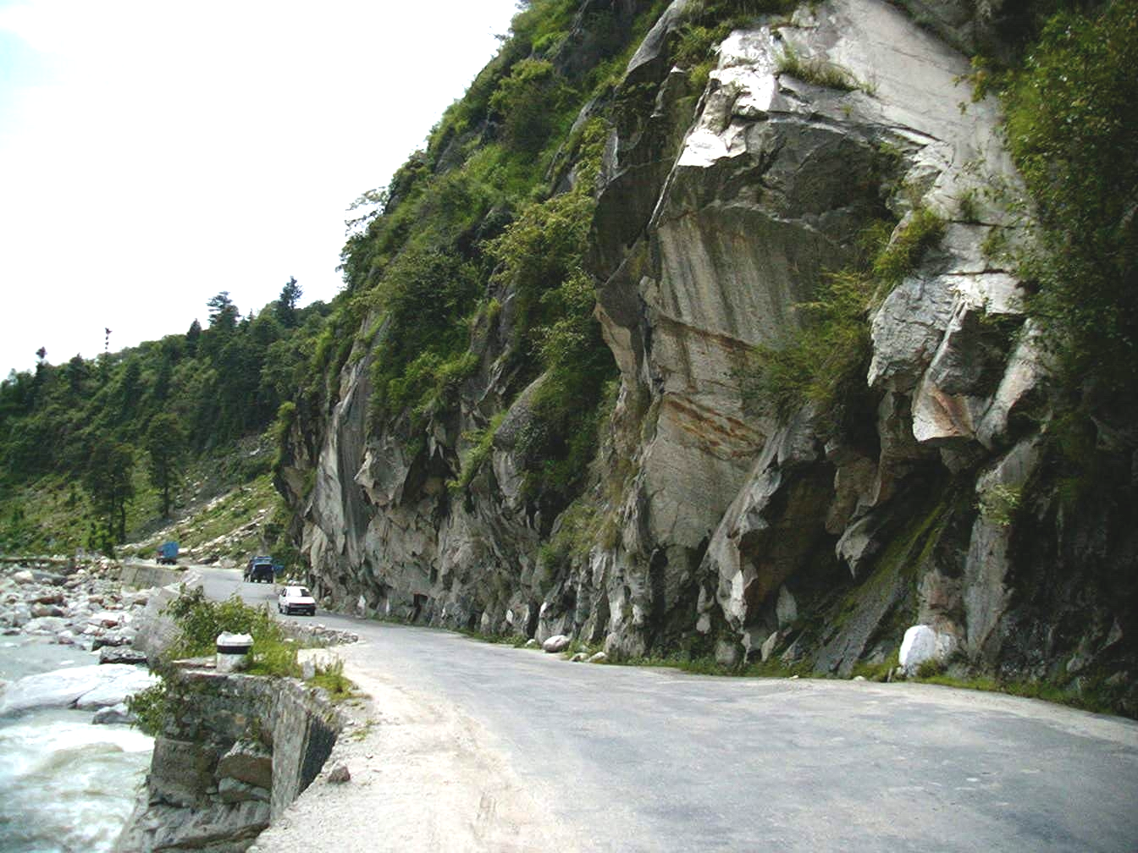
- Refer to the picture below and identify the type of mass wasting process operating on this slope. Describe in detail the conditions which favour this type of mass wasting process. [15]
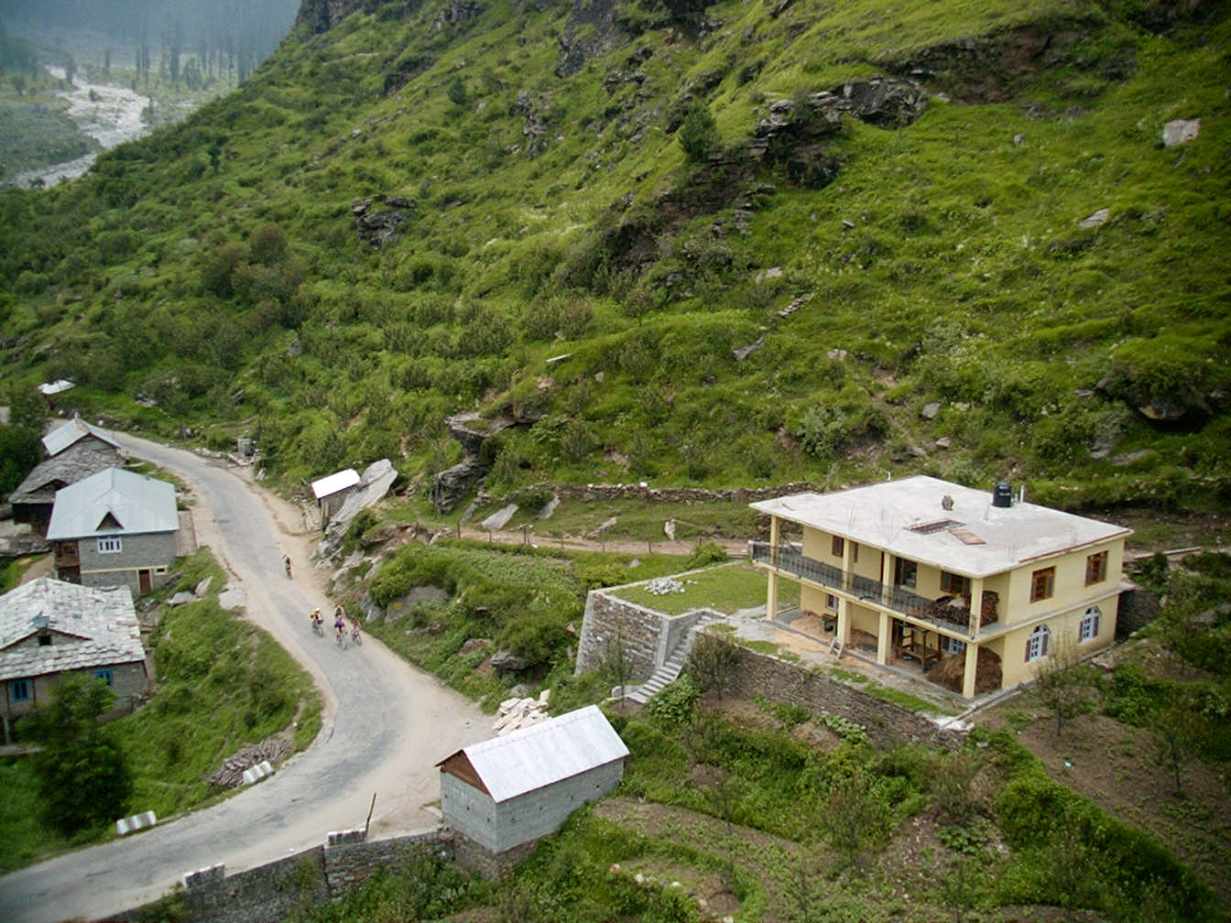

- This slope is being subjected to several types of mass movement. Identify and describe as many factors as you can which promote slope instability (either through reduction of shear strength or increase in shear stress) visible in this picture. [15]
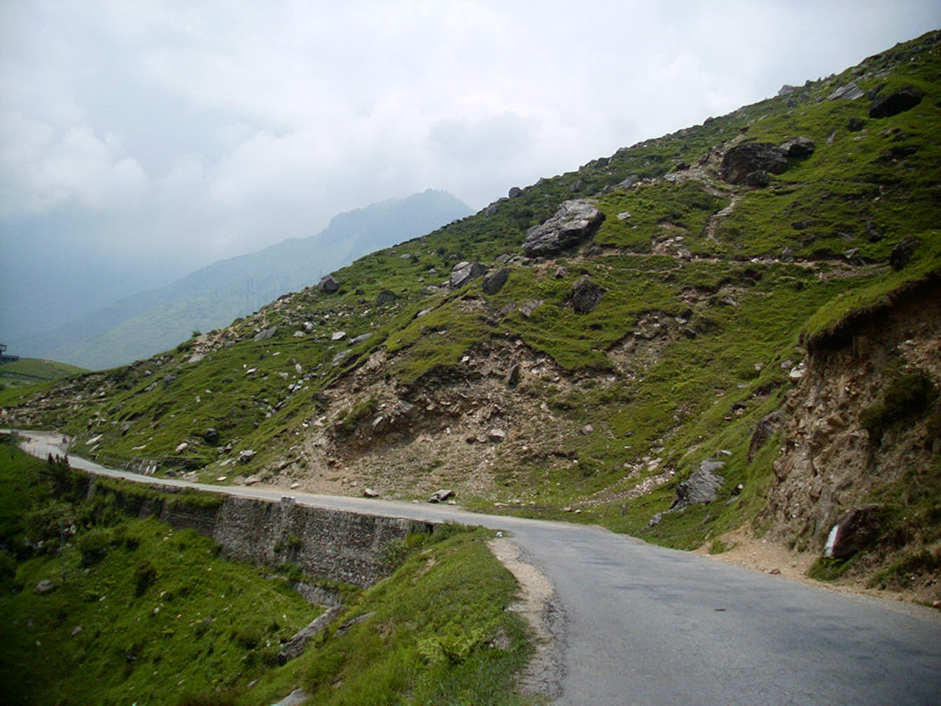
- What are some of the important assumptions and limitations associated with carrying out a Factor of Safety analysis? The Factor of Safety value is most sensitive to changes in which input variables? [10]
- You are hired to carryout a Factor of Safety analysis on a slope adjacent to a highway that is going to be twinned. Through field and laboratory testing, you’ve determined the values for the following variables:

φ = 20°, c’ = 15kN/m², γ = 19kN/m³, β = 22°, z = 2m, m = 0.5, γ_{w} = 9.81kN/m³

      - Compute F.S. given the variables above.
      - Assuming the slope was completely drained using pipes, could the required F.S. for this engineering project (F.S. = 2.0) be achieved?
      - Twinning the highway will require an increase in slope from the current 22° to 35°. What will be the new range of F.S. values knowing that the water table fluctuates from below the sliding plane upto 0.3m below the slope surface?
      - Will this slope require additional stabilization measures in order to keep it stable under the worst possible conditions?
      - What are some potential mitigative measures that could be applied to a slope in order to increase its stability? [35]

