**AUTO-MOTIVE SOCIETY**

   If it is an exaggeration to say that North America is an auto-motive society--a society 'motivated' by the automobile--it is certainly not much of one. The automobile determines how we live, work, play, eat and shop. The purchase, maintenance, refueling, and repair of the automobile is [a critical part of our society's economy](http://www.cargroup.org/?module=Publications&event=View&pubID=16); and, through heavy taxation, an equally substantial part of our governments' economies. Furthermore, through the petroleum that fuels them, automobiles are significant actor in global politics: our cars, it can be said, drive international affairs. And in addition to its economic and political importance, the automobile has conspicuous structural and psychological consequences for society.

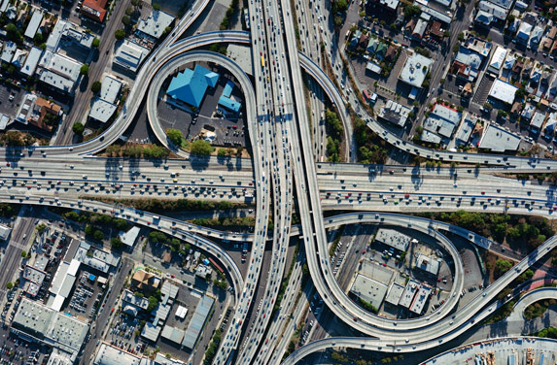

The centre-margin arrangement of our cities and towns, the urban-suburban arrangement with its widening 'sprawl', is an automotive effect on the literal structure of our society. Work and workers can be at ever-wider location of remove; shopping can be arranged into 'centres'; and recreation can be made a series of travel destinations. These configurations of city and suburb around automotive consequences influence, or even determine, the functional self-perception of individual citizens. The concept of 'soccer mom', for instance, is part of a larger present-day conception, noted by McLuhan, and far from fanciful, of the mother (or, alternatively, father) as full-time chauffeur. Also, a significant social majority spend hours of their work-day in isolated commute: the [current Vancouver Metropolitan census reports](http://www.vancouversun.com/business/Despite+massive+investment+public+transit+most+Metro+Vancouver+residents+favour+commuting+their+vehicles/8581015/story.html) that 1.2 million Greater Vancouver residents commute to work daily, with 71% of them in private vehicles.



This automotive reality creates a compound of effects on the individual psyche. Applying McLuhan's basic formulation, the automobile extends our feet and legs; significantly extending foot speed and range, but at the cost of alienation. Evidence for the alienating effect of our extended automotive selves can be found in the social phenomenon of **road rage**. We perhaps fail to wonder enough why people will behave when behind the wheel in a manner very--even completely--differently from their lives at home, at work, and at social occasions. The automobile, as we all know, and perhaps all-too well, frequently creates a condition in men and women of intense aggression and abusiveness, in word and deed, toward perfect strangers. It fits the facts, then, to say that the intimate condition between car and driver creates an alienated state which weakens or breaks outright the psychological barriers (the unspoken and unrecognised lines that we ordinarily do not cross between, internally, our feelings, drives, and urges, and, externally, other people) that human society necessitates to enable peaceful and safe interaction among its members.

**THE EXEMPLARY TECHNOLOGY**

   With the automobile, then, we are able to see in exaggerated size the economic, political, structural, and psychological effect of technology on society. Indeed, the automobile is an ideal case for a study into technology and society, as it presents that relationship in relief on a large scale and in a universally-familiar frame of reference.

   The exaggerated size and scope of the automobile is an uniquely-effective opportunity to establish one particular and important social characteristic of *all* technology: that is, its double-sided nature. It is in the very nature of technology that both in general and in each specific case it is both boon and bane: technology helps and harms to the identical degree. This can shown in every case. Consider heroin. Its christening 'heroine' is in recognition of its 'heroic' status in medicine, and indeed it more deserves the name 'hero' for the lives it saves and the pain it removes. Yet its very heroic properties cause it to be a very great social blight with immense and highly visible costs to individuals (in the form of decay and death) and society (in the form of crime and costs of prevention and treatment.)

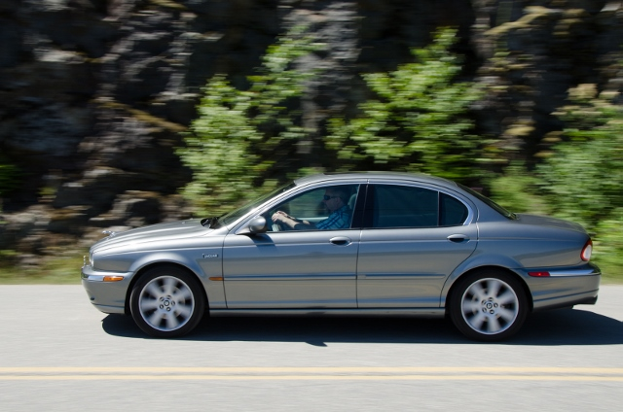

   This double character is especially evident of the automobile. Automotive technology has been a social leveller, with mass production making mobility universally accessible across society. The car (the *auto-mobile*; lit. the 'self-mobility') has advanced individual freedom, giving each person the ability to drive to a place, at a time, and on an itinerary of his or her own choosing. And automotive technologies have an intense and undeniable æsthetic aspect. Sir William Lyons, who founded the magnificent Jaguar claimed that 'The car is the closest thing we will ever create to something that is alive': a clear expression of the sense of beauty and love that automobiles inspire. On the subject of British automobiles, we should not fail to note that the engine technology developed for the majestic Rolls Royce (by the two titular founders) was applied into the Supermarine Spitfire aeroplane; enabling it to become the greatest of the World War II fighter planes, and, at the Battle of Britain, repel the German air invasion. The automobile engine, it can be said, saved Western society from Nazi tyranny.

  There is, then, a very great sum on the credit side of the automobile's double-ledger. But the debit side is equally large.

  Individually there is the alienation: 'packed like lemmings into shiny metal boxes' as the pop song goes. Traffic deaths and maimings are a common part of life in Western society. Nationally there is pollution--great pollution which some claim is apocalyptic in scope--of air, of land, of water, and of urban and suburban spaces. And internationally there are wars, invasions, economic distortions, exploitations, and even more pollutions. The social cost of the automobile is very high.

**TWO ARTICLES IN READINGS FOR THE WEEK**

   This week our readings and discussions focus directly on this doubleness: we use the exaggerated case of the automobile to exemplify the double-nature that all technology possesses. We have two essays, both of them polemical, but each quite differently done. The essay by P.J. O'Rourke.,"The End of the Affair", puts the favourable case for the automobile in short, strong, smooth, smiley, and significant form. The Wikipedia article, in hard contrast, makes the unfavourable case definitely, but not with openness. Wikipedia is chosen here for this purpose very pointedly. As an intellectual resource, Wikipedia is at best of uncertain value, and at worst is a corrupting effect on scholarly knowledge. An academic framing of the form of technology that Wikipedia is, and the effect that form has on society, will come later in the Term. For now, you will yourselves learn of its nature from your own engagement here.



  The Wikipedia article is titled (suitably enough for our study) "Effects of the automobile on societies". Your reading will, through comparison with the O'Rourke article, evaluate the form and the content of this article and make a determination of its intention--as it seems--to make an implied polemical case against the automobile.

**DOUBLENESS FEATURES LARGE IN WESTERN SOCIETY**

  This week's Readings & Resources also contain a set of lecture slides on the concept of doubleness as a characteristic (arguably, a defining) mark of Western society. The slides help establish fuller context for what is meant when we study "society" as part of our Course subject, and also put in a diachronic historical frame the double-sided aspect of automotive technology specifically and of technology in general. Not, of course, to say that only in Western civilisation does technology has its double-sided character, but rather that the uniquely-intense technological concentration in Western civilisation is an all-but necessary outgrowth and consequence of the West's fundamental attitude of configuring the world and its aspects into doubles.

**MARSHALL McLUHAN ON MOTORCARS' FUTURE PAST**

   Concluding this contextual look at automobile technology and society, we turn again to the theories of Marshall McLuhan. Broadly, McLuhan frames the social effects of automobile technology in two aspects: the way it contributes to centre-margin expansion in twentieth-century Western society, and how it facilitates the specialisation of labour that is necessary to maintain centralised post-tribal and post-City-State societies.

   Notably in the two optional chapters in this week's Reading & Resources, 10 and 19, McLuhan emphasises the expansion of centralised political control in post-tribal societies which the automobile's speed of transport (of material, force, and command) and communication (of information, instruction, and idea) provides. The automobile not only expands the margins of the centre structure (*i.e.*by creating more-widely-spread suburbs), but it also measurably increases the centre's capacity for control. In contrast, an Imperial structure, such as the British Empire, which relies on much slower modes of transport than the automobile--usually, ocean transport--sustains itself by actively seeding colonies; a model in which, within a reasonably short time (that is, on the scale by which Empires are measured), the colonial societies function with much independence from the Imperial centre.

**This is an expanation, by the bye, of the British Empire's decision to allow the French Empire to retain its laws and language in Canada after its defeat: in this manner, the Canadian Dominion could, the idea went, the better manage its two large populations of English and French independently, given the distance from the Empire centre in London**.

So, automobile technology is an active and important agent in centre-margin societies such as North America.



   The second of the two social effects which McLuhan attributes to the automobile is its promotion of the specialisation of function which centralised post-tribal societies require for their existence. Tribal societies and city-states have a high degree of integration: the relatively small number of members and localised area both allows and, for survival, requires, everyone to perform, or at least have functional familiarity with, all of the types of labour done within the tribe. When communication and transport technology forces expansion beyond the tribal or city-state reach, members can neither have universal familiarity with all manner of labour nor can they travel or communicate in sufficient time to be able to allow for labour interchange. Accordingly, the centre-margin structure demands specialisation of task by distant and separate individuals and workgroups: increasing performace efficiency and information exchange for the centralised power, but radically increasing the social fragmentation already introduced by the breaking of the tribal society's containing barrier.

   In this light, we can see that the single-occupant vehicle commuting up to ninety-minutes distance from suburban margin to urban centre is a perfect representation of modern labour specialisation and social fragmentation.

**AS FOR HORSES SO FOR CARS**

   Interestingly, in our assigned chapter for the week from *Understanding Media*, the chapter devoted by title to the automobile, McLuhan concentrates on outlining the future of the automobile in society; having dealt already in two earlier chapters with wheeled transport generally and the automobile as a specific case past and present.

   McLuhan quotes one William M Freeman, a New York Times journalist with a futurist bent, making a prediction, in the context of transport, about shopping of the then–future (remember, *Understanding Media* was published in 1964):

"….Mrs. Customer will be able to tune in on various stores. Her credit identification will be picked up automatically via television. Items in full and faithful coloring will be viewed. Distance will hold no problem, since by the end of the century the consumer will be able to make direct television connections regardless of how many miles are involved."

This is close enough to our experience today of buying on Amazon and eBay: and that seems worth a pat in the back for a clever guess from fourty years back.

  But McLuhan is unimpressed.  And, on reflection, I think that we can see why. The extrapolation is good, not more so than we any of us, with a bit of thought on the matter, could have come up with. McLuhan in contrast frames the automobile’s future more rigourously, profoundly, productively:  in a word, more *scientifically.*

**

   Automobile technology, he argues, must be seen in context of the ‘global village’—the state of communication at instant, electronic, speed: our internet age. The Freedman prediction, McLuhan implies, makes the mistake of assuming that automotive transport and shopping will change in their incidentals—people will go shopping and drive to work in a different manner, but they will still “go shopping” and “drive to work.” This is a great failure of conceptualisation. In fact, in the revolution to the age of electric instantaneity, the entire character of shopping and going to work is overthrown.

  Making purchases online is not ‘going shopping’ because, for one, no-one is going anywhere, and, for another, Amazon and eBay (just for two prominent instances) are not shops: they are parallel distributed networks of trans-national storage and access. We may still (for a while) use the word “shop”, as we use many vestigial words from obsolete technologies (for instance, we use the animal words “ride”’ and “drive” vestigally for our car travels), but we are actually doing something more like a computer does—making data transactions on stored digital access. We are making purchase on a computer, and we are, as always, being transformed into the model of the technologies that we use.

  So, for the automobile this transformation also applies. McLuhan makes the following concrete scientific prediction, potting the car in line with its transportation predecessor, the horse:

….going-to and coming-from work are almost certain to lose all of their present character. The car as vehicle, in that sense, will go the way of the horse. **The horse has lost its role in transportation but has made a strong comeback in entertainment. So with the motorcar**. Its future does not belong in the area of transportation.

The McLuhan predication, as I read it, is that the internet age will transform work, just like it transforms shopping. Work will be done virtually, from home, or from anywhere, as the predominant mode of the economy in Western society—and thus employment in the West—necessarily shifts from office and factory work to work that can be done virtually. There being no ‘there’ to ‘go’ to, automobiles will not be predominantly used to “drive to work”.

   The chapter “The Mechanical Bride”, of course, fills this out, but its relevancy for our study of **the automobile and society** is clear our study here of this aspect. The predication here, as you see, a broad-based one that is entirely consistent with McLuhan’s encompassing theory. It is up to events, then, the empirical world, to determine whether McLuhan’s theory is valid or invalid. This is exactly the character of scientificity: and it is your own judgement to make, at this point in our society’s history, whether this plausibly matches your understanding of the tendency of present events or it does not.

**�** 2013 by British Columbia Institute of Technology, Burnaby, British Columbia, Canada