Final Exam Economics 355 Student Name ____________________
December 6, 2003 Student ID ____________________
Instructor Don DeVoretz Teaching Assistant ________________

Instructions: Sit every other seat, no exceptions. All materials under unoccupied desk. Only fact sheet allowed during
exam. Answer all questions in given spaces. Answers in the back don’t account. You have exactly 3 hours.
Bonne Chance.

Part A: True, false or uncertain: worth two points. Reason worth three points.

- To improve rural health care for the poor in low income countries, training nurses is more effective in reducing infant mortality rates than training doctors. _____
Why?

- In low income countries, the infant mortality rate has decreased since the 1960's. _____
Why?

- Devaluation of your country’s currency should improve the country’s balance of trade. _____
Why?

- A Brain Drain from your country is good for the individual immigrant and the sending country. _____
Why?

- The green revolution raised agricultural productivity but led to increased rural-urban migration. _____
Why?

6. The infant industry industrialization policy requires you to pick a product which achieves the greatest fall in l ong run average costs with the minimum market share. _____
Why?

- International Commodity Agreements often work in the short-run but not in the long-run____
Why?

8. Canada’s foreign aid can be rationalized economically with the foreign exchange gap arguement. _____
Why?

- A less developed country should not sign the Koyoto agreement but just apply their own pollution tax._________
Why?

- Minifundos in Latin America are more productive than Latifundios because they have a better balance between inputs. _________
Why?

Part B: Multiple Choice: 5 points each. Circle the best answer.

1.
1. Individuals' demand for education is most affected by
- direct and indirect costs of schooling.
- development priorities of the country.
- the desire to escape agricultural work.
- all of the above.
- all but one of the above

2. The supply of public school places is determined by
- individuals' demand for education.
- direct and indirect costs of schooling.
- political processes, often unrelated to economic criteria.
- all of the above.
- none of the above

3. Which of the following environmental problems are largely caused by persistent poverty?
- deforestation.
- soil erosion.
- ground water contamination.
- all of the above.
- all but one of the above

4. The ratio of a country's average export price to its average import price is
- its absolute advantage.
- its comparative advantage.
- its terms of trade.
- its exchange rate.
- none of the above

5. Which of the following is an argument in favor of trade liberalization?
- Increased technical efficiency.
- Accelerated technical progress.
- Decreased shortages of foreign exchange.
- all of the above
- all but one of the above.

6. The effective rate of protection is
- value added with protection divided by value added without protection.
- value added with protection.
- value added without protection.
- (value added with protection minus value added without protection) divided by value added without protection.
- none of the above

7. The debt service ratio is the ratio of
- external debt to the size of the service sector.
- external debt to total GNP.
- internal debt to the size of the service sector.
- internal debt to total GNP.
- none of the above.

8. An argument in favor of direct foreign investment is that it tends to
- reduce inequality.
- promote rural development.
- increase access to modern technology.
- decrease local ownership.
- none of the above.

9. A motivation of developed countries in providing development assistance is
- the creation of markets.
- geopolitical influence.
- genuine humanitarian concern.
- all of the above.
- all but one of the above.

10. According to Joseph Stiglitz, economic development plans in the past have failed because:
- they focused primarily on economics.
- economists attributed the underlying problem to market failures and developed programmes that had government replace the absent and imperfect markets.
- economists felt that government intervention was the problem. Markets by themselves would lead to efficient resource allocation.
- economists felt that macroeconomic imbalance was the problem and focused their efforts on correcting these imbalances.
- all of the above.
- none of the above.

11. The supply curve of labor to industry in the Lewis model is horizontal if there is surplus labor in agriculture. This condition persists as long as
a. The marginal product of labor is less than the average product of labor in agriculture.
b. The marginal product of labor in agriculture is less than the marginal product of labor in industry.
c. There are diminishing returns to labor in agriculture.
d. The marginal product of labor in agriculture is zero.
e. All of the above
f. All but one of the above

12. One of Kuznets' characteristics of modern economic growth is
Rapid social and political transformation.
Limited spread of development to only a third of world population.
High growth of productivity.
Spread to all the world population.
All of the above.
All but one of the above

13. What conclusion can be reached from the following data on income shares?
Percentage of Income Received by
Lowest 40% Highest 20%
Bangladesh 17.3 45.3
Indonesia 14.4 49.4
a. Absolute poverty is more widespread in Bangladesh
b. The size distribution of income is more unequal in Indonesia
c. Bangladesh has adopted a strategy of redistribution with growth
d. Growth in Bangladesh is calculated using poverty weights rather than income weights
e. All of the Above
f. All but one of the above

14. The Gini coefficient provides a measure of
- The level of poverty.
- The level of relative inequality.
- Disguised unemployment.
- The rate of growth.
- All of the above
- All but one of the above

15. Which of the following would most likely reduce the birthrate?
- Public health improvements
- An increase in child mortality
- A decline in the availability of secondary education
- A reduction in the opportunity cost of a woman’s time
- All of the above.
- All but one of the above

16. The Malthusian Population Trap is characterized by
- three stable equilibriums.
- a relationship between the growth rate in aggregate income and levels of per capita income.
- a relationship between the population growth rate and levels of per capita income.
- the concept of stage I in the Demographic Transition Theory at low levels of per capita income.
- All of the above.
- All but one of the above

17. The number of live births per 1000 people in the population per year is the
- hidden momentum of population growth.
- population growth rate.
- demographic transition.
- crude birth rate.

18. Sharecropping can be best understood as
- a type of agreement preferred by peasants.
- a type of agreement preferred by landlords.
- a compromise between peasant and landlord preferences.
- a type of agreement preferred by neither but given by tradition.
- All of the Above
- All but one of the Above

C

19. The Todaro Migration model shows that
- migration is stimulated by rational economic considerations of relative costs and benefits.
- migration is dependent on the actual rather than the expected urban wage differentials.
- the probability of finding an urban job is inversely related to the urban employment rate
- migration rates in excess of urban job opportunity growth is both irrational and not possible.
- All of the above
- All but one of the above

20. In the micro economic theory of fertility
- agents are assumed to maximize their satisfaction subject to their income constraints and the price of having children relative to all other goods
- the intrinsic psychological and cultural determinants of family size are take into account in the model
- the demand for children is positively related to household income
- children are treated as a normal good
- All of the above
- All but one of the above

Part C: In the space(s) provided please answer the attached questions:

- In the second half of the course we looked at particular devices to lead to development. These included education, international migration, globalization, good government, industrialization, to name a few.
- Pick one tool that would be the best device to invest in for your country and with the aid of facts from your country show how that tool has been used as a successful tool. (20 pts)

- Pick one strategy that did not work and argue with facts why that strategy did not work. (5pts.)

Part D. Fill in the Blanks

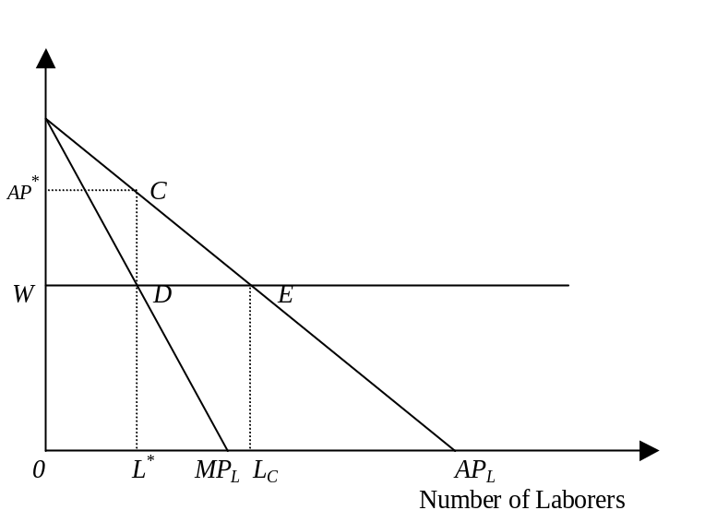
Return to labor

1. The above diagram shows that in the case with common property resource, any potential profits or scarcity rents will be competed away.
- If land is privately held, the landowner will hire _____ workers where the market wage rate W equals _____. Scarcity rents collected by the landowner will equal to the area ___________ as a result of total revenue (area) __________ minus total cost (area) _________. (10pts in total)
- If under a system of common property, _____ workers will be attracted to cultivate the land where the market wage rate W equals _____. Scarcity rent is _____ and arises as a result of total revenue (area) __________ minus total cost (area) __________. (10 pts in total).

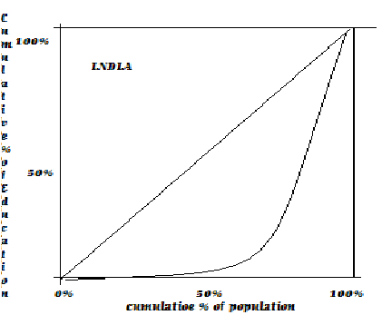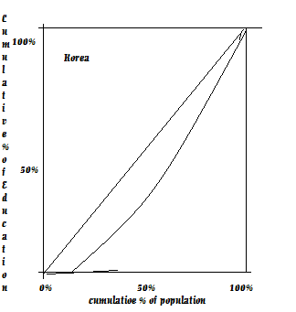

- The above diagram taken from Todaro illustrates the size distribution of education in India and Korea.

A. The straight line in either case illustrates perfectly ideal educational equality since the first 50 % of the Indian (or Korean) populations would receive -______ percent of the available education in either country. In reality for India the first 45% of the population receives _______% education while in Korea the first _________ percentage of Korea’s population received the same share of as the 58% in India. Given the shape of the above diagram, India’s Gini is __________ is value than Korea’s but still less than maximum inequality or ________% (10 points in total)

Part E: From the News in the Views please pick a letter relevant to your country and write a letter to the editor to illustrate the following points:

    - What was the thesis of the argument in the article
    - What were the strong points in supporting this argument
    - What were the weaknesses in the article
    - What policy prescriptions follow from this article to enhance development in your country.

