IAT267 Course Project

Milestone 3

Team Members (D102-Team 8):

* Tim Heng, 301131671, [bheng@sfu.ca](mailto:bheng@sfu.ca)
* Christian AKL, 301109786, [cca111@sfu.ca](mailto:ca-60@hotmail.com)
* Kwai Yin Chau, 301127333, [kwaiyinc@sfu.ca](mailto:kwaiyinc@sfu.ca)
* Xiaoyang Luo, 301107136, [xla56@sfu.ca](mailto:xla56@sfu.ca)
* Albert Lin, 301150238, [chl28@sfu.ca](mailto:chl28@sfu.ca)

Title: Dodge! Dodge! Beam!

Project topic:

The concept behind the game involves 2 opposing players stationed at each end of a gaming board. While positioned there, they are given the ability to navigate a sprite, which takes the form of an abstract representation of a gun, from left to right and as such are able to shoot at one another by way of depicted laser beams shown on the board. The objective of the game is for one opposing player to destroy the other’s gun in order to win. During the gameplay, obstacles will be generated for the purpose of blocking beams and as such will contribute to the overall tactic of the game by allowing players to beneficially utilize these them as shields in avoiding attacks.

Physical installation:

Two LED dot matrixes (8x8) and a MAX7221 LED matrix driver chip are connected to the Arduino board and placed inside a box made out of cardboard. At the side of the box, there is a hole that made for the USB to connect the Arduino board to the computer. The slider sensors and force sensors will be installed on the top of the box, at the sides of the LEDs. Hot glue will be used to stick all the wires and components together and in place.

Processing application running on the computer system:

Our Processing program controls all the screen displays on the computer. It includes the menu, instructions, and different display screens during and after the game.

We have accomplished to create a menu page and an instruction page as well as a credit page. In the menu page, the players have the choice to start the game, read the instructions, view the credits or exit the game. On each of those pages the players have the choice to go back to the menu page at anytime. After the players click on the “Start” button, they are asked to input their names and start the game. During the game, the names of the players are displayed on the top and at the bottom of the screen. When one of players has won the game, the winner’s name is displayed along with celebrating animations. Images below are the screenshots taken from the running Processing.

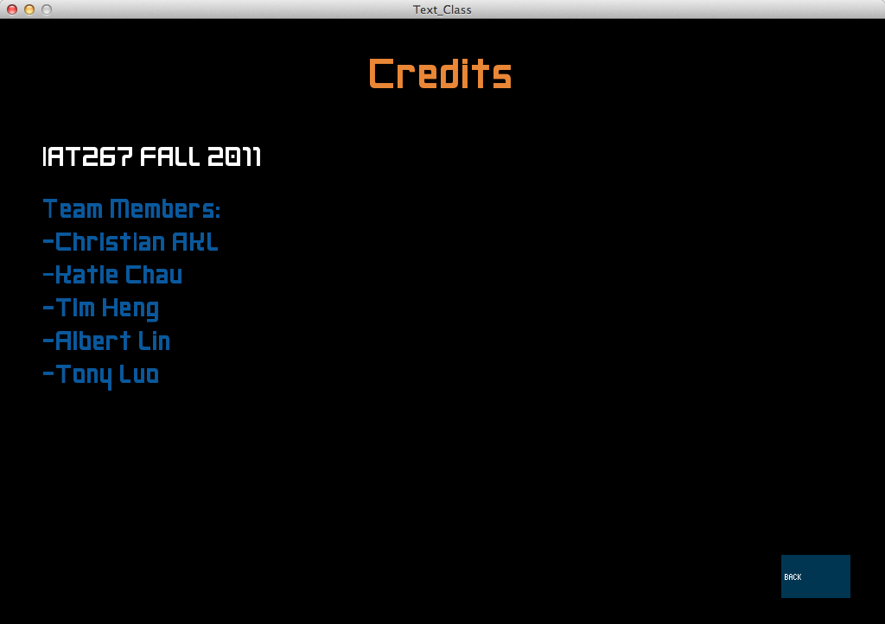 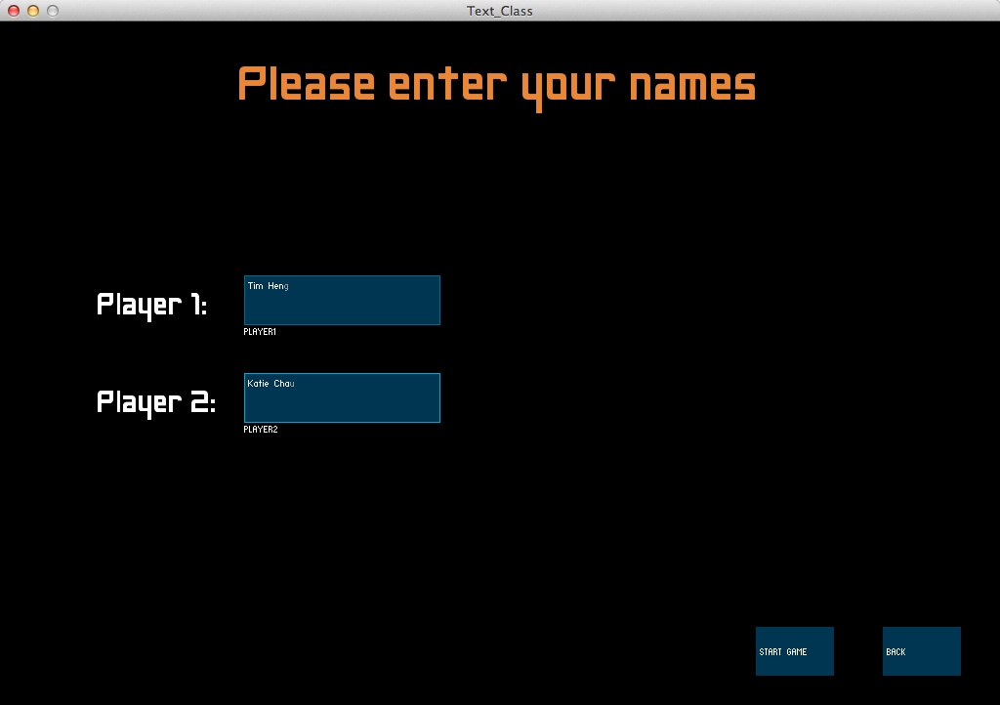 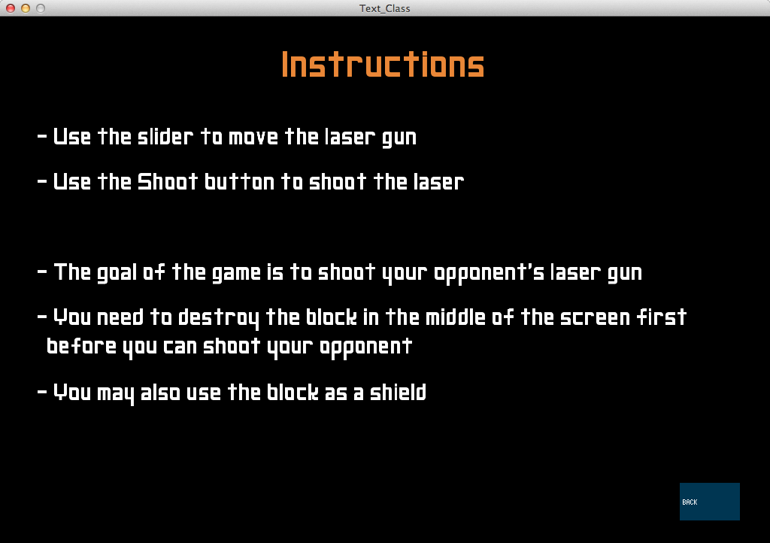­­

 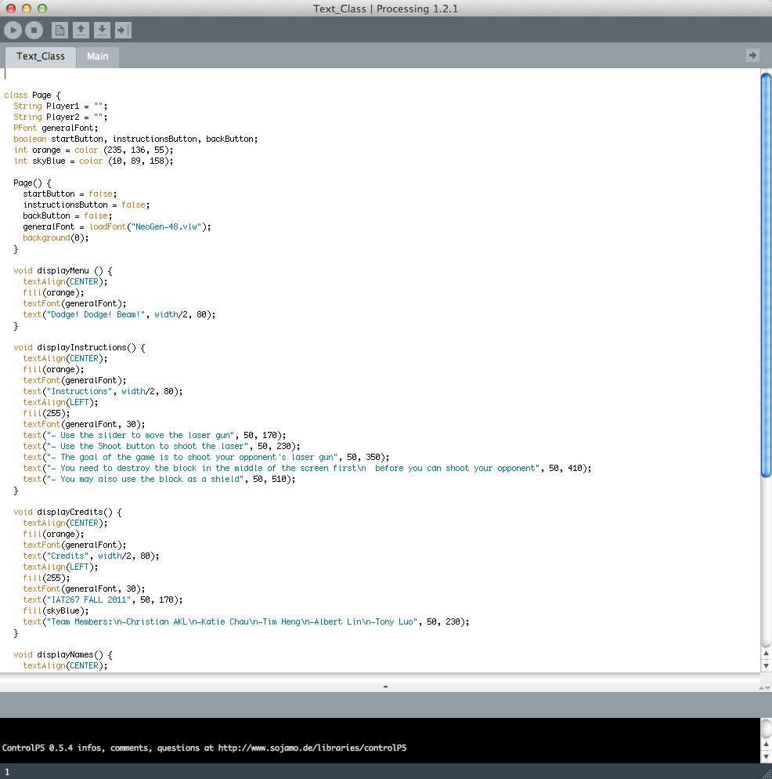

Challenges:

We have difficulties on connecting the LED dot matrix (8x8) to the MAX7221 chip, also with the installation of the slide sensors.

* The LED dot matrix is too big for the breadboard that leaves no pinholes to connect it to the chip with wires.  The solution we came up with is to connect them with glue.
* 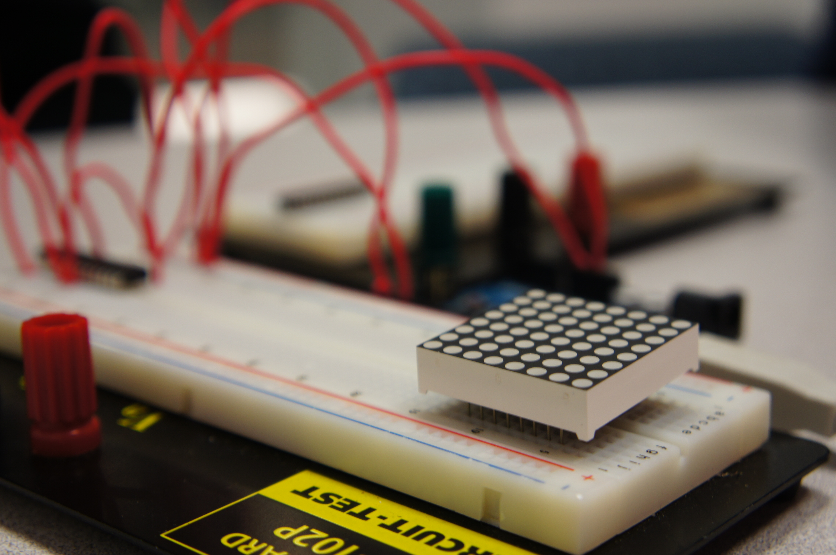The pins on the LED matrix are not aligned as the diagram shown in the lecture notes.
* Since the size of the gaming board is significantly reduced, the slide sensors from the library are now too big in proportion. We will discuss this issue once the challenges above are dealt with.

Deviations from the original project idea:

There have been some changes since we came up with the idea of this game.

* A huge block replaces the random blocks in the middle of the screen. The block would separate the two players from shooting each other right away. The player will have to destroy the block first before they can shoot each other. By doing this, we can create a more challenging and entertaining game because the users would be able to decide what part of the block they want to use as a shield.
* Since having a 11x8 inch game screen is too complicated for us to handle, we have changed the size of the game screen to 16x16 LEDs. Because of that, the size of the gaming board will be decreased and breadboards will not be used.