Jan Marontate & Dave Murphy Fall 2008
School of Communication Simon Fraser University

CMS 387-4 SPECIAL TOPICS: Visualization and Visual Culture

Handout 3: Visualization Analysis Exercises

“Everyday experience … involves navigating and decoding multiple kinds of visual codes and signs. We read visual information in many contexts and have learned how to code-switch among all the genres and visual content. Everything from street plans, building designs, and the look of different neighborhoods to messages in advertising… styles of clothing and everyone's "look" conveys cultural messages. “
- Martin Irvine, Visual Culture and Everyday Life , 2005.

Mr. Yuk warns children |   Image of a Step in a Knit Stitch | 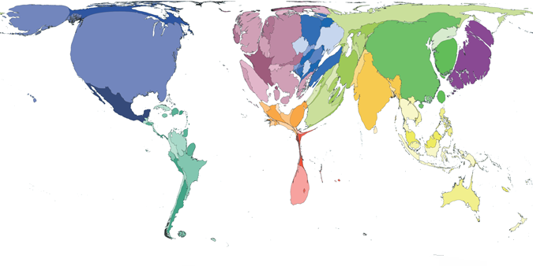  Carbon Emissions in 2000

Two of the laboratory exercises ask you to analyze a “visualization” related to your work on your first two design assignments. The first (due September 18) should focus on a visualization of a concept of an aesthetic nature or which is qualitative. The second analysis (due October 16) should examine a visual presentation or visualization of quantitative data.

Steps:
- Find a visualization. It may be an image in print media, television, video, film, computer screens, or maps, etc. Or it could be found in a place (for example signage or design features of the university, a hospital, a shopping mall, a museum or a park).

- Obtain or make an electronic image of the visualization and put it in your portfolio space on the course site.

- Conduct research on what is represented (the content), and the conventions or codes that the visualization draws upon. Seek information about how it was created, its purpose, context and reception. Investigate the design process used to develop this visualization. Look for other visualizations of the same type of content and compare them to the one you are studying.

- Analyze the visualization.
  - “Decode” the image by looking for multiple registers of meaning. For example if it is an ad selling a product does it also make appeals to consumers that links the product to lifestyles or aspirations. What? How?
  - What conventions does it follow or transgress?
  - Is it effective in communicating about the phenomenon represented? Why or why not?
  - Make suggestions for improvements and offer a creative critique of the design.
  - Consider how you may use lessons from the example in your own design work.

- Prepare a short written statement (1 page) that presents the image, explaining its significance and content, summarizing your research and analysis, and citing sources. Post the paper in your folder before class.

- Show the visualization and briefly discuss your analysis in class on the due dates.

** Refer to at least one required reading by using concepts presented in the reading in your analysis. Choose appropriate concepts and terminology.

